MINISTRY OF HEALTH
NATIONAL INSTITUTE OF HYGIENCE AND EPIDEMIOLOGY &
CENTER FOR RESEARCH AND PRODUCTION OF VACCINES AND MEDICAL BIOLOGICALS (POLYVAC)
----- -----

TECHNICAL ASSISTANCE PROJECT
VIETNAM COVID-19 EMERGENCY RESPONSE PROJECT

ENVIRONMENTAL AND SOCIAL
MANAGEMENT PLAN

HA NOI – 9/2020
TABLE OF CONTENTS

CHAPTER I PROJECT INTRODUCTION 5
1. Project title and owner 5
2. Description of the project locations 5
2.1. The National Institute of Hygiene and Epidemiology 5
2.2. The Center for Research and Production of Vaccines and Biologicals (POLYVAC) 6
3. Project activities 6
CHAPTER II ORGANIZATIONAL STRUCTURE AND RESPONSIBILITY ASSIGNMENT 9
1. Organizational chart and responsibilities in laboratory safety management 9
1.1. Organizational chart 9
1.2. Responsibility for managing the laboratory safety 9
2. Organizational chart and responsibilities in waste management 11
2.1. Organizational chart and responsibility for waste management of NIHE 11
2.2 Organizational chart and responsibilities for waste management of POLYVAC 12
3. Organizational chart and responsibilities for waste management in social safeguard 13
3.1. Director 13
3.2. Ethical Council 14
3.3. Project Management Unit 14
3.4. Faculties, Departments, Centers 14
CHAPTER III REQUIREMENTS AND PROCEDURES FOR BIO-SAFETY IN LABORATORIES 15
1. Bio-safety Level and Risk Assessment 15
1.1. Groups of Risk posed by microorganisms and bio-safety levels of laboratories 15
1.2. Risk Assessment for Laboratories 15
2. Physical facilities 19
2.1. Bio-safety level II laboratories 19
2.2. Bio-safety level III laboratories 20
3. Equipment 22
3.1. Personal Protective Equipment (PPE) 22
3.2. Biosafety cabinets 29
3.3. Autoclave 30
3.4. Other equipment 30
4. Monitoring occupational health 32
5. Training 32
6. Biosafety practice 33
6.1. Regulations on Entry and Exit of Laboratories 33
6.2. Common Regulations on Practice 33
6.3. Decontamination and sterilization 34
6.4. Segregation, collection and treatment of laboratory waste 38
6.5. Package and Transportation of Samples 41
6.6. Prevent, respond to incidents 45
7. Safety related to power, fire, explosion and chemicals 51
7.1. Power safety 51
7.2. Fire and Explosion Safety 53
7.3. Chemical Safety 56
CHAPTER IV requirements and procedures for waste treatment 61
1. Assessment of risks associated with waste 61
2. Management of Solid Waste 62
2.1. Procedure of collecting, storing, transporting, treating and disposing solid waste of NIHE 62
2.2. Procedure of collecting, storing, transporting, treating and disposing solid waste of POLYVAC 65
3. Wastewater management 69
3.1. Collection and treatment of waste water in NIHE 69
3.2. Collection and Treatment of wastewater at POLYVAC 74
CHAPTER V Human RESOURCE MANAGEMENT PROCEDURE 77
1. Assessment of risks associated with project workers 77
2. Measures to mitigate risks associated with labour management 81
2.1. Occupational Health and Safety (OHS) 81
2.2. Age of Employment 83
2.3. Terms and Conditions and Equal Opportunities 83
2.4. Grievance Mechanism 84
CHAPTER VI mesures for protecting community safety and health 86
1. Assessment of risks associated with Community 86
2. 88
2.1. Samples 89
2.2. The best time to collect the samples 89
2.3. Methods to collect samples 90
2.4. Preserving, packaging and transporting samples to the labs 94
2.5. Collection, treatment and disposal of waste generated in the sampling process 95
CHAPTER VII MONITORING AND EVALUATION 97
1. Bio-safety in Labs 97
1.1. External Evaluation and announcement to meet bio-safety standards 97
1.2. Internal Assessment 97
2. Waste management 97
2.1. NIHE 97
2.2. POLYVAC 98
3. Human Resource Management 98
ANNEX I 99
ANNEX II 101
ANNEX III 112
ANNEX IV 120
ANNEX V 127
ANNEX VI 128
ANNEX VII 137
ANNEX VIII 146
ANNEX IX 153
ANNEX X 178
ANNEX XI 185
ANNEX XII 195
ANNEX XIII 212

project INTRODUCTION

1. Project title and owner
Title of Technical Assistance Project: “Vietnam COVID-19 Emergency Response Project”
Project owner: National Institute of Hygiene and Epidemiology (NIHE)
Co-Implementation agency: Center for Research and Production of Vaccines and Biologicals (POLYVAC)

2. Description of the project locations

2.1. The National Institute of Hygiene and Epidemiology
The National Institute of Hygiene and Epidemiology (hereinafter referred to as the Institute) is a public non-profit health care agency affiliated to the Ministry of Health, established under the Ordinance No. 4P dated October 3, 1945 by the President Ho Chi Minh City. The National Institute of Hygiene and Epidemiology was adopted under Decision No. 230/1998/QĐ-TTg dated November 30, 1998 by the Prime Minister. The National Institute of Hygiene and Epidemiology is the Institute at national level in the field of preventive medicine for disease prevention and control (including infectious diseases, non-communicable diseases and other public health issues).
The Institute has the only one office at No. 1 Yecxanh, Pham Dinh Ho Ward, Hai Ba Trung District, Hanoi. The Institute's geographical location is in the Southeast of Hanoi, bordering the Red River dyke.
- The North of the Institute: border with Yecxanh street
- The South: border with Nguyen Cao street
- The West: border with Lo Duc street
- The East: border with Institute of Occupational Health and Environment
In 2018, the Ministry of Health issued the Regulation on the organization and operation of the Institute based on the Decision No. 558/QĐ-BYT dated January 23, 2018 by the Minister of Health defining the organizational structure of the Institute, including: 04 functional departments, 12 faculties/ offices/ professional centers, 03 service units (see Appendix I).

2.2. The Center for Research and Production of Vaccines and Biologicals (POLYVAC)
The Center for Research and Production of Vaccines and Biologicals was built at 418 Vinh Hung, Thanh Tri, Hoang Mai, Hanoi, with an area of about 8000 m2, including different buildings for: vaccine manufacturing building; Office building; Clean rabbit breeding building; Building for animal breeding for experiments; Mechanical building; Building for vaccination services; the rest area include internal roads and gardens with the following territories:
- The North: border with a residential high building (under construction)
- The South: border with the Lane 416 of Vinh Hung street
- The East: border with a vacant land area
- The West: border with the Vinh Hung street
Organizational structure and personnel: The Center consists of 13 functional and professional departments, one experimental animal farm (see Appendix I).

3. Project activities
Project Development Objective To assist Vietnam to strengthen capacities for detecting and responding to COVID-19.
The Project will be financed by the PEF Insurance Window allocation for Vietnam to support the country’s COVID-19 response and to strengthen the health system for public health emergency. The project components and activities under each component are designed to improve the capacities of surveillance and diagnostics for COVID-19. The project will complement other efforts that have already been committed by USAID, USCDC, WHO, ADB and UN agencies. The implementation period of the project is very short, only about six months from July 2020 to January 31st, 2021, which will have some implications on the scope of project activities and outcomes. The project will comprise the following three components. The project will comprise the following three components.
Component 1. Strengthening surveillance and testing capacities [US$4.59 million]

Sub-component 1.1. Strengthening the capacity of laboratory systems at NIHE. This sub-component will: (i) provide equipment to the laboratory systems for levels 2 and 3; (ii) develop the Standard of Procedure (SOP) for the new equipment financed by the project; and (iii) train the technicians and staff on the new SOP.
Sub-component 1.2. Assessing and strengthening the capacity of laboratory systems nationwide to respond to COVID-19. This sub-component will: (i) assess the testing capacity and bio-safety conditions and other aspects of the laboratories involved in COVID-19 surveillance and testing in hospitals and Provincial CDCs nationwide; and (ii) provide technical support and training on testing techniques, bio-safety, and quality assurance and other aspects related to COVID-19 for technicians and laboratory staff at provincial level.
A comprehensive assessment on infrastructure, equipment, technical capacities, quality and safety will be conducted in about 200 laboratories in Vietnam. Results from the assessment will be used to develop training packages and development strategies for the provincial laboratory systems.
Sub-component 1.3. Evaluating community immunity with COVID-19 and conducting other studies related to COVID-19. This sub-component will evaluate community immunity with COVID-19 for epidemic forecasting as a foundation for pandemic prevention, surveillance and response strategies applying SARS-CoV-2 antibody test. The project will support NIHE to collect the samples from the population in selected localities and to test the samples. It is expected that at least 6,000 samples will be tested. In addition to that, the project will finance relevant COVID-related studies, which will be selected based on the country’s needs and subject to the Bank’s prior approval.
Regarding the study on community immunity with COVID-19, the project will finance the sample collection and testing; hiring consultants for preparing study proposal, data analysis, and writing report. For samples collection, NIHE will sign non-consulting service contracts/agreements with Provincial CDCs to collect samples in selected provinces under a force account (FA) arrangement. The contract/agreement amounts are calculated based on the following cost components: organization and management, payments for sample collectors and givers, rental of venues for collecting samples, sample transportation and storage, reagents and consumables and other reimbursables. The estimated number of samples is subject to the pandemic evolution at the time of implementing the assessment. For samples analysis and testing, the same arrangement of FA contract/agreement will be applied. NIHE will assign the task of sample analysis and testing under a force account arrangement through a non-consulting service contract to the Center for Applied Biomedical Science – a NIHE’s affiliate that has independent legal and financial status. The contract/agreement amount is calculated to include human resources, and equipment expenses.
Component 2. Strengthening research capacity for COVID-19 vaccines and test kits [US$1.29 million]
This component will provide equipment for research of COVID-19 vaccine and test kits for POLYVAC. It is expected that the new equipment will contribute to improve the capacity of POLYVAC for research and development of new vaccine and quick diagnostic test to prepare for future waves of COVID-19.
Component 3. Communication, Project Management, Monitoring and Evaluation [US$0.68 million]
Sub-component 3.1. Communication. This sub-component would help to (i) conduct communication activities for strengthening engagement of project stakeholders; (ii) assess the COVID-19 risk communication activities in Vietnam; and (iii) produce a comprehensive documentary on COVID-19 response for further communication and lessons learnt.
Sub-component 3.2. Project Management and Monitoring and Evaluation (M&E). This sub-component will finance the associated cost for project management at NIHE. This will include additional NIHE staff and/or consultants hired to staff the PMU. It would also support, among others, monitoring and evaluation of the project, including training in monitoring and evaluation, travel of staff to project sites, evaluation workshops, development of an action plan for M&E, audit, and final evaluation.

ORGANIZATIONAL STRUCTURE AND RESPONSIBILITY ASSIGNMENT

1. Organizational chart and responsibilities in laboratory safety management

1.1. Organizational chart
DIRECTOR
BIO-SAFETY AND QUALITY MANAGEMENT BOARD
CENTER OF LABORATORY QUALITY ASSURANCE AND CALIBRATION

FALCUTIES, CENTERS
LABORATORIES AND RELATED AGENCIES

1.2. Responsibility for managing the laboratory safety
1.2.1. The Director
- Ensuring the resources needed to implement safety-related activities;
- Determining the organizational structure and assigning biosafety responsibilities to different units and individuals in the Institute;
- Approving the Manual of the Laboratory Safety and guidance on laboratory safety;
- Managing and supervising the implementation of safety-related activities.
1.2.2. The Bio-safety and Quality Management Board
- Deciding on the strategies and plans for bio-safety development of the Institute;
- Issuing guidelines and regulations related to biosafety;
- Deciding on the necessary measures to ensure biosafety;
- Advising and supervising the implementation of biosafety-related activities;
1.2.3. The Center of Laboratory Quality Assurance and Calibration
- Planning to ensure biosafety for laboratories in the Institute;
- Compile and update biosafety regulations, procedures and guidelines;
- Organize training and retraining on biosafety;
- Check and supervise the implementation of procedures, instructions to ensure bio-safety for units in the Institute. Coordinate the implementation of appropriate measures to handle an incident or emergency scenario;
- Manage and preserve samples, pathogenic microorganism strains of the Institute;
- Manage, operate and maintain Biosafety Level 3 (BSL3) laboratories;
- Calibrate equipment to ensure biosafety;
- Conduct administrative duties of the Biosafety Board;
- Periodically report to the Institute Leaders on biosafety issues.
1.2.4. Related Functional Departments
- Coordinate the implementation of different tasks related to laboratory safety according to safety requirements and as the direction of the Institute's leaders.
1.2.5. Laboratories’ managers
- Ensure the laboratories comply with regulations and guidelines of the Institute;
- Create favorable conditions for staff to participate in bio-safety training and other biosafety activities.
1.2.6. Persons in charge of bio-safety in laboratories
- Coordinate with the Center for Quality Assurance and Calibration in training, monitoring, supervision, ensuring the implementation of regulations and guidelines on the laboratory's bio-safety;
- Update regulations and guidelines on bio-safety and disseminate them to lab staff;
- Submit reports on bio-safety of the labs to the Center of Laboratory Quality Assurance and Calibration as required;
- Participate in planning, preliminary review, final review meetings and other activities related to bio-safety.
1.2.7. Laboratory staff
- Comply with regulations on biosafety.

2. Organizational chart and responsibilities in waste management

2.1. Organizational chart and responsibility for waste management of NIHE

DIRECTOR
ADMINISTRATION DEPARTMENT
FALCUTIES
CENTER FOR LABORATORY QUALITY ASSURANCE AND CALIBRATION
WAST TREATMENT COMPANY

2.1.1. The Director
- Ensure the necessary resources for implementing waste treatment activities;
- Manage and supervise the implementation of waste activities
2.1.2. Administration Department
- Select a qualified waste treatment company and sign the contracts;
- Operate the Institute's wastewater treatment system;
- Monitor and supervise the company's waste treatment activities;
- Manage the worker team who collect domestic waste.
2.1.3. The Center for Laboratory Quality Assurance and Calibration
- Compile and update regulations, procedures and guidelines on waste treatment;
- Inspect and supervise the implementation of waste treatment procedures and guidelines;
- Treat medical waste before transporting it to the concentrated collection area of the waste treatment company
2.1.4. Faculties, Departments
- Sort the waste as required;
- Gather waste and transport it to the appropriate treatment area.
2.1.5. Waste Treatment Companies
- Collect and treat all kinds of waste of the Institute according to the contents of the signed contracts;
- Ensure safe waste treatment and comply with national regulations on waste treatment.

2.2 Organizational chart and responsibilities for waste management of POLYVAC
DIRECTOR
ORGANIZATION-ADMINISTRATIVE DEPARTMENT
DEPARTMENTS
TECHNICAL DEPARTMENT
WASTE TREATMENT COMPANY

2.2.1. Director
- Ensure the necessary resources for implementing waste treatment activities;
- Manage and supervise the implementation of waste activities
2.2.2. Organization – Administrative Department
- Select a qualified waste treatment company and sign the contracts;
- Select a company to perform environment monitoring
- Monitor and supervise the company's waste treatment and environment monitoring activities of the Center;
- Manage the worker team who collect domestic waste
- Compile and update regulations, processes and guidelines on waste treatment;
- Inspect and supervise the implementation of waste treatment procedures and guidelines;
2.2.3. Technical Department
- Operate the wastewater treatment system according to the right process.
2.2.4. Departments
- Sort the waste according to regulations;
- Treat medical waste before transporting it to the concentrated collection area according to regulations;
- Gather waste and transport it to the concentrated areas according to regulations.
2.2.5. Waste treatment company
- Collect and treat different types of waste of the Center according to the contents of the signed contracts;
- Ensure safe waste treatment and comply with national regulations on waste treatment.
2.2.6. Environment Monitoring Companies
- Periodically perform environment monitoring according to the signed contracts.
- Submit reports with environment monitoring data to the Center.

3. Organizational chart and responsibilities for waste management in social safeguard

DIRECTOR
ETHICAL COUNCIL
FACULTIES, DEPARTMENTS, CENTERS
PROJECT MANAGEMENT UNIT
GROUPS IMPACTED BY THE PROJECT

3.1. Director
- Ensure the resources needed to implement social safeguard activities;
- Manage and supervise the implementation of activities of social safeguard.

3.2. Ethical Council
- Approve research related to community immunity;
- Conduct monitoring and supervision to protect the interests of subjects participating in community immunity research;
- Receive and handle complaints of subjects participating in research and give feedback to the Project Management Unit.

3.3. Project Management Unit
- Identify people affected by the project;
- Assess risks and develop policies and procedures to minimize risks and ensure benefits for these objects;
- Check and supervise the implementation of policies and procedures developed;
- Receive and handle complaints and grievances of the people affected by the project.

3.4. Faculties, Departments, Centers
Implement the policies and processes to minimize risks and ensure benefits for people affected by the project.

REQUIREMENTS AND PROCEDURES FOR BIO-SAFETY IN LABORATORIES

1. Bio-safety Level and Risk Assessment

1.1. Groups of Risk posed by microorganisms and bio-safety levels of laboratories
- According to the Decree No. 103/2016/NĐ-CP of the Government, microorganisms (VSVs) that are at risk of causing infectious diseases to humans are classified into 4 groups including groups 1, 2, 3 and 4. The Ministry of Health has issued Circular No. 41/2016/TT-BYT dated November 14, 2016 issuing the list of microorganisms causing infectious diseases by risk group matching with bio-safety level suitable for testing techniques. Decree No. 103/2016/NĐ-CP classifies laboratories into 4 biosafety levels from level 1 to level 4. Each laboratory determines the necessary bio-safety level based on the Circular No. 41/2016 /TT-BYT.
- Pathogens or testing techniques that are not mentioned in Circular No. 41/2016/TT-BYT which stipulates the list of microorganisms causing infectious diseases by risk group and biosafety level matching with test techniques, to determine the appropriate bio-safety level, the Head of the Lab should request the Bio-safety Board to determine.

1.2. Risk Assessment for Laboratories
1.2.1. Preparation for risk assessment
- Time for assessment: Assessment of biological risks need to be implemented periodically once a year or could be reviewed in the following cases:
- There are changes of staff.
- Starting a new task like starting to work with a new biological agent, a change in the workflow or the amount of biological agent used.
- New construction or renovation of laboratories, change of machines and equipment or the way of operating machines and equipment.
- Human resource changes in the laboratory.
- Significant changes in standard operation procedures (SOP) or practices such as decontamination methods, waste treatment, use of personal protective equipment, laboratory entry / exit regulations...
- When an undesired event occurs which may be related to the management of a biological hazards.
- When the results of the previous risk assessment no longer match the new regulations of the agency or of the country.
- When planning emergency prevention and response.
- Locations of assessment: at the biosafety laboratories of the National Institute of Hygiene and Epidemiology.
- Scope of assessment: Assess risks associated with laboratory procedures.
- Assessment objectives: to help determine the appropriate bio-safety levels of libraries and necessary measures to control risks.
- The composition of the assessment team: laboratory staff, the person in charge of the laboratory, the person in charge of bio-safety.
- Prepare related documents:
- Previous risk assessment findings (if there are)
- Material Safety Data Sheet (MSDS) of the materials available in the lab: pathogens, chemicals…
- Test procedures
- Policies, regulations, guidelines applied in the lab
- Agreement in the team about the following issues:
- Classify and describe the levels of consequences
- Classify and describe level of likelihood of occurring
- Assigning responsibility to the leader and secretary of the team: The team leader is responsible for directing the evaluation process and making the final decision based on the team's discussion. The team secretary has the role of recording all the information during the risk assessment process based on the STAT-BM01 - Risk Assessment Record.
- Use table 1 in STAT-BM01 - Risk Assessment Record to fill in the names of testing procedures, procedures for using equipment in the laboratory. For each process, list the steps to be taken in the process.
1.2.2. Risk assessment
- Identify hazards and risks
- Hazards in the laboratory are factors that can cause harm to humans, animals and the surrounding environment. There are many hazards in a laboratory that contains pathogens. These hazards are divided into 3 main groups, including:
- Biological hazards are materials containing pathogens such as samples, sample tubes, testing tools, infectious waste ...
- Physical hazards can be electricity, fire, explosion, heat, hot vapor, cold vapor, pressure ...
- Chemical hazards can be toxic chemicals or radiological substances that are dangerous to human health and the environment.
- Biological hazards are the most concerned hazard in the laboratory. An understanding of the features of the pathogen is essential in the identification of biological hazards. One of the important features to consider in the risk assessment process is the risk group of the pathogen. In Vietnam, the Ministry of Health has issued the List of microorganisms causing infectious diseases by risk group and corresponding bio-safety level suitable for the testing techniques attached with Circular No. 41/2016/TT-BYT dated November 14, 2016. However, data on risk subgroups for microorganisms that cause infectious diseases are insufficient for the risk assessment process. Key factors to consider include:
- Risk group of the pathogen;
- Infection routes;
- Infection dose;
- The viability of the microorganism in the environment;
- Host factors;
- Availability of effective preventive and curative measures.
- Identify level of risk
- Risk is the likelihood of an undesired event, related to a particular hazard, with consequences. The risk is presented by the following formula:
- Risk = likelihood x consequence. The risk matrix is used to evaluate and classify the level of the identified risk. The risk matrix is a table, reflecting the interaction between the levels of consequences and the likelihood of occurrence, forming the level of risk. The risk matrix is divided into several categories depending on the classification of the severity of the consequences and the likelihood of the risk. The labs at the Institute apply 3x3 matrixes when conducting risk assessment as follows:
Table 1. Risk Matrix 3x3
Likelihood | Consequences
Likelihood | Minor | Moderate | Major
Very likely | Average | High | High
Likely | Low | Average | High
Unlikely | Low | Low | Average

- In which, the level of likelihood and consequence will be considered and determined by the team. The example of classification and description of likelihood and consequence is as follows:
Table 2. Example of classification and description the level of likelihood
Likelihood | Description/Definition | Example of likelihood
Unlikely | An event that rarely occur. Only occur in special circumstances | Occur less than once in a 20 year period
Likely | Likely to occur in most of the circumstances | Occur at least once in a 5 year period
Very likely | Expected to occur in most of the circumstances | Occur at least once a year

Table 3. Example of classification and description of consequence
Consequence | Description
Minor | Minor accident, spill or failure of equipment or system, can be solved without assistance
Moderate | Accident causing minor injury or exposure and requires external assistance
Major | Fatal accidents or infections
- The level of risk is determined based on the risk matrix and is classified into 3 levels as shown in Table 4.
Table 4. Level of risk and necessary control measures
Risk level | Description
Low | The risk is acceptable if it is managed according to the available management procedures and monitored regularly
Moderate | The risk is acceptable but requires additional risk control measures
High | The risk is unacceptable and requires immediate implementation of the risk control measures
1.2.3. Risk control
- Risk control includes the development, implementation, and management of control measures to reduce the level of risk. The risk control measures can be classified into five main groups of measures, including: physical facilities, equipment, personnel, practices and prevention, and handling biosafety incidents.

2. Physical facilities
Laboratories at bio-safety level I, II, II must satisfy the conditions specified in Decree No. 103/2016/NĐ-CP, Decree 155/1018/NĐ-CP of the Government, other Decrees and Circular No. 37/2017/TT-BYT of the Ministry of Health and current regulations.

2.1. Bio-safety level II laboratories
- BSL II laboratories are often used to study, diagnose, and test pathogens in risk group 2 and to conduct the tests for BSL I laboratories. In addition, BSL II laboratories are also used to conduct some tests with pathogens under the risk group 3. Circular No. 41/2016/TT-BYT details the list of microorganisms and testing techniques to be conducted BSL II laboratories.
- The physical facilities of BSL II laboratories must fully satisfy the requirements on physical facilities of BSL I laboratories.
- There is a system for collection treatment of or equipment to treat wastewater. For testing establishments that were operating before the effective date of Decree No. 103/2016/NĐ-CP, they must have test results of wastewater meeting national technical regulations on environment before being discharged into concentrated storage facilities.
- Must be separate from other functional rooms of the testing premise.
- There must be signs of biological hazard on the entrance of the testing area as prescribed.
- The laboratory doors must be closed all the time when tests are being conducted.
- Design diagram of BSL II laboratories: see section 3.2.2.

2.2. Bio-safety level III laboratories
- The physical facilities of BSL III laboratories must fully satisfy the requirements on physical facilities of BSL II laboratories.
- There are testing rooms and access rooms;
- Separate between the labs and other areas of the lab areas;
- The laboratories must be closed to ensure sterilization;
- The entry door system to the testing area must be in working conditions; the doors of the access rooms or test area are only open at a certain time;
- Laboratories has a transparent glass panel or a device for observing the inside of the test area from the outside;
- The ventilation system must be designed based on one-way principle; air flows from the test area must pass through a High efficiency particulate air filter;
- There is an alarm system when the pressure of the test area is not up to standard; test area pressure is always lower than that outside when the test area is working;
- The air exchange frequency of the test area is at least 6 times per hour;
- The air supply system only works when the exhaust system is in operation and stops automatically when the exhaust system stops working;
- There is shower equipment for emergency in the testing area;
- Laboratories have a two-way communication system and an alarm system.
- Below is the diagram of a BSL II laboratory system
- Basement Floor B1: A drain treatment room is located on the basement floor to treat wastewater drained from P3 laboratories’ sinks.
Drain treatment room

- P2 laboratories (3rd floor): Six laboratories and a specimen storage room is separated by calcium silicate boards on light-gauge steels (LGS). Height of roof: 2700 mm. Type of wall: Not resistant to formalin.
- P3 laboratories (3rd floor): Four rooms and a corridor in the middle are separated by air-tight panels. Height of roof: 2500 mm. Type of wall: Plant fabricated panels, resistant to formalin.
- Office (3rd floor): A management office is located between P2 laboratories zone and P3 laboratories zone. Height of roof: 2500 mm. Type of wall: Not resistant to formalin.

P3 laboratories zone
P2 laboratories zone
ゾーン
- Machine room (4th floor):

3. Equipment

3.1. Personal Protective Equipment (PPE)
- Laboratories select the appropriate personal protective equipment for each test operations and types of pathogens based on the results of risk assessment. The Lab Manager is responsible for ensuring the availability of the appropriate PPE (quantity, type, size) for employees and ensuring staff are trained to properly use the PPE.
- Personal protective equipment used in laboratories at the Institute includes:
- Hairnet;
- Goggles;
- Face shield;
- Masks;
- Lab blouse;
- Lab gown
- Anti-epidemic suit;
- Tyvek;
- Gloves;
- Closed toe shoes / sandals;
- Shoe cover;
- Boots.
- For BSL III labs, follow the procedure of BSL II lab management, code QL09-QT01 (see Annex II).
- In the BSL II laboratories at the Institute, the test staff when entering the laboratory must use at least a lab blouse and closed toe sandals. Depending on each operation performed in the laboratory to choose additional suitable PPE such as gloves, masks, glasses, hats, gowns…
- Protective clothing
- Protective clothing helps to prevent contamination of pathogens or dangerous chemicals on the body or normal clothes. The protective tops used in laboratories are long-sleeved blouses with a suitable length. In some operations to handle a dangerous pathogen, lab staff may use front cover gowns over the blouses.
- Laboratories must arrange suitable areas for taking off/ putting on protective clothing to prevent contamination to surrounding areas (shared corridors, administrative areas, offices ...). Protective clothing must be separated from general clothing.
- Lab staff must wear lab blouses throughout working time in the lab. Do not wear blouse used in the lab to outside the laboratory area (shared corridors, administrative area, office, toilet ...)
- The used lab clothing must be collected at least once a week or when necessary and transferred to the Decontamination Department, the Center of Laboratory Quality Assurance and Calibration for laundry. The used protective clothing must be washed in washing equipment designated for washing the laboratory's protective clothing.
- The order of putting on or taking off the protective clothing depends on each kind of clothing (one piece or separate pieces) or on each specific situation, but it must follow the principle: remove the part with the highest risk of pathogen contamination first, remove from outside to inside, specifically:
- The nose and mouth need to be protected most carefully, so the mask is worn first and will be removed last.
- After working with pathogens, lab staff should spray the entire surface of PPE before removing it.
- The outer gloves directly contact with the specimen. Thus, they are the most likely to be contaminated, so removed them first.
- When working with dangerous pathogens, if staff wear boots, soak and wash the boots in disinfectant solution for at least 30 seconds. If disposable shoe bags are used, remove them and put in bags, in bins of infectious waste.
- The dirty side only contacts with the dirty side (contaminated face), the clean side contacts with clean side. When taking off the PPE, make sure to curl up the clothes, the inside will turn outwards.
- In case of taking part in epidemic prevention and control or collecting samples in the field, lab staff should wear full set of anti-epidemic clothing including: gown, pants, hairnet, goggles, mask, gloves, shoe covers. The procedure to put on or take off this set is also very important to avoid the risk of being contaminated with the pathogens. Lab staff shall conduct different steps to put on or take off anti-epidemic clothing.
- Example of the procedure to put on and take off single-use protective equipment in labs (separated top, pants, shoe covers and goggles) demonstrated in the picture as follows:
No. | Protective equipment | Put on | Take off | L2:1  L1:8  L1:7  L2:8  2  6  5  7  3  4  6  4  3  2  1  5
 | Pants | 1 | 4
 | Shoe covers/ boots | 2 | 3
 | Top | 3 | 2
 | Hairnet | 4 | 7
 | Masks | 5 | 6
 | Goggles | 6 | 5
 | Gloves – the first layer | 7 | 8
 | Gloves – the second layer | 8 | 1
- Gloves
- Depending on different operations at work to select appropriate gloves:
- When handling samples containing pathogens: use thin disposable gloves (latex or nitrile gloves);
- When handling corrosive chemicals: use chemical resistant gloves;
- When cleaning or decontaminating tools or surfaces: use thick, long rubber gloves
- Lab staff use gloves as following:
- Use gloves of the appropriate size for the user to for easy handling.
- Gloves should be worn over protective sleeves.
- In some cases, it is necessary to wear 2 layers of gloves for safety.
- When wearing gloves, the procedure should be handling the work need contact with clean surface first before work requiring contact with contaminated surfaces.
- If gloves are contaminated, minimize touching other surfaces to protect the staff and the surroundings as gloves can be a source of infection.
- Disposable gloves should not be washed for reuse.
- Gloves, after being used to handle pathogens, should be considered as infectious waste.
- Do not use gloves that are being or have been used in the laboratory to open or close doors
- Taking off gloves:
- Step 1 + 2: Use your gloved hand to remove the other glove by pulling from above to turn the inside of the glove out.
- Step 3: Use the gloved hand to hold the glove that has just been taken off.
- Step 4 + 5: Use the hand that the glove has just been removed to remove the other glove so that the latter covers the former and its inside is flipped out. Make sure do not let the hands come into direct contact with the outside of the glove.
- Step 6: Put off gloves in the bag containing infectious waste. Then wash hands with soap and clean water or disinfect hands with a rapid antiseptic solution.
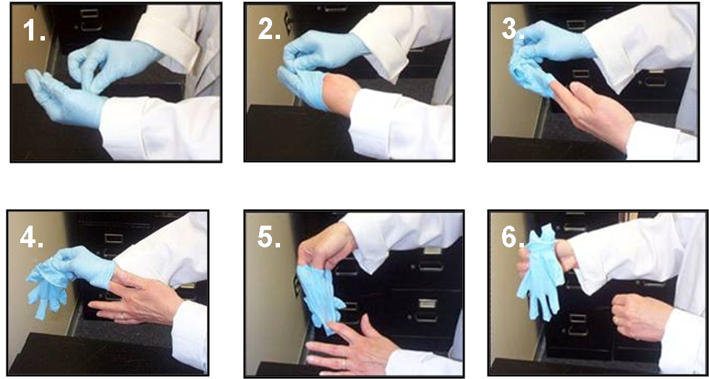
After removing gloves, laboratory staff should perform wash or disinfect hands according to the regular hand washing procedure (following picture)

- Hair cover
Use a hair cover in operations that have the risk of splashing solutions containing pathogens, dangerous chemicals on the head, hair, or ears or in order to hold hair, avoid entanglement and infection of the tested specimens.
- Masks
- Use a mask when handling pathogens that might be infected through respiratory tracts or having operations that could result in droplets, aerosol containing pathogens or dangerous chemicals. Masks used in laboratories include medical masks and N95 masks. It is up to the risk assessment to choose the right mask for each test operation. Lab staff should use N95 masks when performing tasks that could cause aerosols or droplets with extremely dangerous respiratory pathogens such as influenza A / H5N1, tuberculosis ... in BSL III laboratories. Operations that could cause aerosols, droplets with normal pathogens of risk group 2, use medical masks.
- Lab staff wear and remove the N95 masks and medical masks as follows:
a) Medical masks
- How to wear a mask:
- Use both hands to put the mask on your face covering the nose and mouth, the blue side is outward, the metal strip (with hard veins) facing upwards.
- Pull the strings around the ears with your hands.
- Use the two fingertips of both hands to press the metal strip of the mask to fit the nose.
- Hold the top edge of the mask, pull the lower edge of the mask over the chin.
- How to remove a used mask:
- Use hands without gloves to remove the mask. Be careful not to touch the outside of the mask.
- Fold the outside of the mask inward and place it in the bag of infectious waste.
b) HEPA mask
- How to wear N95 mask (Figure 4)
- Step 1: Put the mask on the palm of the hand, release the strings freely under the back of the hand.
- Step 2: Put the mask around your nose and mouth, with the metal strip facing upwards. Pull the upper string over your head and place it behind the top of your head, above your ears.
- Step 3: Pull the lower string over the head and place it on the back of the neck below the ear.
- Step 4: Use the tip of the index finger and the middle finger of two hands to press the metal strip so that it fits snugly with the nose.
Step 1 | Step 2 | Step 3 | Step 4
- How to remove N95 masks
- Hold the lower string, bring it over your head.
- Hold the upper strap, bring it over your head to remove the mask.
- Place the mask in the bag of infectious waste.
- Note: to not touch the outside of the mask with hands without gloves because after using could be contaminated with pathogens.
- Goggles
Goggles help protect eyes from the risk of exposure to pathogens or chemicals. Laboratory staff should use goggles in operations that are likely to produce droplets containing pathogens or dangerous chemicals. Goggles must be appropriately decontaminated before reuse.
- Footwear
- Laboratories must arrange shoes and sandals for use in the laboratory only. Arrange appropriate area for shoes and slippers in the laboratory, to avoid contamination of the area around the laboratory and normal shoes and slippers. The lab defines the line of changing shoes and slippers in the laboratory. Shoes and sandals in the laboratory are toe closed. If the laboratory does not have enough closed toe shoes or sandals, disposable shoe covers can be used instead when necessary.
- The procedure of wearing and removing PPE for BSL III labs is described in the procedure for managing BSL III laboratories (Code QL09-QT01),

3.2. Biosafety cabinets
- Labs should select bio-safety cabinets in line with use purpose, protection purposes and conditions of each lab.
Use purposes | Types of cabinets
Protect laboratory staff and the surroundings from exposure to samples containing pathogens | BSL I, II, III Cabinet
Protect samples | BSL II, III cabinets and clean cabinets
Protect laboratory staff and the surroundings from low amounts of harmful chemical vapor | BSL I, IIB, III cabinets (cabinets emit air from laboratories)
Protect laboratory staff and the surroundings from harmful chemical vapors | Chemical hood
- Do not use clean cabinets to handle pathogens or harmful chemicals. Limit the use of open flames inside biosafety cabinets. When installing biosafety cabinets, labs need to meet the following requirements:
- Do not place safety cabinet near entrance doors, windows, walking ways; avoid the airflow from the air conditioner or ventilation
- Place the cabinet at least 30cm from the wall and at least 40cm from the ceiling
- Laboratories must develop equipment profiles and instructions for use of bio-safety cabinets according to the equipment management procedures. Instructions for use of bio-safety cabinets must include the following precautions for use:
- Use of bio-safety cabinets for laboratory operations that have the risk of creating aerosol causing diseases through the respiratory tracts
- Before starting work, turn on the cabinet and let it run for at least 3 minutes to stabilize air flows
- Disinfect the interior surfaces of the cabinet with appropriate disinfectants before and after operations in the cabinet.
- Arrange tools, equipment and samples into the cabinet, ensuring they are arranged in 3 areas: clean area, working area, dirty area. Do not place tools on top of the ventilation of the cabinet
- When using the cabinet, 3 areas are separated: clean area, working area, dirty area.
- The lab must make a plan to test biosafety cabinets after installation and once a year when they are in use. The testing of bio-safety cabinets in the Institute is carried out by the Center for Laboratory Quality Control and Calibration. Lab staff must be trained on how to use bio-safety cabinets before operating it.

3.3. Autoclave
- Autoclaves are used for autoclaving waste or infectious equipment after conducting a tests
- Laboratories having autoclaves should build and follow the instructions for using autoclaves. The autoclave operation must comply with the National Technical Regulation on autoclaving medical waste (QCVN 55: 2013/BTNMT) Ministry of Natural Resources and Environment.
- Autoclaves need to be periodically tested according to the provisions of the Circular No. 07/2014/TT- BLĐTBXH dated March 6, 2014.

3.4. Other equipment
- Centrifuge
Depending on each type of centrifuge, there are different ways to operate the machine, but it still must meet some general requirements as follows:
- Centrifugal tubes must be made of thick glass or plastic, with a closed lid (preferably with screw lids).
- Do not fill the solution more than 3/4 of the centrifuge tube
- During centrifugation, the centrifugal tubes must be balanced and symmetrically placed
- After finishing the process of centrifugation, wait for the machine to stop completely before opening the lid of the centrifuge chamber
- If solution tubes containing pathogens are being centrifuged at high speed, do not open the tube lids immediately after centrifugation. It is recommended to wait at least 10 minutes after centrifugation so that the aerosol particles settle and do not spread around
- The lids of the centrifuge tubes should be opened in a bio-safety cabinets to avoid aerosol spread
- Cleaning, checking and maintaining the machine periodically.
- Mixers, grinder, ultrasound machines
- Grinders or mixers used in households are often open and create aerosol particles, so they are not used in laboratories. Only use equipment specifically designed for the laboratory. The process of mixing, grinding samples of solutions containing pathogens can create aerosols. Therefore, these works should be carried out in the bio-safety cabinet (if possible).
- Ultrasound machines must be operated in the bio-safety cabinets or be shielded around when being used to handle materials containing pathogens.
- Pipet Aid
- Do not use mouth suck a pipette, use pipette aid to avoid the risk of pathogen infection.
- Disposable inoculating loops
- Disposable inoculating loops have the advantage of not having to be disinfected for reuse. Therefore, using disposable inoculating loops in the bio-safety cabinet will limit the use of an open flame (alcohol burners, gas burners) that can disturb the air flow in the bio-safety cabinet. After use, the loops must be disposed as infectious waste.
- Micro combustion
- A micro combustion is used to sterilize reusable inoculating loops. The combustion is compact in size and can be easily placed in the bio-safety cabinet. Using a micro combustion in a bio-safety cabinet instead of an alcohol burner will reduce the risk of fire and explosion caused by open flames. A micro combustion with a borosilicate glass or ceramic shield helps reduce the splash and spread of infectious materials when sterilizing inoculating loops. However, micro combustion can disturb the air flow, so they must be placed at the back of the working surface in the bio-safety cabinet.

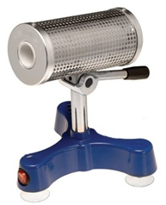 | 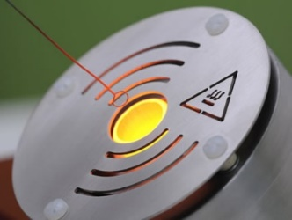

4. Monitoring occupational health
- Laboratory staff must be vaccinated or use preventive drugs against diseases related to the pathogens handled in the laboratory, unless there are no vaccines or preventive medicine available for that pathogen yet.
- Lab staff who are pregnant, have an infectious disease or have immunodeficiency; suffered from an accident compromising the ability to move hands and feet, have open wounds must notify the person in charge of the laboratory to be assigned with appropriate tasks.
- Records of periodic health examination, immunization records of employees must be kept at the Institute.
- All staff in the Institute, if having any symptoms of COVID-19 infection will be monitored for health and undergone diagnostic tests.
- Employees participating in stages at risk of exposure to COVID-19 will be screened once a month by the Department of Virology with Realtime-PCR technique.
- If the employee is positive to COVID-19, the Institute will implement quarantine and treatment measures in accordance with the regulations of the Ministry of Health in Decision 963/QĐ-BYT dated March 18, 2020 on the issuance of "Interim Guidance for monitoring, prevention and control of COVID-19”.

5. Training
- All laboratory staff in the Institute must be trained on bio-safety level II. People working on BSL III laboratories must be trained in bio-safety level III.
- People in charge of decontamination, waste treatment, etc. are trained / instructed on safety related to the work.
- The Institute staff are trained on occupational safety and firefighting according to the current regulations.
- The Center of Laboratory Quality Assurance and Calibration and the Center for Training and Science Management are responsible for organizing training and retraining on biosafety for laboratory staff in the Institute.
- The person in charge of bio-safety of the laboratory is responsible for keeping training records, including qualifications, employee certificates, certificates of training in biosafety, records of training in occupational safety, firefighting.
- The requirements for management of human resources, training for laboratory staff are specified in the Institute's personnel management and training procedure and the BSL III laboratory management procedure (Code QL09-QT01).
- Detailed regulations on personnel training are presented in the Professional and Service staff Management and Training Procedure (code QL02-QT05) (see Annex III).

6. Biosafety practice

6.1. Regulations on Entry and Exit of Laboratories
- Laboratories shall develop and post the laboratory's entry and exit regulations on the laboratory's doors
- Only the responsible people can enter the laboratory. Other people accessing the laboratory must be approved by the competent person and instructed and supervised
- At the entrance of the laboratory, a bio-hazard warning sign must be posted as required.
- For details of regulations on access to laboratory BSL III (QL09-QT02), see Appendix IV.

6.2. Common Regulations on Practice
- Do not suck the pipette with mouth
- Do not eat, drink, smoke, shave and use cosmetics in the laboratory
- Do not use laboratory equipment to store or process food
- Do not bring personal belongings, food into the laboratory
- Do not use syringes or needles to replace pipettes or for any purpose other than injecting, transmitting or absorbing fluid from laboratory animals.
- After using needles and syringes, they must be put in a specialized sharps container, do not bend, break, cover the needle or remove the needle from the syringe.
- Wash hands with soap and water after removing gloves and before leaving the laboratory.

6.3. Decontamination and sterilization
Laboratory Decontamination
- Clean the laboratory
- Purpose: Dust, dirt or organic matter can cover microorganisms and affect the ability of the disinfectants to kill microorganisms. Therefore, mechanical cleaning is required before effective disinfection or sterilization.
- Procedure: The same disinfectant can be used for wiping, when wiping, be careful to avoid contamination of pathogens. It is necessary to clean the laboratory or the following equipment:
- Clean the surface of benches, bio-safety cabinets before and after a test.
- Clean the surfaces of laboratory machines, equipment (such as centrifuges, shakers, refrigerators ...) and other common equipment such as benches, chairs, shelves, chemical cabinets.
- Clean laboratory walls and floors periodically with regular cleaning agents.
- Disinfect and sterilize the laboratory
- Purpose: Disinfect the space if the laboratory, objects and equipment in the lab in order to:
- Make sure the air in the laboratory is clean air.
- Prevent the possibility of spreading by spilling large quantities of samples containing pathogens.
- Avoid cross-contamination when changing patient samples.
- Implementation:
- Sterilize the surfaces with one of the following solutions:
- 70% alcohol solution (v/v). Ability to kill bacteria, viruses, fungi but not spores. The big advantage of using alcohol is that it does not stay on the treated items.
- The mixture of 70% alcohol (v/v) with formaldehyde 100g/l solution and alcohol containing 2g chlorine /l.
- Sodium Hypochlorite (NaClO) solution of 1g /liter or 5g/liter in case of high risk.
- Solution containing Hydrogen peroxide (H2O2 - hydrogen peroxide) concentration of 3%. It is capable of disinfecting at large spectrum; however, it is corrosive to metals as well as discoloring fabrics, skin, hair and mucous membranes. Items treated with hydrogen peroxide should be washed thoroughly before contacting eyes and mucous membranes
- Sterilize laboratories with fumigation of formaldehyde (formaldehyde is created when paraformaldehyde is heated). Fumigation is conducted at a minimum temperature of 21⁰C and the relative humidity is 70%.
- Note: Labs that need to be sterilized with formaldehyde fumigation must report and request engineers from the Center of Laboratory Quality Assurance and Calibration for implementation.
- Biological safety cabinets sterilization
- Purposes:
- To prevent possible contamination when spilling large quantities of sample containing pathogens.
- When it is necessary to replace the HEPA, check and maintain the bio-safety cabinet.
- Avoid cross-contamination when changing samples for research.
- Implementation:
- Lab staff need to clean the bio-safety cabinets before sterilization
- It is possible to sterilize both tools in use in the bio-safety cabinet (except liquid and paper), but be careful that tools must be formaldehyde resistant (stainless, not susceptible to corrosion).
- The sterilization and checking effectiveness of bio-safety cabinet sterilization must be carried out by the Engineer of the Bio-safety-Quality Management Department upon request from the laboratory. The engineer team conduct sterilization of safety cabinets according to the following steps:
- Cover the cabinet with plastic. Pay attention to the model of bio-safety cabinet:
- Cabinets that emit air out of the laboratory: Close the exhaust valve completely.
- Cabinets that exhaust gas directly into the laboratory: cover the exhaust door position carefully (usually on the top of the cabinet).
- Calculate the amount of formaldehyde used based on the cabinet volume: 10ml 37% formaldehyde or 5mg 90% paraformaldehyde used for 1m3 air. If the air humidity is lower than 70%, add about 10ml of water to the same formaldehyde solution.
- Use chemical or biological indicators to evaluate the effectiveness of formaldehyde sterilization.
- Neutralize with ammonia:
- Ammonia is used 10 - 12 hours after sterilization has started.
- Quantity of Ammonia: 20ml (3-5%).
- Employees wear formaldehyde filter protection masks in operations.
- Maintain a neutralization period for at least 7 hours.
- Decontaminate test tools
- Purpose: Sterilize tools for reuse: test tubes, glass bottles, stainless steel boxes…
- Implementation:
- It is necessary to classify the tools into two types, the ones with chemicals only and the ones contaminated with microorganisms for sterilization.
- Disinfect tools contaminated with microorganisms by autoclaving (wet autoclave): make sure to loose the stoppers of bottles and jars and arrange the tools so that the steam can contact all their surfaces. Guidance for sterilizing tools with an autoclave.
- Soak the tools in water or a suitable solution.
- Wash off with soap.
- Rinse several times with deionized or distilled water.
- Let them dry themselves or dry them.
- Sterilize them with steam before use (use a designated autoclave to steam clean items).
- Dry them.
- Types of indicators to check the sterilization efficiency of the autoclave
- Chemical indicator


- This type of indicator has many advantages and is relatively popular today. There are chemicals on the indicator that can change color when exposed to high temperatures. Therefore each time an autoclave is used, attach this indicator with the sterilized materials will help the users know the working status of the autoclave.
- Advantages: low cost, easy to use, easy to maintain
- Disadvantage: It is impossible to know the exact sterilization efficiency of the autoclave. However, there are some chemical indicators that can help us evaluate the sterilization efficiency of an autoclave, but it is much more expensive than this type.
- Biological indicators
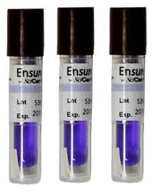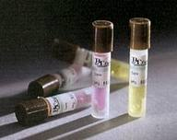

- This type of indicator can help us to accurately evaluate the sterilization efficiency of an autoclave.
- In this indicator the spores are separated from the culturing media that feeds them. After the sterilization process has been completed, the spores can be exposed to the culturing media and then incubated in an incubator (culture conditions depend on the type of indicator). After culture, if the spores are still alive (the media solution change color), it means that the autoclave is inefficient and vice versa.
- Advantages: Evaluate accurately the effectiveness of the autoclave; Easy to use.
- Disadvantages: Expensive; strict storage conditions, short shelf life; have to wait for the incubation time to know the results.
Details about the Decontamination for BSL III Laboratory areas (code: QL09-QT07) is presented in the Annex III.

6.4. Segregation, collection and treatment of laboratory waste
- Segregating waste
Laboratory staff must sort the waste at the place time that it is generated and place it in the respective bag/bin:
- Non-sharp infectious wastes: put it in yellow bags and bins with biohazard symbols
- Sharp infectious waste: put it in a sharps infectious waste container. This box has thick, hard walls, unlikely to be penetrated
- Liquid infectious waste: collected in a separate container
- Non-infectious hazardous chemical wastes are put in black bins or bags with corresponding hazardous chemical warning signs.
- Ordinary waste: put it in green bins or bags
Note:
- Each type of waste must be classified separately into corresponding waste storage packages, tools and equipment in accordance with the above regulations:
- Hazardous medical wastes that are incapable of reacting, interacting with each other and applying the same treatment method can be put into the same storage packages, tools or equipment.
- When infectious waste is mixed with other wastes or vice versa, the waste mixture must be collected, stored and treated as infectious waste.
- For tools contaminated with pathogens that need to be reused, they must be kept separately in yellow bags and bins, not together with other types of waste.
- Where to place waste bins: Each department and room must specify the location of the waste bin and bag. Waste bin areas must have instructions on how to classify and collect the waste.
- The instruction diagram of waste sorting and collection is presented in Annex V
- Collection of infectious waste / neutralization of toxic chemicals
- Infectious waste:
- At the end of the working day or when necessary, the lab staff or the person in charge shall collect infectious waste separately from the generated place to the general drying and washing area of ​​the Institute, at least once a day;
- Some laboratories have designated requirements in writing, the staff of the Decontamination Department shall collect the waste at the laboratories;
- During the collection process, the waste bag must be sealed and put in the waste transport containers. Waste transport containers must have tight lids to ensure that wastes does not drop or leak during the collection process;
- Waste with a high risk of infection must be treated immediately at the BSL III area before being collected into the concentrated waste storage area of the Institute;
- During waste collection and transportation, employees must use protective clothing, gloves and appropriate personal protective equipment.
- Non-infectious Hazardous Waste:
This waste is collected separately and put into the bin with the corresponding color code in the concentrated waste storage area of the Institute. Administration - Materials Department will hand over it to the Environmental Company for processing.
- Normal Medical Waste:
This waste is collected to the waste collection trucks in the Institute Premise
- Receiving infectious waste
- The Decontamination Department staff shall check the waste bags to ensure that they are of the correct type as required and have been tied;
- The laboratory transferring the waste must fill in information and sign the form of transferring and receiving infectious tools and wastes
- Autoclaving infectious waste
Staff of Decontamination Department shall sterilize the waste in accordance with the instruction for use of autoclaves
- Segregating the waste after sterilization
- The reusable tools are retained to be cleaned according to the tool washing procedure;
- The waste that is not to be reused will be transferred to the infectious waste gathering area of the Institute.
- Transporting sterilized waste to the Institute's waste gathering area
Decontamination Department staff, after autoclaving infectious waste, check sterilization efficiency, transport waste to the concentrated waste gathering area of the Institute and place it in corresponding bins.
- The Concentrated Waste Storage of the Institute
- The Institute waste storage, located between building F and Vabiotech company, is covered, with corresponding waste containers.
- The environmental sanitation company collects waste at from Storage at the end of the working day.
- Procedure of Waste Treatment and Decontamination in BSL III Laboratory Area (Code QL09-QT07).
- Medical Waste Records comply with the provisions of Joint Circular No. 58/TTLT-BYT-BTNMT dated December 31, 2015 on Medical waste management.
- Details of waste treatment and decontamination procedures in the BSL III laboratory area (code: QL09-QT07) are presented in the Annex VI.

6.5. Package and Transportation of Samples
- Transporting and receiving samples in the Institute
- When the sample is transferred to another laboratory in the Institute: fill out the information in the sample transfer form, with approval of the Faculty Management. Contact the laboratory about the reception and fill out the laboratory's sample management book before transporting the samples.
- Packaging, transporting:
- The first layer of container out of the pathogens is the test tube (may be eppendorf tubes sizes 1.5ml or 2ml, tubes containing blood, serum or falcon tubes sizes 15ml or 50ml ...), the test tubes must be covered tightly; sample solution does not occupy more than ¾ of the volume of the tube.
- Place the tubes containing the pathogens in the appropriate tube rack. Place the tube rack in the second layer as the sample transport box (made of plastic or foam, sturdy, with a lid and a handle, make sure not to break if there is a slight hit during transportation). Insert dry ice / gel ice packs around the tube rack in the second box if the pathogens need to be refrigerated. A cooler can be used instead of a foam container and dry / gel ice.
- Close the second box lid, disinfect the surface of the can with decontamination solution (70% alcohol) and transport it to the destination.
- Receiving:
- In BSL II Laboratories:
- Lab staff refer to the sample acceptance standards of the laboratory.
- If the sample meets the sample acceptance standards, fill in the sample management record with code STAT-BM05 and sign the handover form.
- In BSL III Laboratories:
- Follow the Access Guidance for BSL III Labs
- Use the passbox to transfer the box containing the pathogen in and out of BSL III laboratories. If the samples are stored at a BSL III laboratory, the researcher must update the information on the sample storage map on the storage freezer and the pathogen management record code STAT-BM05
- Transport and receive pathogens in the country
When the pathogen is transferred to or received from an external agency outside the Institute: complete the pathogen transfer form STAT-BM04 and sign for approval by the management of the Faculty / Center and the unit management.
- Transport pathogens out of the Institute
- Contact the agency receiving the pathogens about the transport, reception, and the expected time that the sample will arrive at the destination. Fill out the information in the sample management record of the laboratory with code STAT-BM05.
- Check if the transferred pathogens are in the list of category A infectious pathogens or not, if not, it is a category B infectious pathogen.
- The first layer of container out of the pathogens is the test tube (may be eppendorf tubes sizes 1.5ml or 2ml, tubes containing blood, serum or falcon tubes sizes 15ml or 50ml ...), the test tubes must be covered tightly; sample solution does not occupy more than ¾ of the volume of the tube. The junction between the cap and body of the tube is wrapped with a paraffin tape.
- Select the second packaging layer suitable to each type of infectious substances:
- For Category B infectious substances: place the pathogens to be transported in the 2nd layer (zip bag with lock, plastic box with screw cap…).
- For Class A infectious substances: place the pathogens that need to be transported in the second layer, which is a force-resistant plastic box, with a screw lid, and a rubber ring at the top of the box to minimize leakage of the solution containing pathogens.
- If transporting more than 2 samples at the same time, there must be separation between the tubes to avoid collision during transport. Between layer 1 and layer 2, it is necessary to add absorbent materials and a cushion layer to avoid impact.
- Put the second layer after packing into the third layer, which can be a cooler, a foam or carton box... depending on the sample storage conditions; outside the 3rd layer, there must be information about the recipient, sender, emergency contact phone number, shipping symbols appropriate for each type of infectious substance.
- Transport the samples to the receiving unit: can be by airway or by road. Confirm with the receiving unit whether the sample has been received by the receiving unit or not.
- Note: Depending on the shipping time, lab staff need to estimate the amount of dry/gel ice to ensure the satisfactory storage temperature during the transportation
- Receiving pathogens
- Receiving samples at a BSL II laboratory:
- Recipients use appropriate personal protective equipment, open the first and the second layers of packaging, check the sample to see if it meets the laboratory sample acceptance standards (for samples of inhalation infection, check if there is a sign of leakage, open the 2nd layer in a bio-safety cabinet).
- If the sample meets the laboratory's sample acceptance standards, it will be labeled according to the laboratory's regulations and transferred to the laboratory's storage equipment, fill in the appropriate information in the laboratory's sample storage map and sample management records.
- If the sample does not meet the laboratory's acceptance standards, it will be disposed by autoclaving. Prepare a sample disposal note and notify the unit sending the sample.
- Receiving samples at a BSL III laboratory:
- Pass the sample through the passbox, do not turn on the UV light. In the BSL III Lab, the researcher opens the outermost layer, then moves the sample box to the bio-safety cabinet and opens the second layer, checking whether the sample meets the acceptance standards or not.
- If the sample meets the laboratory's sample acceptance standards, it will be labeled according to the laboratory's regulations (if any) and transferred to the storage equipment in the BSL III laboratory, record necessary information in the sample map. Go to the administrative area to fill in the laboratory's sample management record.
- If the sample does not meet the laboratory's sample acceptance standards, the sample will be disposed by autoclaving with a 2-door autoclave in the BSL III laboratory. Prepare a sample disposal note and notify the unit sending the sample.
- Sending or receiving pathogens to or from a foreign country:
- The Lab needs Ministry of Health’s approval for exporting, importing samples before sending or receiving samples
- The files to be prepared include:
- Document requesting permission for import and export of pathogens, code STAT-BM06, approved by the Institute's leaders.
- Copy of the project document: The page with the content about the import and export of the pathogens and the cover page with the project's approval stamp (For the project pathogens) or the consent letter of the recipient.
- A copy of the business registration certificate, establishment decision or other documents proving that the agency has the function of exporting, importing, researching, storing, preserving, transporting and testing the samples.
- Submit the application to the General Department of Preventive Medicine for the import and export of pathogens. The General Department of Preventive Medicine shall process the approval within 10 working days from the date of receipt.
- After receiving the written approval from the General Preventive Medicine Department, contact the transportation agency, prepare the sample for packaging and send or receive the sample.
- Admission of pathogens: Follow the guidance on the reception of pathogens in the country.
- Note: For other samples, the packaging and transportation depends on the features of the sample, decided by the labs, ensuring the safety and quality of the sample during transportation.
Details about the Procedure of managing pathogens in BSL III labs (code: QL09-QT05) are presented in Annex VII.

6.6. Prevent, respond to incidents
- Plan for preventing and handling incidents
Laboratories working with dangerous pathogens must develop prevention plans suitable to the pathogens and laboratory conditions. A prevention plan includes the following contents:
- Assess risk to identify possible incidents in the laboratory
- Identify and localize areas at risk of occurring incidents in the laboratory
- Identify people responsible for handling the incidents
- Contact quarantine and treatment facilities for the exposed and infected persons
- Supplying and equipping the necessary equipment and tools for handling incidents
- Develop procedures for emergency response and incident handling
- Organize regular drills to raise awareness and practice of laboratory staff in responding to possible incidents in the laboratory.
- Handling incidents
Possible incidents in labs include:
- Spill solution containing pathogens on the laboratory floor or in bio-safety cabinet
- Broken centrifuge tubes containing pathogens while centrifuging
- Sharp objects stabbed into the hand
- Materials containing pathogens splashing into the eyes
- Power-off
- Explosion
- Incidents of spilling solutions containing pathogens
- The laboratory must develop a handling process in case of spill of samples containing pathogens corresponding to each type of pathogens used in the laboratory. Laboratories should prepare a spill kit to handle pathogen spill. The spill kit is placed in a suitable location and close to the area where incidents might occur. Laboratories can prepare this kit for their own laboratories. Suggestions for an incident spill kit are as follows.
- Tool box with lid, capacity is about 3 - 5 liters.
- Personal protective equipment such as gloves (5 pairs), medical masks (2 pieces), eye protection goggles.
- Tongs made of stainless steel, approximately 30cm long.
- Bags for infectious waste (2-3 bags).
- Appropriate disinfectant (chlorinated chemicals), plastic bottles containing 1 liter of water for mixing chemicals.
- Absorbent tissues or absorbent towel (enough to absorb the spillage).
- Instructions for handling spills containing pathogens.
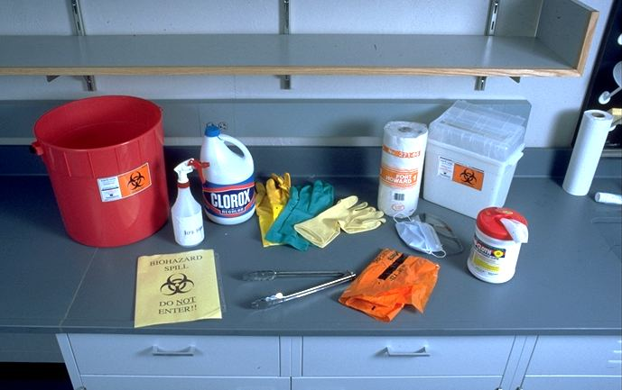
- Note: Lab staff must be trained how to handle spill containing pathogens.
Spill of solution containing pathogens in a bio-safety cabinet
- In case of spillage solution containing pathogen on the working surface of the bio-safety cabinet, keep the cabinet running to prevent spreading aerosol out of the bio-safety cabinet. The lab staff follow the steps below:
- Notify a colleague working nearby (if any).
- Remove gloves and move your hands out of the bio-safety cabinet
- Get a spill kit for spillage with pathogens.
- Wear new gloves. Use absorbent towels/ tissues to contain the edges and cover the spilled sample.
- Mix disinfectant, pour disinfectant on the spilled area from the outside in.
- Remove gloves, take your hands out of the ATSH cabinet. Allow about 30 minutes for the disinfectant to work against the bacteria (contact time depends on the types of disinfectant and types of pathogens).
- Wear new gloves. Use tongs to collect the absorbent towels/ tissues to place in the infectious waste bag. If there are sharp fragments, use the tongs to pick up the fragments into the sharps container.
- Clean the spill with absorbent towels/ tissues.
- Wipe the work surface, the inner wall of bio-safety cabinet and all tools inside the cabinet with a cloth / tissue absorbent with disinfectant.
- Remove gloves and wash hands properly.
- Record the incident based on the Nonconformity Control and Corrective Action Procedure (QL10-QT05), report the incident to the person in charge of laboratory management.
- Be able to resume work after 10 minutes or as instructed by the person in charge of the laboratory
- Note:
- If using chlorine-containing disinfectants, make a new one to ensure efficiency and after use, wipe with clean water to avoid corrosion on the bio-safety cabinet surface.
- If the solution containing pathogens spill onto the tray under the work surface of the cabinet through the ventilation grille, the disinfectant solution should be poured to the lower tray through the ventilation grille. Then remove the ventilation grille and cabinet surface to clean the disinfectant in the tray under the work surface.
- If suspect that the pathogen has plashed on personal protective equipment or come into contact with the body, the researcher should remove it, shower / rinse (if necessary) as soon as possible.
Incident spilling a solution containing pathogens outside a biosafety cabinet (on the floor, test bench surfaces)
- In case of spilling a solution containing pathogens that are not transmitted through inhalation, laboratory staff shall perform the following handling steps:
- Notify a colleague working nearby (if any).
- Remove gloves. Change other PPE (gown, pants, shoe/shoe covers...) if suspecting that there is contact of solution containing pathogens
- Get a spill kit for spillage with pathogens.
- Use absorbent towels/ tissues to contain the edges and cover the spilled sample from outside to inside.
- Pour the disinfectant on the spilled area from the outside in. Allow about 30 minutes for the disinfectant to work against the bacteria (contact time depends on the types of disinfectant and types of pathogens).
- Change new gloves. Use tongs to collect the absorbent tissues and sample containers to put them in an infectious waste bag. If there is sharp debris, use the tongs to pick up the debris into the sharps container.
- Clean the spill area with absorbent towels/ tissues and put them in an infectious waste bag.
- Change gloves, conduct decontamination and add consumables to replace the used ones in the spill kit box.
- Clean the lab floor area that the pathogen could splash to with appropriate disinfectant.
- Remove gloves, wash hands properly
- Record the incident based on the Nonconformity Control and Corrective Action Procedure (QL10-QT05), report the incident to the person in charge of laboratory management.
- In case of spilling solution containing pathogen infected through the respiratory tract (such as influenza virus, tuberculosis bacteria ...), the laboratory staff shall perform the following handling steps:
- Hold your breath and leave the room immediately.
- Tell colleagues working in the room (if any) to leave the lab and close the door.
- Place warning signs "DANGER, PROHIBITED" at the entrance and exit of the laboratory.
- Remove protective clothing, gloves, masks ... and put in bags/ bins of infectious waste.
- Wash and disinfect hands and suspected splash of solution containing pathogen.
- Wait at least 30 minutes for the aerosols caused by spillage to settle or exchange out of the laboratory.
- After 30 minutes, put on PPE and follow steps 3 to 11 of incident handling procedure for pathogens that are not transmitted through inhalation.
- Breaking tubes containing infectious material in the centrifuge
Breaking tubes containing infectious material in a centrifuge without closed cups (bucket)
- If a tube containing infectious material is found to be broken while the centrifuge is working, immediately turn off the centrifuge, do not open the lid of the centrifuge, wait 30 minutes for the aerosol generated in the centrifuge to settle.
- If detecting a tube containing infectious material when opening the lid of the centrifuge, immediately close the lid of the centrifuge, placing a warning sign on the top of the centrifuge lid "BREAKING INCIDENT". In case of centrifugation of pathogens infecting through inhalation, immediately leave the centrifuge area, warn colleagues who are work in the room (if any) to leave the laboratory and close the door; place warning signs "DANGER, PROHIBITED" at the entrance and exit; wait at least 30 minutes for the aerosols to settle or exchange to outside of the laboratory
- Get a spill kit for pathogen containing solution.
- Wear another pair of thick gloves.
- Use tongs to pick up fragments of centrifuge tubes and place them in a sharp waste container.
- Remove and completely immerse the rotor in the decontamination solution which is not corrosive to rotor's materials for a suitable time (approximately 30 minutes).
- Rinse the rotor again with water and allow it to dry.
- Wipe the inner chamber of the centrifuge with absorbent towels/ tissues decontaminants that are not corrosive to the materials of the centrifuge.
- Remove gloves, wash hands.
- Record the incidents based on the Nonconformity Control and Corrective Action Procedure (QL10-QT05), report the incident to the person in charge of laboratory management.
Breaking tubes containing infectious material in a centrifuge without closed cups (bucket)
- Bring the bucket containing the broken tube into the bio-safety cabinet, remove the sharp fragments (if any) and put them into a sharps container. Use absorbent tissues to blot any spilled solution.
- Decontaminate the bucket in one of two ways as follows.
- Loosen the lid of the bucket and sterilize it by autoclaving.
- Open the lid of the bucket and soak in disinfectant solution that is not corrosive to the bucket materials for a suitable amount of time (approximately 30 minutes), rinse with water and let it dry.
- Change gloves, wash hands.
- Record the incidents based on the Nonconformity Control and Corrective Action Procedure (QL10-QT05), report the incident to the person in charge of laboratory management.
- Incident of a sharp object stabbing into the hand while working with a pathogen
In the event that a needle or other sharp object that contains or is suspected of containing pathogens, the laboratory staff shall take the following actions:
- Notify the colleagues working nearby (if any).
- Revealing the wound (eg. removing or tearing gloves).
- Flush the wound immediately under clean running water (about 5 minutes). Note, let the wound bleed on its own, do not squeeze or rub the wound.
- Wash the wound area with soap and clean water.
- Use a bandage with a suitable disinfectant to cover the wound.
- Record and report the incident to the person in charge of the laboratory.
- Depending on each specific case, there shall be follow up appropriate treatment measures
- Power failure while working with pathogens in a biosafety cabinet
- If the Institute's backup power supply automatically starts, the researcher shall not take his hand out of the bio-safety cabinet, wait until the power is back on to continue working.
- If the Institute's backup power supply does not start automatically, the researcher needs to clean up or inactivate and store the pathogen so as not to spread it.
- For BSL III labs, follow the procedure for rehearsal and response to incidents that occur in BSL III Lab (Code QL09-QT08) - Annex VIII.

7. Safety related to power, fire, explosion and chemicals

7.1. Power safety
The power supply system must comply with the National electrical safety standards and regulations. Electrical equipment in the laboratory must also be installed, operated, and maintained according to regulations or recommendations of the manufacturer. Laboratories need to develop procedures to handle incidents related to power outages.
- General Power Safety
All electrical equipment and electrical wiring system must comply with National electrical safety standards and regulations, specifically as follows.
- There is an alternate power source;
- The wiring system and controlling equipment, power supply must ensure safety and compliance with technical specifications (capacity, quality ...);
- There is an overload protection system;
- Grounding the entire system;
- Electrical equipment related safety
- See and follow the guidance of the manufacture to ensure arranging and setting up the electrical equipment properly.
- Devices must be grounded according to manufacturer's recommendations.
- Select the location to install the equipment so that environmental factors such as noise, smoke, temperature, and steam do not exceed the acceptable limits.
- Establish and implement a periodic equipment maintenance plan, especially for equipment such as biosafety cabinets, centrifuges, autoclaves ...
- For equipment not often used, it should be monitored with periodically checking to detect damages.
- Keep complete and detailed usage records for each device.
- Make sure the contact surfaces of the working person (hands) are dry before touching electrical equipment or extension cord.
- For a 3-pin plug, the ground pin must not be removed.
- Periodically check the power outlet, wire for signs of open or damage. Replace if needed.
- Make sure there is a sufficient number of outlets to avoid using an extension outlet.
- In the event of an electric shock (even minor) or there is smoke or a burning smell, immediately mark the machine as "broken" and ask for repair.
- Do not short circuit fuses or breakers.
- Do not hold the power cord to remove the plug from the outlet.
- Make sure the extension cord with a 3-pin plug is in good condition and of the right capacity for the intended use purpose.
- Do not use extension cords through walls, doors, ceilings and floors.
- Do not let the power cord lie on the walkway because it can cause fall-off or damage, protect the wire by running it along the wall or wrapped in a protective layer.
- What to do in case of power outage
- For computer and information management systems
- Check UPS, make sure UPS is working well, check how long the UPS can work; there should be about 10 minutes to shut down the system.
- Log in to the information management software (if any), check users and programs. If there are still users on the software, send a system notification asking the users to log out immediately.
- Stop and turn off the database.
- Turn off the server
- Turn off the UPS
- Wait until the power is supplied again
- For Lab Equipment
- Normally the Institute's backup power supply will automatically start up during a power outage.
- If the backup power supply is not working:
- Setting so that the power supply for refrigerators and freezers can automatically switch to emergency power.
- Stop and turn off all devices.
- Wait until the power is back on, the person in charge of the equipment checks whether the equipment can work and recommends the next actions. Depending on the severity, continue to follow the Nonconformity Control and Prevention Plan Procedure (QL10-QT05).
- Record in the device usage log.
- Attention: For BSL III Lab on the 3rd floor of the High-Tech Building, specific requirements are base on the instructions on handling incidents occurring while working at BSL III laboratories (code QL09-QT08).

7.2. Fire and Explosion Safety
- All the buildings at the Institute must be fully equipped with fire protection facilities, including: smoke sensors, fire alarms, fire extinguishers, water sprayers, and emergency exit design with exit signs. Annually, the fire prevention and fighting system of the Institute is checked for safety by the fire fighting police.
- Annually, all staff of the Institute are trained in fire prevention and fighting and take part in fire prevention and fighting drills organized by the Institute. Ensure all staff in the Institute are aware of the regulations on fire prevention and fighting and how to respond in case of a fire or explosion incident.
7.2.1. Common causes of fire and explosion in labs
- Circuit overload;
- No periodically check and maintenance of the electrical equipment;
- Use open flames (alcohol burners, gas burners) near flammable materials;
- Improper arrangement and storage of explosive or flammable materials;
- Arranging reacting chemicals in a discrete way;
- The equipment can emit electric sparks near flammable substances and gases;
- The ventilation system is not properly and fully qualified.
7.2.2. Categories of fire
Categories of fire | Example | Fire extinguishing Equipment
Category A | Common flammable substances: Wood, paper, cloth… | High pressure water and dry chemicals
Category B | Flammable liquids: Gases, grease, paint… | Dry chemicals and carbon dioxide
Category C | Electricity: Equipment, computers… | Dry chemicals and carbon dioxide

7.2.3. Operating Fire Extinguishing Equipment
Operating Fire Extinguishing Equipment | Water | Carbon Dioxide | Dry chemicals
 | 1. Pull the latch  2. Aim the hose direction  3. Squeeze the handle  4. Sweep the fire extinguisher | 1. Pull the latch  2. Aim the hose direction  3. Squeeze the handle | 1. Pull the latch  2. Aim the hose direction  3. Squeeze the handle
Distance for spraying | 9 – 12 m | 0.9 – 2.4 m | 1.5 – 6 m
Time of spraying | 60 seconds | 30 seconds | 30 seconds
Checking | Once every 3 months | Once every 3 months | Once every 3 months
7.2.4. Information on fire safety
Fire alarm button | Placed at the top of the hallway on each floor
Emergency exit | Signs: EXIT. Illuminated with emergency lights  Each floor has at least 2 emergency exit doors  Know the location of the exit doors, lead the outside stairs
Fire detection and firefighting equipment | Automatic heat or smoke detection systems are available in all laboratories.  Fire-fighting equipment includes: fire-fighting spray system, fire hose, fire extinguishing equipment.
Fire drill | The Institute organizes fire drills at least once a year.
7.2.5. Exit map
Labs must have map of entrance and exit.
7.2.6. Actions to take when detecting fire
- Comply with the Rules of Firefighting Order of the Ministry of Public Security.
- If the fire is minor and can be quickly extinguished: put out the fire with any available means (water, clothes, water-soaked blankets ...). Close the door.
- If the fire is serious or/and with a lot of smoke: DO NOT TRY TO PUT OUT THE FIRE.
- Ask everyone to go out of room while shouting "Fire" for support. Close exit and entrance doors, fire windows and doors to other rooms.
- For the High-Tech Building and the Standard Animal Breeding Center: turn on the fire alarm (in room 100 - 1st floor of the High-Tech Building) to inform the fire department of the exact location and nature of the fire. For other areas of the Institute, press the fire alarm. Call 114 for the fire department in Hanoi.
- Apply a fire extinguisher at the door of the room having fire to indicate that the fire room should not be re-entered.
- Evacuate under the guidance of the person in charge.
- Attention: The order of the steps above can be flexible. However, evacuating the people from the room and isolating the fire is a top priority
7.2.7. Instructions for emergency exit when there is fire alarm
- Whenever you hear the alarm, you must keep calm.
- If you have time: turn off lights and electrical equipment, close windows and doors after leaving the room.
- Use a fire extinguisher if there is a chance to extinguish the initial flame and quickly evacuate from the fire area.
- Make sure everyone in the room and next to the laboratory has left, but do not run back into the fire area.
- Leave the building along the nearest stairs. If the stairs are full of fire and smoke, use the fire escape ladder. Do not use the elevator.
- Leave the building and gather in the yard until it is known as being safe to return to work.
- Depending on the severity, continue to follow the Procedure of Nonconformity Control and Prevention Plan (QL10-QT05).
- Attention: For the BSL III lab on the 3rd floor of the High-Tech Building, specific requirements are following the Guidance for Dandling Incidents Occurring while working in a BSL III lab (code QL09-QT08).

7.3. Chemical Safety
The Institute’s labs usually have to use chemicals for testing or research purposes, and many of which have dangerous properties. To ensure safe use and storage of chemicals, laboratories must be equipped with adequate facilities and equipment and develop appropriate chemical management procedures.
7.3.1. Monitoring chemicals
- Complete and update information on the monitoring sheet of the use of chemicals and biological use according to the Institute's procedure
- Zoning areas separately for chemicals for each research group, each type of chemical (Clause 4, Article 4 of the Law on Chemicals, based on the GHS classification principle).
- Arranging a signaling system suitable to the hazard level of chemicals in the area of chemical use and storage. In case a chemical has many dangerous properties, the warning symbol must fully show those properties.
- The Material Safety Data Sheets - MSDSs of hazardous chemicals must be managed in the laboratory as follows:
- The Material Safety Data Sheets of all hazardous chemicals used must be kept in the laboratory.
- MSDSs must be in Vietnamese or English
- MSDSs must be disseminated to the staff before chemicals are used in the laboratory, and the historical records of dissemination must be kept at the laboratory.
- The MSDSs must be kept in places that are known to the laboratory staff, visible, accessible and easy-to-search when necessary.
7.3.2. Chemical Preservation
- Principles for preserving chemicals in labs:
- Substances that are reacting to each other must be kept in separate areas.
- Flammable and explosive chemicals (acid, alcohol, acetone ...) should be kept in containers with locks (dedicated chemical containers) which as paced on the floor and away from sources of fire and power.
- Listing chemicals used and stored in the laboratory and update the list regularly.
- Pay attention to the durability of chemical containers such as heat resistance, corrosive chemical resistance ...
- All self-made chemicals for use in the laboratory must be stored in bottle with lids and labels with all the information as listed in the following form:
Name of the chemical |  | Concentration
Person mixed it |  | Preservation | °C
Date of mixing |  | Expire Date
Lab:…………………………………
Organization: ………………………………………….
- For small chemical bottles, they can be labeled directly on the bottles, as long as all the above mentioned information must be presented.
- Peroxide-generating chemicals must be indicated with two specific times (of receiving and opening chemicals).
- Locations to place chemicals:
- In the laboratory's compartments and cabinets, if the chemicals are stored at room temperature.
- In medical refrigerators if the chemicals are stored at 4 - 80C.
- In -800C medical freezers if storing chemicals in deep cold temperatures.
- Do not place liquid chemicals higher than the user’s reach.
- Some chemicals need to be avoid light need priority
- Periodically check chemicals to remove the expired, no longer used chemicals and fill out the material monitoring sheet according to Institute’s Procedures
7.3.3. Use of Chemicals
- Only place chemicals that are required for daily use in the laboratory, the rest should be kept and preserved in a specially designed room / area.
- Chemical fume hoods or bio-safety cabinets with hard ducks to outside of the laboratory to work with highly toxic, volatile chemicals.
- Prepare chemicals to neutralize, decontaminate, incident response equipment such as emergency showers, eye wash sinks, other materials such as tongs, absorbent tissues, sand, natricarbonate powder, foam sprayers ...
- Tools are fully equipped when dealing with dangerous chemicals, dedicated containers are available for chemical storage and transport
- PPE is supplied to ensure maximum safety for lab staff. Clothing, gloves must be resistant to chemicals (not absorbent or corrosive). Eye protection goggles or face shields and respiratory protection equipment such as masks are available.
- Comply with the general practice principles in the laboratory (do not eat, drink, smoke, makeup or wear contact lenses in the laboratory, do not suck a pipette with mouth).
- Understand and practice operations such as mixing chemicals, pouring hazardous chemicals according to the steps recommended by the manufacturer (do not pour water into a container with thick acids, do not pour reacting chemicals together).
- Must be careful when handling toxic chemicals, avoid breaking and splashing chemicals around the laboratory.
- Limit the use of glassware in unnecessary cases.
7.3.4. Handling incidents
- Most chemical manufacturers have instructions for handling chemical spill. Laboratories need to assess the risk of chemical spills and refer to the manufacturer's information to provide an incident handling procedure for each chemical used in the laboratory. Laboratories need to organize training of practical skills and chemical knowledge for employees directly working with chemicals.
- Laboratories need to post instruction boards in prominent places in the laboratories and have spill kits available for handling spills, including:
- Personal protective equipment such as: clothing, apron, thick rubber gloves, pants with boots or rubber boots, eye protection, masks.
- Warning signs.
- Tongs to pick up broken glass.
- Mops, absorbent towels, absorbent paper.
- Black chemical waste bags buckets / barrels.
- Na2CO3 or NaHCO3 powder to neutralize acids and corrosive chemicals.
- Sand to sprinkle on alkaline spill
- If spilling chemicals, depending on the quantity and danger level of spilled chemicals to take timely measures such as:
- Follow the manufacturer's instructions or the MSDS when the problem occurs.
- Notify the person in charge of bio-safety of the laboratory and the laboratory's manager about the incident.
- Evacuate people not on duty from the spilled area.
- If the spilled material is flammable, immediately put out the fire, lock the gas cylinder in the room and surrounding areas, open windows (if possible) and turn off appliances that could cause sparks.
- Avoid breathing vapors of the spilled substances.
- Create an air outlet if possible.
- Use the spill kit for chemicals.
- Depending on the severity, continue to follow the Procedure of Nonconformity Control and Preventive Actions (QL10-QT05).

requirements and procedures for waste treatment

1. Assessment of risks associated with waste
No. | Risks | Risk level |  |  | Measures to mitigate risks
No. | Risks | Likelihood | Consequence | Level | Measures to mitigate risks
1 | Solid waste is not treated properly, causing harm to the surrounding environment | Rarely | Medium | Low | - Register ownership of hazardous waste source with Hanoi Department of Natural Resources and Environment  - Register environmental protection projects  - Sort, collect and treat waste according to the state regulations and the institution’s procedures  - Train staff in sorting, collecting and treating waste
2 | Wastewater is not properly treated before being discharged into the municipal wastewater system, causing harm to the environment | Rarely | Medium | Low | - Register environmental protection projects  - Apply for discharge permit  - Use a wastewater collection and treatment system before discharge the wastewater into the municipal wastewater system.  - Periodically check wastewater against the National Technical Regulation QCVN 28:2010/BTNMT, column B (applicable to medical wastewater)
3 | Collection staff are infected during the medical waste collection | Rarely | Serious | Medium | - Issue waste collection and treatment procedures  - Training for waste collectors  - Provide adequate personal protective equipment, biosafety tools during the collection process in accordance with the issued procedures and relevant national regulations.

2. Management of Solid Waste

2.1. Procedure of collecting, storing, transporting, treating and disposing solid waste of NIHE
2.1.1. Registration and Planning
- NIHE has registered to be a hazardous waste generator with the Department of Natural Resources and Environment of Hanoi and has been issued with the registered book of hazardous waste generator: code QLCTNH: 01.000417.T.
- The Institute has registered the project of environmental protection from February 11, 2010 No. 52/TN-MT
2.1.2. Collecting solid waste from the labs to the concentrated storage area of the Institute
- For domestic waste: the workers will collect by ordinary garbage truck and transfer it to the concentrated storage of the Institute.
- For medical waste: Lab staff sort and treat solid waste according to the procedure outlined in section 3.6.4 of this plan. After the initial waste treatment by autoclaving method, the Center of Laboratory Quality Assurance and Calibration is responsible for transferring the waste to the Institute's concentrated storage by using stainless steel bins with lids or yellow medical waste bins with lids and wheels for easy portability.
- Frequency of collection: daily.
- Solid waste collection and treatment diagram:
Generated waste
Sorting of infectious waste

Sterilization of infected waste

Unreusable waste will be moved away
Reusable tools such as: test tubes, sorted bottles
Transferring waste to the centralized area
Soak and rinse
Dry the tools

2.1.3. Storage
- The waste collectors notify the Administration-Materials Department for receiving the wastes and then put them in boxes of corresponding colors.
- Administration - Materials Department will lock the door of the waste storage until it is transferred to the 13 Urban Environment Company (URENCO 13). This storage area is located in a low-traffic area, adjacent to the wall next to Nguyen Cao Street, with a roof.

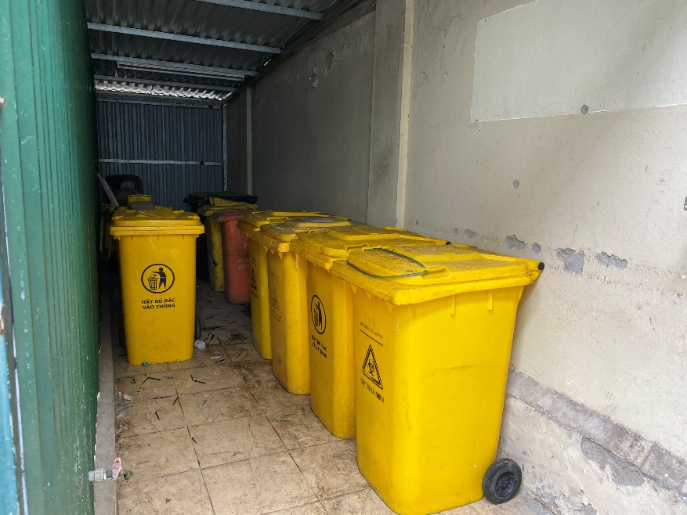
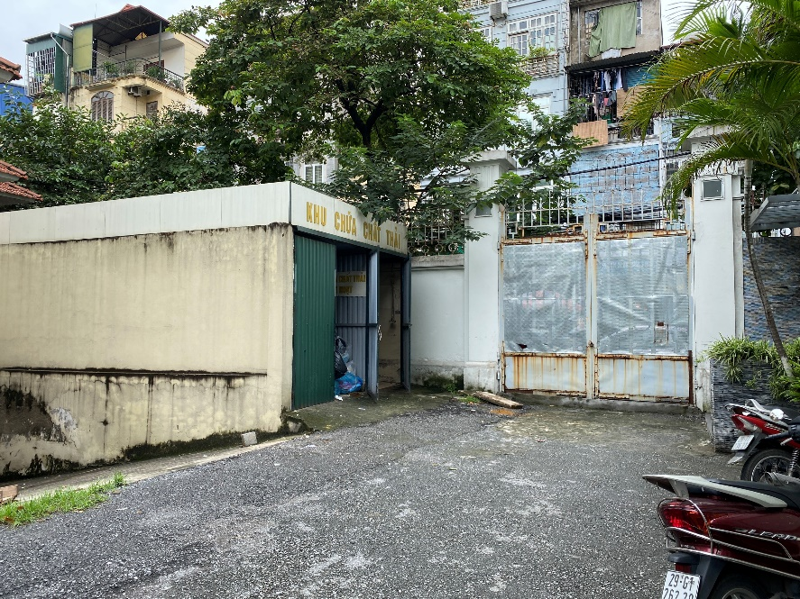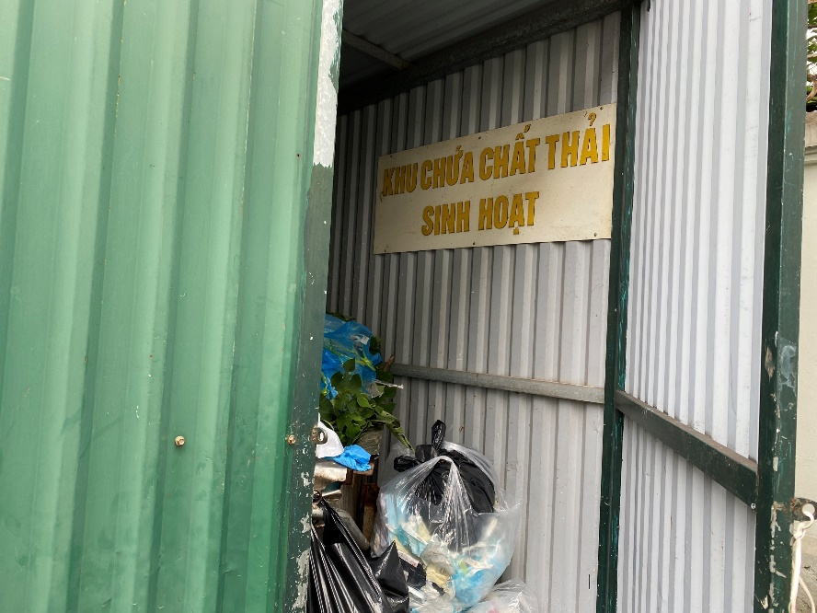

- Frequency of transferring the waste to URENCO 13:
- Domestic waste: Daily
- Medical waste: twice a week
2.1.4. Transporting, treatment and disposal
- Annually, the Institute signs a contract with URENCO 13 so that the company shall collect, transport and treat domestic wastes and medical and hazardous wastes. URENCO 13 has a license to treat hazardous waste, code QLCTNH: 2.105.VX. Office address / Head office: No. 246 Ton Duc Thang Street, Hang Bot Ward, Dong Da District, Hanoi. The scope of operation of URENCO 13 is as follows:
- Provide transportation and treatment services for medical and hazardous wastes for the waste generators in the area,
- It is allowed to use and operate specialized vehicles and equipment
- Allowed to transport and treat medical and hazardous wastes
- Can make adjustments (if any) based on regulations
- Means of transportation: URENCO 13's specialized trucks
- Technologies and methods for treating infectious waste: Steaming, incinerating.
- Technology and methods for treating normal waste: Landfilling.
- Process of waste transfer and use of hazardous waste documents: gather medical and hazardous wastes into storage, sorting it into different containers according to the codes of the medical waste generator’s book. Notify the functional agencies to transport it for treatment, make a handover record between the two parties, after finishing the treatment, the URENCO 13 returns the documents to the delivery agency of the medical and hazardous wastes.
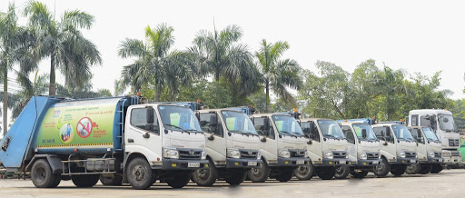

2.2. Procedure of collecting, storing, transporting, treating and disposing solid waste of POLYVAC
2.2.1. Registration and Planning
- POLYVAC has registered to be a hazardous waste generator with the Department of Natural Resources and Environment of Hanoi and has been provided with the registered book of hazardous waste generator: code QLCTNH: 01.000417.T.
- The Center has been approved with the detailed environmental protection proposal No. 855/QĐ-STNMT dated September 6, 2013.
2.2.2. Collect solid waste from work areas to the concentrated storage area
- For the area of the production buildings
- Employees in the departments under the Production and Inspection function are responsible for collecting waste from the place of generating in their area to the concentrated waste area (the waste house).
- The sharp objects must be put into hard, thick containers to ensure they are not penetrated before they are put in yellow plastic bags which are tied closely then.
- After initial treatment, clinical wastes need to be put in yellow plastic bags which are tied closely then.
- Waste generated must be transported to the concentrated waste storage area of the agency at least once a week or depending on the waste volume.
- Tie the plastic bag containing waste when the bags have reached the specified volume (2/3 bags). Do not use staples to seal the bag.
- For the area of Animal Breeding for Experiment:
- Staff are responsible for collecting waste from place of generation in their area to the concentrated area for waste (the waste transfer house).
- The sharp objects must be put into hard, thick containers to ensure they are not penetrated before they are put in yellow plastic bags which are tied closely then.
- After initial treatment, clinical wastes need to be put in yellow plastic bags which are tied closely then.
- Tie the plastic bag containing waste when the bags have reached the specified volume (2/3 bags). Do not use staples to seal the bag.
- Waste generated must be transported to the concentrated waste storage area of the agency at least once a week or depending on the waste volume
- For the Administration and Outdoor Area:
- Employees in the administrative division are responsible for storing garbage and waste at the right place (the bins are placed near the source of the waste generation, at the office, hallway, cafeteria, yard ...).
- Waste here is sorted into 2 types:
- Ordinary domestic waste is stored in green bags.
- Wastes such as sharp objects, broken glass, metals, ink cartridges, ect…. are stored in black bags
- The cleaning staff are responsible for collecting, transporting and storing waste daily from different departments to the gathering place with bins out of their places. The clean building and the administrative building have regulations for domestic waste.
2.2.3. Storing
- Places for bins, bags of hazardous medical wastes and domestic wastes must be specified in each room and must be located in a place close to the source of waste generation such as the tool washing room, production room, and changing room, corridors, ect.. Each department should have places to store waste bags and bins for different types.
- Wastes from each department, before being transported to the concentrated places (the waste house or the waste transfer houses) must be labeled with the waste generation department and waste delivery date.
- Waste bags must comply with the specified color system, yellow and black bags of hazardous waste must not be replaced with green bags.
- At the waste concentrated areas in the production area and the animal breeding area, the waste bags containing waste from the departments must be stored at the right places (the bins with specific color) and comply with the regulations on recording entry and exit from the waste house.

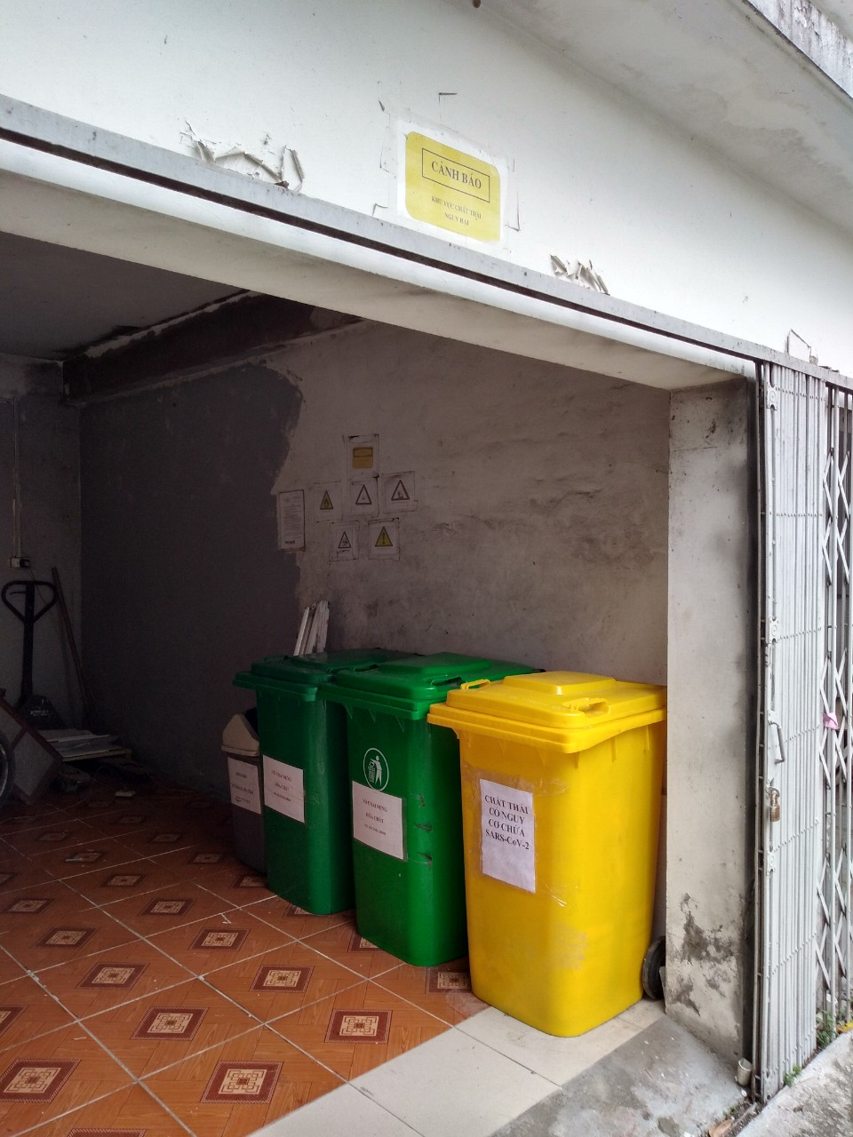

2.2.4. Transporting, Treating and Disposing
- Transporting waste (trash) out of the building: cleaning staff transport waste at 4:30 pm daily. When the waste is taken out of the production building and administrative building, it is gathered in containers in accordance with regulations.
- Transporting waste in clean house area: Waste transportation means are only used to transport waste. Means of waste transport must be designed so that: they are easy to enter, easy to take out waste, easy to clean, easy to disinfect, and easy to dry.
- Initial treatment:
- General rule: Clinical wastes with a high risk of infection must be safely treated near the place where the waste is generated, then it is put in yellow plastic bags for transportation to disposal places.
- Initial treatment methods included:
- Disinfection with chemicals.
- Sterilization with dry heat or humid heat.
- Treatment of clinical wastes: Clinical wastes need to be initially treated in one of the two ways above, then put in designated color bags taken to the waste house. Refer to SOP "Handling of Nonconforming Products", Doc#: 01-SOP-06-02.
- Chemical waste treatment:
- Non-hazardous chemical waste treatment: One of the following methods can be applied:
- Reuse
- Dispose like normal domestic waste.
- Hazardous chemical waste treatment:
- Principle: Hazardous chemical wastes must not be mixed with normal waste systems (including liquid solutions).
- Treatment methods:
- For the paper used to weigh hazardous chemicals (QC Chemical Department) must be collected and burned, the ash after burning is put into black bags. All destruction must be done in safe incinerators in the QC's chemical and Physical department.
- For jars containing hazardous chemicals, after using up chemicals or the dates have expired, they must have safety caps closed and put into black bags according to regulations.
- Treatment of pressure containers (containers of gases, N2, CO2): Return to the manufacturers for reuse of the containers.
- Treatment of domestic waste: Domestic waste is not categorized as hazardous waste, so is stored in green plastic bags. It is collected, transported, stored separately from hazardous medical wastes and disposed of by City Sanitation Company. In case of accidental mixing of medical wastes into a domestic waste, such waste bag must be treated like a hazardous medical waste bag.
- Every year, the Center signs a contract with URENCO 13 to collect, transport and treat domestic waste medical waste, and hazardous wastes. URENCO 13 has a license to treat hazardous waste, code QLCTNH: 2.105.VX. Office address / Head office: No. 246 Ton Duc Thang Street, Hang Bot Ward, Dong Da District, Hanoi. The scope of operation of URENCO 13 is as follows:
- Provide transportation and treatment services for medical and hazardous wastes for the waste generators in the area,
- It is allowed to use and operate specialized vehicles and equipment
- Allowed to transport and treat medical and hazardous wastes
- Can make adjustments (if any) based on regulations
- Means of transportation: URENCO 13's specialized trucks
- Technologies and methods for treating infectious waste: Steaming, incinerating.
- Technology and methods for treating normal waste: Landfilling.
- Process of waste transfer and use of hazardous waste documents: gather medical and hazardous wastes into storage, sorting it into different containers according to the codes of the medical waste generator’s book. Notify the functional agencies to transport it for treatment, make a handover record between the two parties, after finishing the treatment, the URENCO 13 returns the documents to the delivery agency of the medical and hazardous wastes.

3. Wastewater management

3.1. Collection and treatment of waste water in NIHE
3.1.1. Registration and Planning
- The registration book of hazardous waste generator: code QLCTNH: 01.000417.T.
- The Institute registered an environmental protection project from February 11, 2010 No. 52/TN&MT.
- Waste discharge permit No. 230 / GP-UBND dated October 27, 201.
3.1.2. Collection and treatment of wastewater from BSL II labs
- Diagram of collection and treatment of waste water:
Hand washing sink with disinfectant
P2
WC
Septic tank
P2
P2
P2
WC
P2
WC
P3
Lab
Sewage drainage
Lab
Lab
Lab
Lab
Lab
Wastewater treatment system for BSL II labs

B2
B3
Wastewater treatment system for BSL III labs

B2
B3

- Wastewater treatment technology: Wastewater of BSL II laboratories is also treated by chemical and physical technology through a separate wastewater treatment system located in the basement of the building.

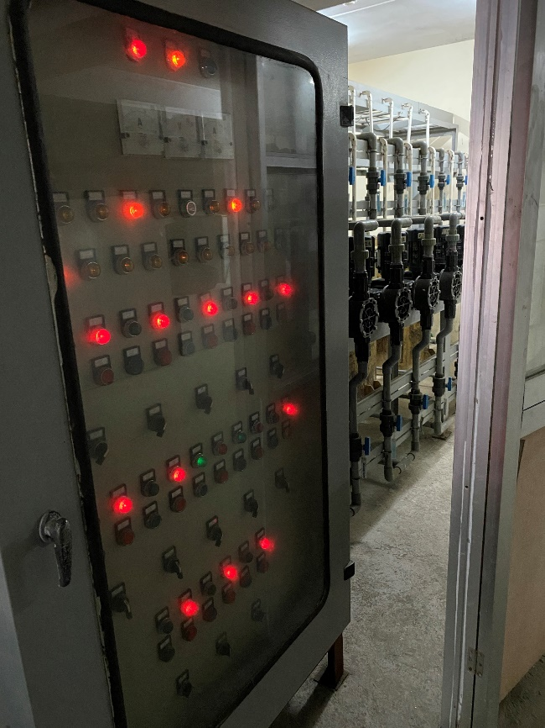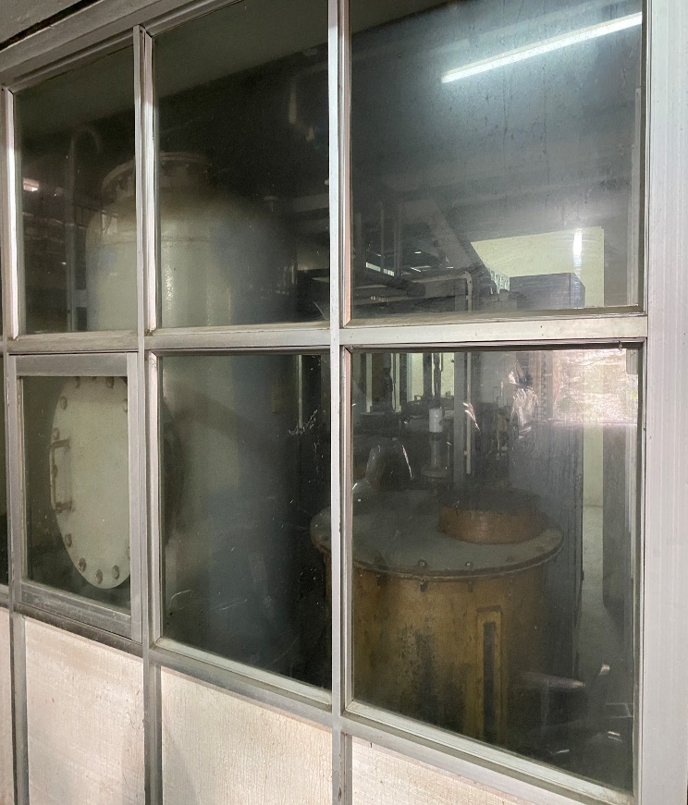

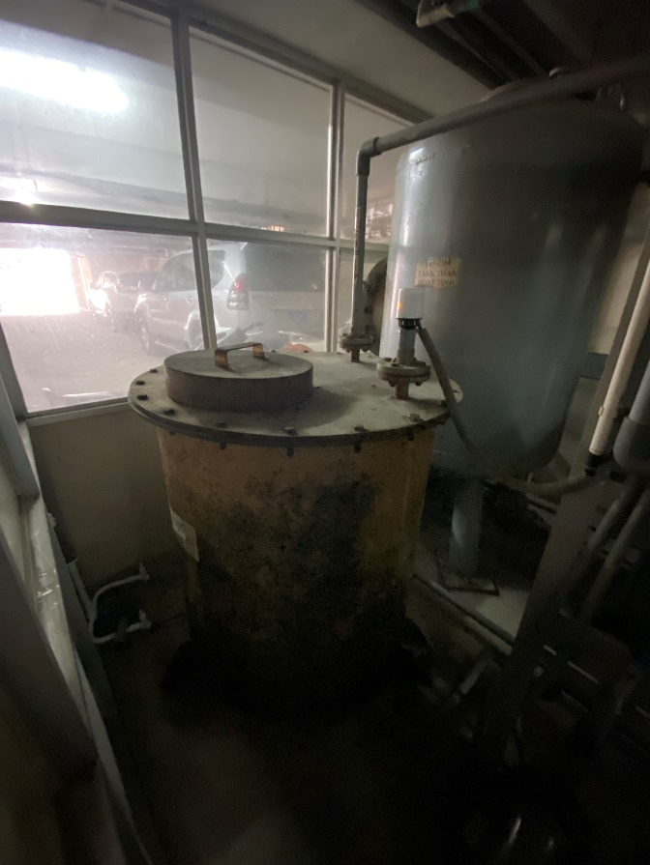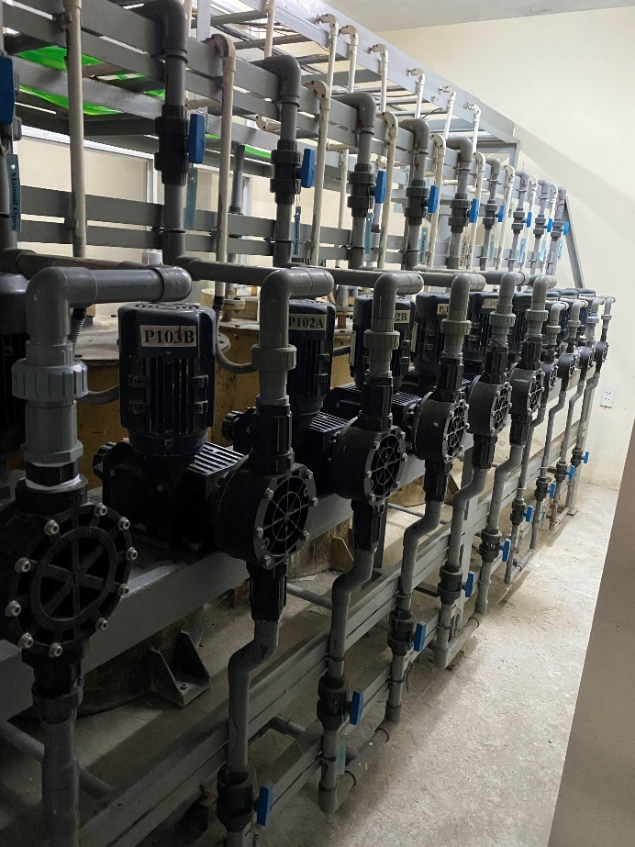

- Treatment steps:
- Add NaOCl to wastewater with a concentration of 100ppm.
- Add HCl to wastewater to reduce pH concentration to 6.5-7.
- Keep Cl concentration at 100ppm and pH of wastewater in the range of 6.5-7 within 1 hour for disinfection.
- After the disinfection time is over, add Na2S2O3 solution to the wastewater to neutralize the residual Cl until the concentration of Cl is less than 2ppm.
- Pump the waste water into the municipal wastewater system via Blow tank.

- The treated wastewater reaches the acceptable values according to the National Technical Regulation QCVN 28:2010/BTNMT, column B (applied to medical wastewater).
- Administration - Materials Department is responsible for operating the wastewater treatment system of BSL II labs.

3.1.3. Collection and Treatment of Wastewater from BSL III labs
- Diagram of collection and treatment of wastewater:
Hand washing sink with disinfectant
P2
WC
Septic tank
P2
P2
P2
WC
P2
WC
P3
Lab
Sewage drainage
Lab
Lab
Lab
Lab
Lab
Wastewater treatment system for BSL II labs

B2
B3
Wastewater treatment system for BSL III labs

B2
B3

- Wastewater treatment technology: Wastewater of BSL III laboratories is also treated by chemical and physical technology through a separate wastewater treatment system located in the basement of the building.
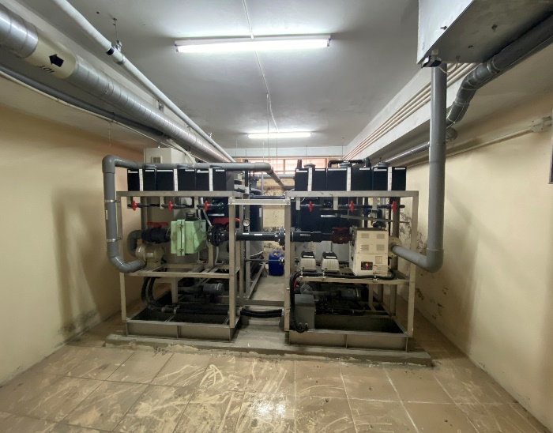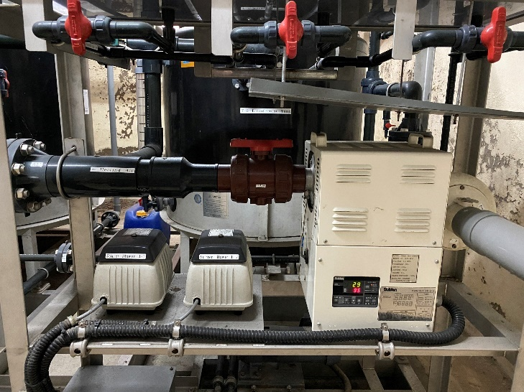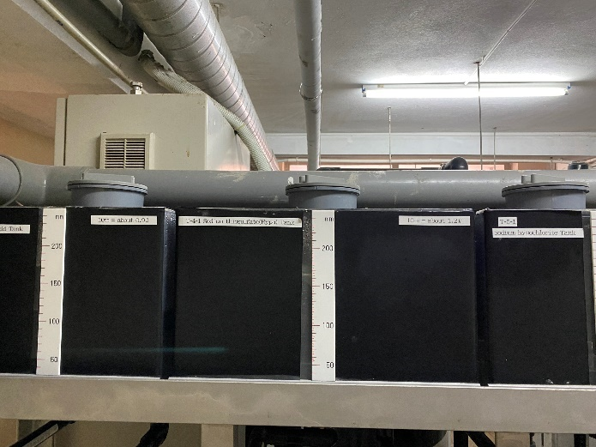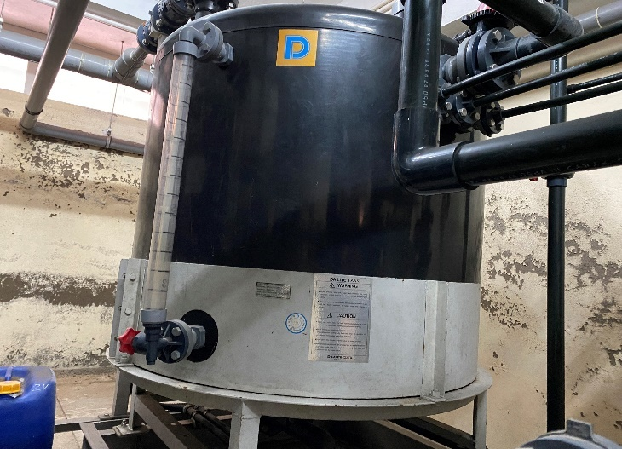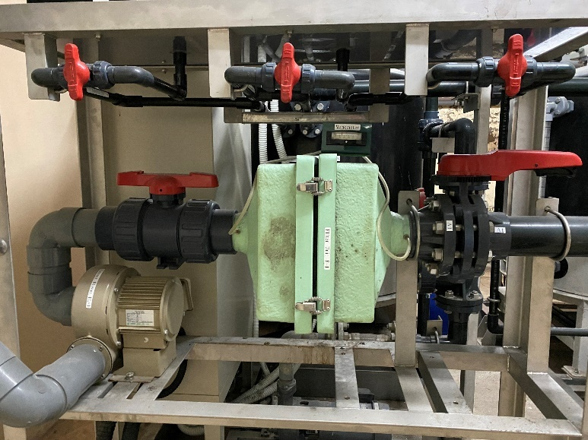
- Treatment steps: Wastewater will be classified into 2 categories: infectious wastewater and other wastewater. Infectious wastewater of BSL III labs will be disinfected initially at the sink in BSL III labs with a disinfection tank containing NaOCl.
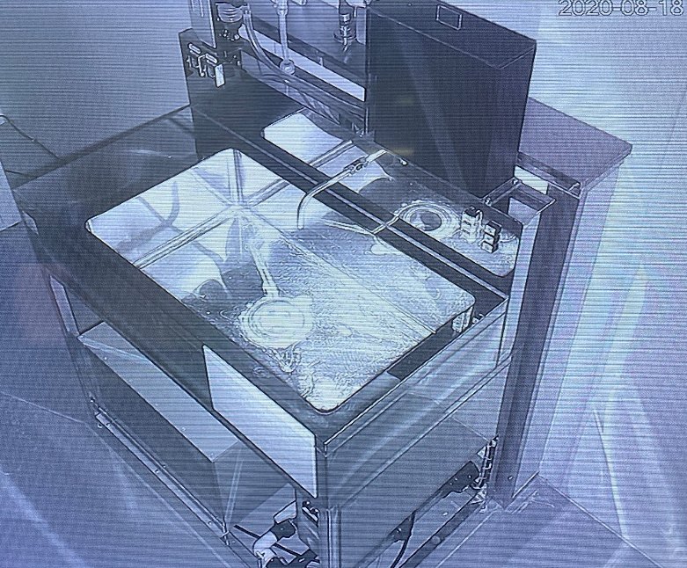
Disinfection tank

- Next, wastewater is directed down to the wastewater treatment system located in the underground floor for further treatment with NaOCl and Na2S2O3 (according to the same process for treating wastewater from BSL II laboratories) before entering the septic tank and at the end, flow into the city's main sewage system. Other wastewater, such as wastewater from autoclaves, will flow down to an outside drain located along the building.
- The treated wastewater should satisfy the acceptable values according to the National Technical Regulation QCVN 28:2010/BTNMT, column B (applied to medical wastewater).
- The Center for Laboratory Quality Control and Calibration is responsible for operating the wastewater treatment systems of BSL III Labs.

3.2. Collection and Treatment of wastewater at POLYVAC
3.2.1. Registration and Planning
- The Registration book of hazardous waste generator: code QLCTNH: 01.000800.T; 01.000801.T.
- Document of completing environmental procedures number: 140/STNMT-CCMT issued on 11 January 2012.
- Approved detailed environmental protection proposal No. 855/QĐ-STNMT dated September 6, 2013.
- Waste discharge permit No. 381/GP-UBND dated 11 October 2018.

3.2.2. Collection and treatment of wastewater
- Wastewater treatment technology: treatment with microbiological
- Treatment steps: Wastewater is collected separately to the collection tanks before treatment. Includes: collection tank for wastewater from the production building; collection tank for wastewater from animal breeding farm; collection tank for domestic wastewater. There is a separate treatment process for each type of wastewater before collecting it all into a tank called air tank. Then it is transferred to the activated sludge tank where the wastewater will be cleaned and flowed to the sedimentation tank, then it is added with chlorinated disinfectants before going to the environment.
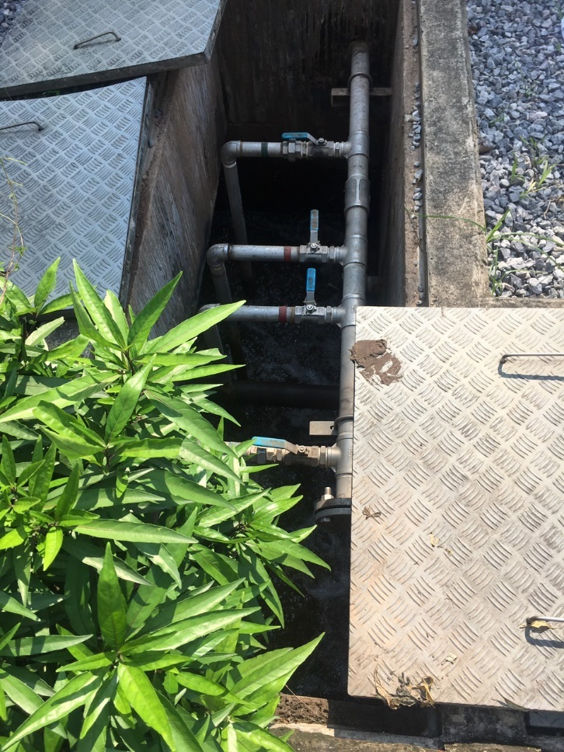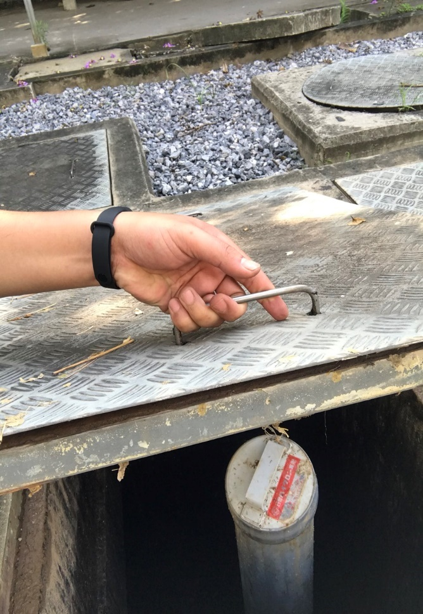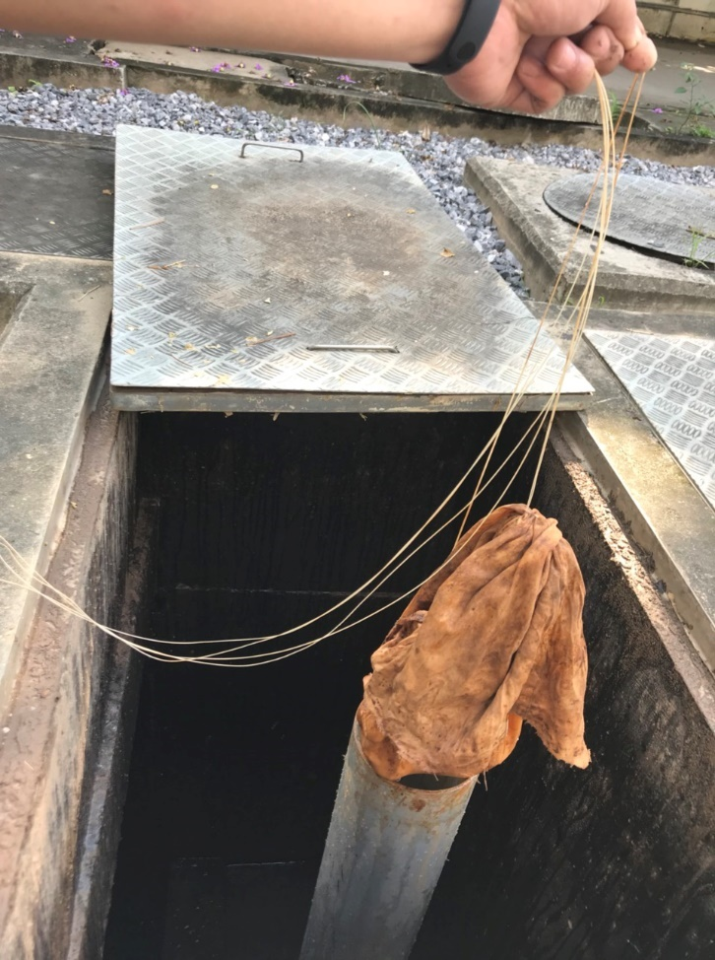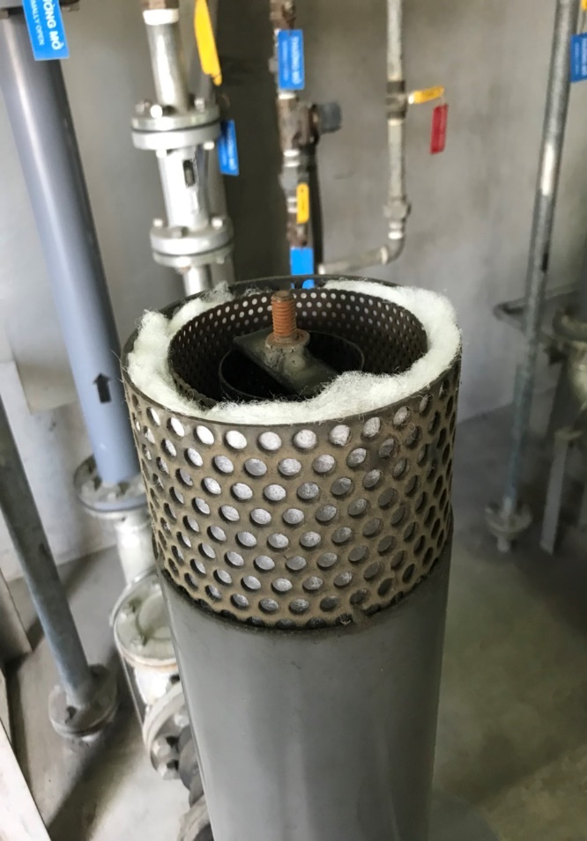
The treated wastewater shall satisfy the acceptable values according to the National Technical Regulation QCVN 28: 2010/BTNMT, column B (applied to medical wastewater).
- Technical workshop staff responsible for operating the wastewater treatment system.

Human RESOURCE MANAGEMENT PROCEDURE

1. Assessment of risks associated with project workers
No. | Risk | Risk level |  |  | Measures to mitigate risks
No. | Risk | Likelihood | Consequence | Level | Measures to mitigate risks
1. | Subjects: Sample collectors (expected 26 persons)
1.1 | Collect samples from the patients/ sample donors | Rarely | Serious | High | - Issue and disseminate sampling SOPs or MOH's guiding circulars on sampling and ensure safety during sampling.  - Provide training to improve knowledge and practice on the correct use of personal protective equipment and regular supervision;  - Provide adequate quality personal protective equipment.
1.2 | Infection from the samples | Rarely | Serious | High | - Issue and disseminate SOPs for sampling or MOH's guiding circulars on sampling and ensure safety during sampling.  - Provide training to improve knowledge and practice on the correct use of personal protective equipment and provide regular supervision;  - Provide adequate quality personal protective equipment.
1.3 | Infection from sampling equipment | Rarely | Serious | Medium | - Issue and disseminate SOPs or MOH's guiding circulars on sampling and ensure safety during sampling.  - Provide training to improve knowledge and practice on the correct use of personal protective equipment, sampling tools and routine monitoring;  - Use disposable sampling equipment;  - Provide adequate quality sampling tools and personal protective equipment.
2 | Subject: Lab staff (expected 11 persons)
2.1 | Infection from the samples | Rarely | Serious | High | - Issue and disseminate SOPs for sample handling and testing with biosafety requirements.  - Provide training to improve knowledge and practice on the correct use of personal protective equipment, good practices in laboratories and regular monitoring;  - Make sure that laboratory staff use personal protective equipment in accordance with the instructions of the Ministry of Health and operate in accordance with the approved testing SOPs.  - Use safety devices such as biosafety level 2 cabinets, centrifuges with lids, etc. to limit aerosol production.  - Provide adequate sampling tools and quality personal protective equipment.  - Periodically monitor the infected persons’ health and make sure they are quarantined and treated properly according to the regulations of the Ministry of Health.
2.2 | Infection from laboratory equipment that is previously contaminated and not decontaminated properly | Rarely | Serious | Medium | - Issue and disseminate SOPs for testing and decontamination or guiding circulars of MOH on decontamination  - Provide training and regularly supervise to make sure proper decontamination of test tools and equipment after each working session.  - Provide adequate decontamination chemicals, quality personal protective equipment.  - Periodically monitor the infected persons’ health and make sure they are quarantined and treated properly according to the regulations of the Ministry of Health.
2.3 | Infection from the Lab air | Rarely | Serious | Medium | - Perform testing in the appropriate biosafety level laboratory (level II or level III).  - Use safety devices such as biosafety level 2 cabinets, centrifuges with lids, etc. to limit aerosol production.  - Use personal protective equipment in accordance with the guidance of the Ministry of Health;  - Provide training in order to improve knowledge and practice regarding the correct use of personal protective equipment, safety equipment and provide regular monitoring.  - Periodically monitor the infected persons’ health and ensure they are properly quarantined and treated according to the regulations of the Ministry of Health.
3. | Subject: Administrative staff/ consultants of the project (expected 20 persons)
3.1 | Project staff are not guaranteed with working conditions or working time as committed | Rarely | Medium | Low | - All project employees have signed employment contracts, including the terms to ensure working conditions and commitments regarding time and remuneration for the signed work.
4 | Subject: Goods and service providers for project activities (expected 9 providers)
4.1 | The providers are not paid on time or have orders canceled | Rarely | Medium | Low | - The contracts to provide goods and services include a compensation term if the signed contents are not complied with.

2. Measures to mitigate risks associated with labor management
- The requirements for human resource management and training for laboratory staff are specified in the Institute’s Procedure of Human Resource and Training Management and Training Process and the Procedure of BSL III Laboratory Management (See Appendixes).
- Besides, NIHE and POLYVAC will incorporate standardized code of conduct and occupational health and safety clauses in the tender documentation and contract documents in order for potential bidders to be aware of requirements that shall expected from them, are able to reflect that in their bids, and required to implement the clauses for the duration of the contract.
- As a core contractual requirement, the contractor is required to ensure all documentation related to OHS and the LMP, is available for inspection at any time by NIHE and POLYVAC. The contractual arrangements with each project worker must be clearly defined. All relevant OHS and LMP requirements will be included in the bidding documents and contracts.
- In addition, NIHE will be responsible to ensure that safe messaging around COVID-19 prevention and OHS measures are distributed and available to all project staff directly hired/working for NIHE, as per provisions in this LMP.
- All project workers must be aware of and sign the Manager’s Code of Conduct (Annex 6A) and/or the Individual Code of Conduct (Annex 6B), as applicable.

2.1. Occupational Health and Safety (OHS)
- All project workers should receive training on OHS, as it relates to working in laboratory environments and managing hazardous medical waste, as well as COVID-19 prevention, social distancing measures, hand hygiene, cough etiquette and relations with local community. Training programs should also focus, as needed, on COVID-19 reporting and actions on COVID-19 cases in the workforce, communication and public-awareness strategies, project’s labor management procedures, stakeholder engagement, grievance mechanism and compliance monitoring and reporting requirements, including on waste management, among others.
- The Health and Safety specifications will include the following provisions:
- Ensuring workplace health and safety standards in full compliance with Vietnam law, at a minimum, and including (1) basic safety awareness training to be provided to all persons as well as on COVID-19 prevention and related measures; (2) All vehicle drivers to have appropriate licenses (3) Safe management of the area around operating equipment inside or outside hospitals and laboratories; (4) Workers to be provided with PPE equipment as needed (particularly facemask, gowns, gloves, hand washing soap, and sanitizer) to protect from COVID-19; (5) First aid equipment and facilities to be provided in line with the ESMP guidelines on OHS; (6) At least one supervisory staff trained in safety procedures to be present at all times when construction work is in progress; and (8) Adequate provision of hygiene facilities (toilets, hand-washing basins), resting areas etc., separated by gender as needed and with distancing guidelines in place;
- Comply with Vietnam legislation, WB’s ESS2 requirements and other applicable requirements which relate to OHS hazards, including WHO specific COVID-19 guidelines;
- All workplace health and safety incidents to be properly recorded in a register detailing the type of incident, injury, people affected, time/place and actions taken, including COVID-19 cases in the workforce, which should be reported to NIHE and the World Bank immediately;
- All workers (irrespective of contracts being full-time, part-time, temporary or casual) to be covered by insurance against occupational hazards and COVID-19, including ability to access medical care and take paid leave if they need to self-isolate as a result of contracting COVID-19;
- Procedures confirming workers are fit to work, which may include temperature testing and refusing entry to sick workers (with insurance in place to cover payment, as described above);
- All work sites to identify potential hazards and actions to be taken in case of emergency;
- Any on-site accommodation to be safe and hygienic, and with distancing guidelines in place, including provision of an adequate supply of potable water, washing facilities, sanitation, accommodation and cooking facilities;
- Workers residing at site accommodation to receive training in prevention of infection through contaminated food and / or water, malaria prevention if relevant, COVID-19 prevention and avoidance of sexually transmitted diseases;
- Provide laminated signs of relevant safe working procedures in a visible area on work sites, in English, Vietnamese and local language as required, including on hand hygiene and cough etiquette, as well as on symptoms of COVID-19 and steps to take if suspect have contracted the virus;
- Construction materials manufactured in Vietnam be procured only from suppliers able to certify that no forced labor (including debt bondage labor) or child labor (except as permitted by the Labour Law) has been used in production of the materials;
- All employees to be aware of their rights under the Labour Law, including the right to organize;
- All employees to be provided training on appropriate behaviour with communities, gender-based violence and violence against children (also see Codes of Conduct).

2.2. Age of Employment
- For this project, the minimum age will be 18 years. This rule will apply for both national and international workers. Workers will be required to provide proof of their identify and age before commencing any works on site.

2.3. Terms and Conditions and Equal Opportunities
- All terms and conditions as outlined in the World Bank Environmental and Social Framework (ESF) ESS2, paragraphs 10 to 15 apply to contracted workers. In addition,
- The normal hours of work of a project worker shall not exceed 8 hours a day or 48 hours a week (Labour Code, Article 104). Hours worked in excess of the normal hours of work shall not exceed 12 hours a week and shall entitle a worker to a proportionate increase in remuneration.
- The wages paid by the employers to the workers shall be set at the appropriate market rate.
- All workers to be covered by insurance against occupational hazards and COVID-19, including ability to access medical care and take paid leave if they need to self-isolate as a result of contracting COVID-19.
- Fair and non-discriminatory employment practices, including equal pay for equal work regardless of gender and ethnicity;
- Provide PPE as suitable to the task and hazards of each worker, without cost to the worker;
- Under no circumstances will contractors, suppliers or sub-contractors engage forced labor or people under the age of 18;
- All employees to be informed of their rights to submit a grievance through the Project Worker Grievance Mechanism;

2.4. Grievance Mechanism
- There will be a specific Grievance Redress Mechanism (GRM) for project workers as per the process outlined below. This considers culturally appropriate ways of handling the concerns of direct and contracted workers. Processes for documenting complaints and concerns have been specified, including time commitments to resolve issues. All project workers will be informed of the Grievance Mechanism process as part of their contract and induction package.
- The process for the Worker GRM is as follows:
- The first step is that the Aggrieved Worker may report their grievance in person, by phone, text message, mail or email (including anonymously if required) to their direct Supervisor as the initial focal point for information and raising grievances. For complaints that were satisfactorily resolved by the Aggrieved Worker or Contractor, the incident and resultant resolution will be logged and reported to the NIHE’s Social Focal Point.
- As a second step, where the Aggrieved Worker is not satisfied, the Supervisor (or the complainant directly) will refer the aggrieved party to the NIHE Social Focal Point. Grievances may also be referred or reported to the NIHE Management if appropriate. The NIHE Focal Point endeavours to address and resolve the complaint and inform the Aggrieved Worker as promptly as possible, in particular if the complaint is related to something urgent that may cause harm or exposure to the person. For complaints that were satisfactorily resolved by the NIHE Focal Point, the incident and resultant resolution will be logged by the NIHE Focal Point. Where the complaint has not been resolved, the NIHE Focal Point will refer to the Management of NIHE for further action or resolution.
- Up until the second stage there will be no fees for the lodgement of grievances. However, if the complaint remains unresolved or the complainant is dissatisfied with the outcome proposed by NIHE Management, the Aggrieved Worker may refer the matter to the appropriate court, at the complainant’s own expense. A decision of the Court will be final.
- Each grievance record should be allocated a unique number reflecting year and sequence of received complaint (for example 2020-01, 2020-02 etc.). Complaint records (letter, email, record of conversation) should be stored together, electronically or in hard copy. The NIHE Focal Point will be responsible for undertaking a regular (at least monthly) review of all grievances to analyze and respond to any common issues arising. The NIHE Focal Point is also responsible for oversight of the GRM.
The Annex IX presents the Labor Management Plan in details.

mesures for protecting community safety and health

1. Assessment of risks associated with community
No. | Risk | Risk Level |  |  | Risk mitigation measures
No. | Risk | Likelihood | Consequence | Level | Risk mitigation measures
1. | Subject: Patients/sample donors (expected 9,491 persons)
1.1 | The patients/ sample donors’ information disclosed | Rarely | Medium | Low | - Research works are approved by an independent Ethical Council including commitments of information confidentiality.  - Information is encoded, restricted access to the databases, and records are kept in a locked cabinet  - Inform the patients/ sample donors about the right to information confidentiality when they engage in the project.
1.2 | Patients are forced to participate in the research | Rarely | Medium | Low | - Research works are approved by an independent Ethical Council including commitments of information confidentiality.  - Participants are fully informed to about the research, the benefits and associated risks before deciding whether to join the study or not.  - The participants can decide to withdraw from the study at any time.
1.3 | People are infected when giving samples | Rarely | Serious | Medium | - Inform the patients/ sample donors about the risks that may be encountered during participation in the project;  - Ensure the sampling staff comply with the issued sampling procedures and sampling guidance circulars to ensure safety during the sampling process of the MOH;  - Use disposable sampling equipment;  - Train sampling staff
2. | Subjects: Individuals/Communities living near testing facilities (expected 262,680 persons)
2.1 | Contamination due to mistakes in waste treatment or sample spills during testing | Rarely | Serious | Medium | - Share information to the community about the project's activities and risks, and risk mitigation measures applied by the project;  - Issue a Safety Handbook which contains instructions on handling spills;  - Pack, preserve and transport samples in accordance with the instructions of the Ministry of Health and other documents on biosafety;  - Each laboratory is equipped with spillkits;  - Sort, collect and treat waste according to the government regulations and the institution’s procedures.
3. | Subjects: CDCs, Provincial Departments of Health, Provincial/city People’s Committees (PPCs) that are implementing the project activities (expected 63 provinces)
3.1 | Project activities may affect the progress and effectiveness of other tasks of CDCs, Departments of Health, PPCs ] | Rarely | Medium | Low | - Inform the CDCs, Provincial Departments of Health, and PPCs about activities and risks, and risk mitigation measures applied by the project.

2. Methods to reduce risks
The process of collecting, transporting, preserving, and handling samples in the community is in accordance with the Decision 1619/QĐ-BYT dated April 9, 2020 on the issuance of an Annex to replace Annex 1 “Collection, preservation and transportation of samples" issued together with Decision No. 963/QĐ-BYT dated March 18, 2020 of the Ministry of Health on "Interim Guidance for monitoring, prevention and control of COVID-19". Details are as follows.

2.1. Samples
Suspected COVID-19 samples must be collected by health staff who have been trained in patient sample collection. It is imperative to take at least one (01) respiratory tract sample, as follows:
- Upper respiratory tract samples:
- Nasopharygeal fluid swab samples;
If nasopharygeal fluid swab sample could not be collected, collect one of the following samples:
- Throat fluid swab samples;
Nasal fluid swab samples (both sides of the nose), only applied for suspected COVID-19 patient with symptoms;
- Nasal / nasopharygeal rinse fluid sample;
- Throat rinse sample
- Lower respiratory tract samples:
- Sputum;
- Alveolar fluid, endotracheal fluid, pleural fluid ...;
- Lung organization, bronchi, alveoli.
- Whole blood sample (3-5 ml)
- Blood sample in acute stage;
- Blood sample in recovery stage (14-21 days after onset of the disease).

2.2. The best time to collect the samples
Type of samples | Good time to collect
Upper respiratory tract swabs (sample of nasopharygeal fluid swab, throat swab sample ...) | 0-7 days after onset of the disease
Lower respiratory tract samples (alveolar fluid sample, endotracheal fluid sample, pleural fluid sample ...) | 0-14 days after onset of the disease
Blood samples in acute stage | 0-7 days after onset of the disease
Blood samples in recovery stage | Day 14 or 21 after onset of the disease
Lung organization, alveoli | In the event of an indication

2.3. Methods to collect samples
2.3.1. Preparation of equipment
- The tools used for nasopharygeal fluid swabs, throat fluid swabs and nasal fluid swabs for the SARS-CoV-2 tests are the ones with handles; they are not calcium or wood, preferably with synthetic fiber tips.
- Tongue pressing sticks;
- 15ml conical shape centrifuge tubes, containing 2-3ml of virus transporting media;
- Plastic tubes (Falcon 50mL Conical Centrifuge Tubes ) or nylon bag for packing samples;
- Bandages and gauze impregnated with antiseptic substances;
- Antiseptic alcohol, pens
- Protective clothes;
- Eye protection goggles;
- Gloves;
- Specialized medical masks (N95 or equivalent);
- Sterile 10 ml syringes;
- Sterile tubes without antifreeze.
- Coolers for sample storage.
2.3.2. Use of PPE
Before sample collecting (put on) | After sample collection (take off)
Specialized medical masks (N95 or equivalent) | Gloves – second layer
Hairnet | Coat
Goggles | Pants
Pants | Boots
Coat | Goggles
Gloves – the first layer | Hairnet
Gloves – the second layer | Specialized medical masks (N95 or equivalent)
Boots | Gloves – the first layer

2.3.3. Sample collection techniques
- Nasopharygeal fluid swab samples
- Ask the patient to sit still, face slightly back, young children must be kept by an adult.
- The person taking the samples tilts the patient's head back about 70 degrees, the arm hold behind the patient's neck.
- The other hand gently brings a cotton swab into the nose, push it while rotating to help the cotton swab go easily to the depth of about half of the length from the nose alar to the earlobe on the same side.
- Note: If you have not reached such depth and feel a clear resistance, pull out a cotton swab and try to take the other nose. When you feel the cotton swab touch the back of your nose throat, stop, turn around and slowly pull out the cotton swab
- Hold the cotton swab at the sampling site for 5 seconds to ensure maximum absorption.
- Slowly rotate and pull the cotton swab out.
- Place the cotton swab tip in the sample tube containing the transporting media and break the swab handle at the marker to have a length corresponding to the length of the test tube containing the transporting medium. The cotton swab sticks after taking the nasal fluid will be put in the same media container with the swabs of throat fluid.
- Close the lid, tighten, cover the tubes with paraffin paper (if any).
- Store the samples at 2-8°C before transferring to the laboratories of NIHE/ Pasteur Institute and other laboratories approved by the Ministry of Health to test for SAR-CoV-2 virus. If the samples are not transported to NIHE/ Pasteur Institute laboratories within 48 hours after the sample collection, the they must be stored in minus 70°C (-70°C) and then they are stored in frozen conditions during transport to the laboratories.
- Note: For young children sitting on parents’ laps, the child's back is facing the parent's chest. The parent needs to hold the child, keep the child's body and arms firmly. Ask the parent to tilt the child's head back.
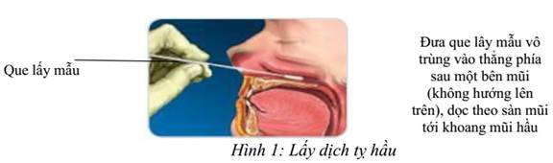

- Throat fluid swab samples:
- Ask the patient to open their mouth wide.
- Use the tool to gently press the patient's tongue.
- Put a cotton swab into the oropharynx, squeeze and gently rotate 3 to 4 times in the area on the sides of the tonsil and the back of the throat to get the fluid and cells in the pharynx area.
- After taking the sample, the cotton swab is put into a tube containing 3 ml of transport media (VTM or UTM) for storage. Note that the cotton swab tip should be completely submerged in the transport media, and if the cotton swab is longer than the transport medium tube, break/ cut the swab to fit the length of the tube containing the transporting media.
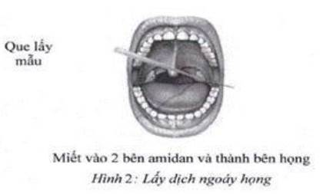
- Nasal fluid swab samples
Only applied for suspected COVID-19 patient with symptoms
- Ask patients to sit still, children must be kept by adults.
- The person taking the sample slightly tilts the patient's head back, supports one hand behind the patient's neck.
- Use the other hand to gently insert the swab into the nose about 2 cm deep, turn the cotton swab into the nose wall for about 3 seconds. After taking a sample from one side of the nose, use the same swab to take a sample from the other side of the nose.
- Place the cotton swab tip in the sample tube containing the transport media and break the swab handle at the marker to have a length corresponding to the length of the test tube containing the transport media.
- Close the lid, tighten, cover with paraffin paper (if any).
- Store the samples at 2-8°C before transferring to the laboratories of NIHE/ Pasteur Institute and other laboratories approved by the Ministry of Health to test for SAR-CoV-2 virus. If the samples are not transported to NIHE/ Pasteur Institute laboratories within 48 hours after the sample collection, the they must be stored in minus 70°C (-70°C) and then they are stored in frozen conditions during transport to the laboratories.
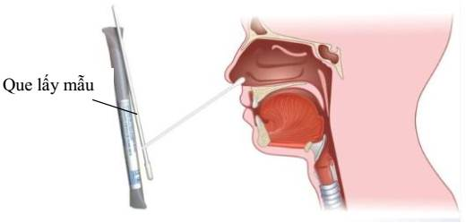

- Nasal / nasopharygeal rinse fluid swab samples
- Attach the sterile suction catheter to the suction device
- Tilt the patient's head back about 70 degrees
- Put a few drops of 0.9% Sodium Chloride Sterile Saline into each side of the nose
- Insert the catheter into the nose (the tube should go to the depth of about half of the length from the nose alar to the earlobe on the same side)
- Start to suck gently. Slowly remove the catheter while gently rotating it
- Place the sample in the tube containing the transport media
- Note: nasal/ nasopharyngeal rinses may not be applicable to infants
- Throat rinse fluid samples
- The patient rinses his/her throat with 10 ml of cleaning solution (saline). Throat rinse fluid is collected in a Petri cup or dish and diluted in 1:2 ratio in viral storage media.
- Endotracheal fluid sample
- The patient is on mechanical ventilation and has been intubated. Use a fluid suction tube, place it in the endotracheal tube and use a syringe to suck the endotracheal fluid along the tube. Put the endotracheal fluid into a tube containing the viral storage media.
- Blood sample
- Use sterile syringes and needles to take 3-5ml of venous blood, transfer it to a tube without anticoagulants, separate the serum and store it at 2°C - 8°C within 48 hours. If the storing time is longer, samples should be stored minus 70°C (-70 ° C).
- Note:
- Label with name, age, address, type of sample, and date of sampling on the sample tube.
- Samples collected in the lower respiratory tracts (endotracheal fluid, alveoli, pleural fluid) must be carried out in collaboration with clinicians during sampling.
- Disinfect the tools and disinfect the sampling area
- All protective clothing is put into specialized plastic bags for medical waste that can withstand high temperatures, together with dirty tools (use new gloves and masks).
- Wash hands with soap and disinfect with 0.1% chloramines of all tools and sampling areas, and cold thermos bottles for transporting samples to the laboratories.

2.4. Preserving, packaging and transporting samples to the labs
2.4.1. Preserving the samples
- The collected samples are transported to the laboratories as fast as possible.
- Samples are stored at 2-8°C and delivered to the laboratories as soon as possible, ensuring no more than 48 hours after collection. In case they cannot be delivered within 48 hours after collection, they must be stored at minus 70°C.
- Do not store samples in the freezer compartment of the refrigerator or at -20°C.
2.4.2. Packaging the samples
- For the samples to be transported, they must be packed carefully in 3 layers of protection, according to regulations of the World Health Organization and the Ministry of Health.
- Tighten the cap of the sample tube, cover with paraffin paper (if any), wrap each tube of the specimen with blotting paper.
- Put the tubes in the shipping bag (or the jar with a sealed lid).
- Wrap the patient bags with absorbent paper or absorbent cotton containing disinfectant (chloramines B ...), place the package in a second nylon bag, and tie it tightly.
- The sample collection sheets are packed into the last nylon bag, tied, put into cold thermos bottles, the outside is marked with the World Health Organization's regulatory logos (logo: biologic samples are stuck in the correct direction, up to the top of the bag) when transporting.
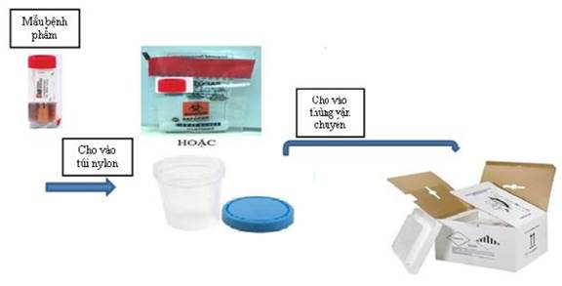
2.4.3. Transport samples to labs
- Inform the laboratory of the intended date and time of delivery of the samples to the laboratory.
- The samples are transported to the laboratory by road or air as soon as possible.
- Make sure protect the samples from being broken or spilled during the transportation.
- For the samples stored at 2-8°C, when they are being transported to the laboratory they are preserved at the temperature from 2-8°C, avoiding freezing and melting many times, which compromises the quality of the samples. For the samples stored at -70°C, when they are being transported to the labs, they must be frozen.

2.5. Collection, treatment and disposal of waste generated in the sampling process
- Sampling staff sort the waste and put it in corresponding containers:
- Non-sharp infectious waste: put in a yellow bag or bin with a biohazard symbol
- Sharp infectious waste: put in a container for sharp infectious waste. This box has thick, hard walls, are not likely to be penetrated
- Liquid infectious waste: collected into separate bottles
- Non-infectious hazardous chemical wastes are placed in black bins and bags with corresponding hazardous chemical warning signs.
- Ordinary waste: put in green bins, bags
- Tighten the waste bag or close the lid of the waste bin.
- At the end of the working day or when necessary, sampling staff or responsible persons shall collect the infectious waste to the gathering area.
- During the collection process, the waste bags must be sealed and put in the waste transport containers. Transport containers must have tight lids to ensure no waste is dropped or leaked during the collection process. During waste collection and transportation, the workers must use protective coat, gloves and appropriate personal protective equipment.
- The waste is transported to the area of wet autoclave treatment and treated at 120°C for 30 minutes before being disposed of with other medical waste or it can be burned in a hospital waste incinerator.

MONITORING AND EVALUATION

1. Bio-safety in Labs

1.1. External Evaluation and announcement to meet bio-safety standards
- In implementation of the Decree No. 103/2016/NĐ-CP stipulating the protection of bio-safety in labs:
- For the BSL I and BSL II laboratories: carry out the procedures for announcing the laboratories meeting BSL I and BSL II standards.
- For the BSL III laboratories: carry out the procedures of applying for the certificates of laboratories meeting BSL III standards III once a year.
- From 2020, BSL III laboratories are recognized by the Bureau of Laboratory Quality Standards, Ministry of Public Health, Thailand as meeting the ISO 15190 standard and under periodic evaluation once a year.

1.2. Internal Assessment
- Once a year, the Center of Laboratory Quality Assurance and Calibration coordinate with laboratories to inspect and supervise the biosafety performance of the laboratories in the Institute. The assessment in 2020 will be implemented in September-October.
- Conduct a biosafety assessment based on the biosafety checklist for each corresponding bio-safety level (see Annex X, XI).
- After conducting biosafety assessment for all laboratories in the Institute, develop an evaluation report, clearly stating the problems discovered during the assessment, corrective measures and the persons/units responsible for resolving the problems.

2. Waste management

2.1. NIHE
- NIHE signs a contract with the Institute of Occupational Health and Environment to conduct environmental quality monitoring in line with the Decision No. 22/2006/QĐ-BTNMT dated December 18, 2006 of the Minister of Natural Resources and Environment on Compulsory Application of Vietnamese Standards (QCVN) on Environment:
- Prepare an environmental monitoring report every 6 months
- Monitor the air environment twice a year based on the QCVN 26:2010/BTNMT, QCVN 05: 2013/BTNMT and QCVN 06: 2009/BTNMT.
- Solid waste: collect information about types and volumes of solid waste. Reported data is compiled based on the source from the Administration - Materials Department and the Center of Laboratory Quality Assurance and Calibration.
- Wastewater: Take samples for analyzing wastewater after treatment 4 times a year as defined by the National Technical Regulation QCVN 28:2010/BTNMT, column B (applied to medical wastewater)
- Results from the 2019 monitoring met Vietnam Technical Regulation QCVN 28:2010/BTNMT and World Bank’s Environmental Health and Safety Guidelines (See Annex XII).

2.2. POLYVAC
- POLYVAC signs an environment monitoring contract with the Center for Environmental Engineering and Chemical Safety - a branch of the Institute of Industrial Chemistry of Vietnam to conduct environment quality monitoring as defined by the Decision No. 22/2006/QĐ-BTNMT December 18, 2006 of the Minister of Natural Resources and Environment on Compulsory Application of Vietnamese Standards (QCVN) on Environment:
- Monitor the air environment twice a year based on the QCVN 26:2010/BTNMT, QCVN 05: 2013/BTNMT, QCVN 06: 2009/BTNMT and QCVN 27: 2010/BTNMT.
- Solid waste: collect information about types and volumes of solid waste. Reported data is compiled based on the source from the Technical Team and related Departments.
- Wastewater: Take samples for analyzing wastewater after treatment 4 times a year as defined by the National Technical Regulation QCVN 28:2010/BTNMT, column B (applied to medical wastewater)
- Observed results in 2019 met Vietnam Technical Regulation QCVN 28:2010/BTNMT and World Bank’s Environmental Health and Safety Guidelines (see Annex XIII).

3. Human Resource Management
- Annually, employees are evaluated and classified based on the "Regulations on assessment and classification of civil servants, public employees and contracted workers in the National Institute of Hygiene and Epidemiology" (QL02-QC05).
- As for professional capacity, annually, the unit management/ Quality Management/ Technical Management shall organize an assessment of the staff's professional capacity in line with the "Procedure for Employee Performance Assessment" (QL02-QT06).

ANNEX I
ORGANIZATIONAL CHART OF THE NATIONAL INSTITUTE OF HYGIENE AND EPIDEMIOLOGY

DEPUTY DIRECTOR
A. Prof. Dr. TRẦN NHƯ DƯƠNG
(Responsibility: checking/mor. )
DIRECTOR
Prof.Dr. ĐẶNG ĐỨC ANH
DEPUTY DIRECTOR
A. Prof. Dr. LÊ THỊ QUỲNH MAI
(Res: HTQLCL, CT, ex. audit, propaganda)
SCIENTIFIC PANEL, ETHIC PANEL
DEPUTY DIRECTOR
A. Prof. Dr. DƯƠNG HỒNG TRƯỜNG
(Res: Trade union)
Admin./Equip. Division
Communicable Disease control
Entomology and medical animals
Public health

Clinical testing center
Public health service center

Virology
HIV/AIDS
Center for biomedical research
Center for standardized testing animals

Center for lab quality and standard control

Personnel and Organization Div.
Planning –International Coop.
Finance-Accounting Div.

Bacteria Fa.

Training and science management Center
Center for Apply biomedical science and technology
National standard program Office

NCD Control Fa.

ORGANIZATIONAL CHART
CENTER FOR RESEARCH AND PRODUCTION OF VACCINES AND BIOLOGICALS
DOB
- Prof.Dr. Nguyễn Đăng Hiền-Director
- Dr. Nguyễn Thúy Hường-DD
- Dr.. Ngô Thu Hường- DD

TECHNICAL BRANCH
(OPV, Rotavin-M 1 vaccine Production)
TECHNICAL BRANCH
(Produce measles vaccine, Measles-Rubella vaccine)
PRODUCTION MANAGEMENT

QUAL. ASSURANCE

ADMIN AND ORGANIZATION

PLANNING-MATERIALS

ACCOUNTING-FINANCE

BUSINESS-SERVICES

TEST ANIMAL FARM

BAN GIÁM ĐỐC

TECHNICAL DIVISION

PRODUCE READY TO USE VACCINES
2
MEDIA PRODUCTION
2
PRODUCE SEMI- READY TO USE VACCINES
2
QUAL. VERIFICATION
2
UNIT RAISING TEST ANIMALS

TECHNICAL DIVISION

PRODUCE READY TO USE VACCINES
QUAL. VERIFICATION

PRODUCE SEMI- READY TO USE VACCINES

MEDIA PRODUCTION

POLYVAC VACCINATION

SAFPO VACCINATION

ANNEX II
PROCEDURE FOR BSL III LAB MANAGEMENT
 | NATIONAL INSTITUTE OF HYGIENE AND EPIDEMIOLOGY | ID: QL09-QT01  Issuance version: 1.19  Effect date: December 01, 2019  No. of pages: 10
 | BIOSAFETY LEVEL 3 LAB MANAGEMENT PROCEDURE

 | Full name | Signature | Date
Prepared by | Đặng Thị Kiều Oanh |  | 11/5/2019
Reviewed by | Nguyễn Thanh Thủy |  | 11/15/2019
Approved by | Lê Thị Quỳnh Mai |  | 11/25/2019
DOCUMENT VERSIONING
Date | Issuance Version | Contents of Changes | Places of changes
12/1/2019 | 1.19 | First version of issuance

- OBJECTIVES
This procedure governs the management and use of biosafety level 3 labs including: The booking of labs, management of personnel, tools, equipment and consumables of biosafety level 3 labs
- SCOPE OF APPLICATION
This procedure shall apply to users of biosafety level 3 labs at the National Institute Of Hygiene And Epidemiology, the Center of Laboratory Quality Assurance and Calibration, Department of Administration and Supplies, Biosafety and Quality Control Department and the Institute leadership.
- RESPONSIBILITIES
- Entities using biosafety level 3 labs at the National Institute Of Hygiene And Epidemiology shall have to comply with this procedure
- The Center of Laboratory Quality Assurance and Calibration shall oversee the adherence to this procedure.
- DEFINITIONS AND ABBREVIATIONS
1.1. Definitions
- Users: Include researchers or individuals/entities performing tests, internships, research or observation at the labs.
1.2. Abbreviations
- BS: Biosafety
- EC: Equipment calibration
- AS: Administration and Supplies
- User: Users:
- BSL3 Labs: Biosafety level 3 labs
- QA: Quality Assurance
- LQA&C: Laboratory Quality Assurance and Calibration

- IMPLEMENTATION STEPS
1.1 Flow charts
    - Personnel management and booking of BSL3 Labs

Steps | Responsible | Implementation sequences | Materials
 | Lab Manager | Lab plans to send researchers to work in a BSL3 Lab
1 | Lab Manager | Prepare researcher list and profiles | QL09-QT01- BM01  Appendix 01
2 | Lab Manager | Send researcher list and profiles to CLQAC | QL09-QT01- BM01
3 | Biosafety and Quality Control Department  CLQAC | Approve and prepare a list of researchers authorized to work in a BSL3 Lab | QL09-QT01- BM01
4 | User | Book a BSL3 Lab | QL09-QT01- BM03
5 | Biosafety and Quality Management Department  CLQAC | Approve  Approve  Disapprove | QL09-QT01- BM03
6 | BSL3 Lab Manager | Inform Manager of Calibration Department, CLQAC | QL09-QT01- BM03

    - Management of BSL3 Lab instruments and equipment

Step | Responsible | Description | Documents
1 | User, person in charge of lab | Specify the instruments, equipment to be brought into the lab
2 | User, person in charge of lab | Fill in the entry form
3 | User | Move the instrument, equipment into the lab | QL09-QT01- BM05
4 | CLQAC | Stick use instructions for the instrument, equipment (if any) near their location
5 | User | Use the instrument, equipment as instructed and record full information in the use log
6 | CLQAC | Move the instrument, equipment out of the lab, fill in the exit form | QL04-QĐ01
7 | User | Send fully filled form to the person in charge of the lab | QL09-QT01- BM06

    - Management of consumables

Step | Responsible | Description | Documents
1 | BSL3 Lab Manager | Prepare a list of required consumables | Appendix 13
2 | CLQAC | Send procurement request as per the Institute’s protocol
3 | CLQAC | Receive commodities from the AS Department, store at the lab warehouse | QL09-QT01- BM08
4 |  | Add consumables to the relevant locations in the BSL3 Lab | QL09-QT01- BM08
5 | CLQAC | Periodically perform inventory checking and carry out purchases in a timely manner | QL09-QT01- BM08

  - Description of work flows
1.2.1. Personnel management and booking of BSL3 Labs
- Step 1: Prepare researcher list and profiles
When researchers booking a BSL3 Lab have a full set of documents required under Appendix 1 of QL09-QT03, the Lab Manager shall prepare a “List of researchers booking a BSL3 Lab” (QL09-QT01-BM01) and prepare researcher profiles.
- Step 2: Send researcher list and profiles to the CLQAC
Send the researcher list and profiles to the BSL3 Lab Manager (2 weeks prior to the start of work at the BSL3 Lab).
- Step 3: Approve the list of researchers authorized to work in a BSL3 Lab
The BSL3 Lab Manager reviews the documents and, if the documents are found complete, submit the request to the Dean of the Biosafety and Quality Assurance under the CLQAC and the Biosafety and Quality Management Department for approval of the “List of researchers booking a BSL3 Lab”. After approval, the BSL3 Lab Manager shall send a copy to the lab where the researchers will work and keep the original
In December of each year, the BSL3 Lab Manager shall consolidate a list of researchers eligible to work at BSL3 Labs using the form QL09-QT01-BM02.
- Step 4: Book a BSL3 Lab:
- The booking user shall meet all the applicable requirements for using BSL3 Labs
- Send the procedure and memo of risk assessment as instructed by the Safety Manual issued by the Institute to the CLQAC.
- The user shall fill in the form “Application to use a BSL3 Lab” (QL09-QT01-BM03) and request approval.
- Step 5: Approval by the Department of Biosafety and Quality Management
- If positive, return to Step 1
- If negative, proceed to Step 6
- Step 6: The user sends the application approved by the Department of Biosafety and Quality Management to the person in charge of the lab at least 3 days prior to the use of the lab. Upon receipt of the approved application, the person in charge of the lab shall send a copy to the using entity.
Note:
- The researcher and the Lab Manager shall be responsible for the mastery of the researcher in the performance of tests in the BSL3 Lab. When working in a BSL3 Lab, a researcher with less than 1 year of experience should be accompanied and instructed by a supervisor who has over 1 year of experience.
- An user who needs to work overtime on an ad-hoc basis shall need to obtain the consent of the CLQAC (a phone call to the technical officer in charge is acceptable).
- In cases where visitors come to the lab, the leader shall fill in the application form and request approval using form QL09-QT01-BM04
1.2.2. Management of BSL3 Lab instruments and equipment
Move the instrument, equipment into the lab
- Step 1: Specify the instruments, equipment to be brought into the BSL3 Lab
- Step 2: Fill in the entry form (QL09-QT01-BM05) (QL09-QT01-BM05)
- Step 3: Move the instrument, equipment into the BSL3 Lab in accordance with the “Instructions on the transport of instruments and equipment into and out of BSL3 Labs” (Appendix 12 to this Procedure)
- Step 4: Stick use instructions for the instrument, equipment (if any) near their location
The use of instruments and equipment in labs
- Step 5: The use of instruments and equipment
- Researchers shall use instruments and equipment in accordance with instructions in appendices to this Procedure. During their use of instruments and equipment, users shall record such use in the use log under the Institute’s protocol. Regarding equipment for which temperature needs to be taken on a daily basis, the using researcher shall fill the Temperature Log under the Institute’s protocol (except for minus 80⁰C freezer and the refrigerator in the lab, the temperature for which shall be taken by the CLQAC).
- Regarding all equipment use log forms, the researcher who fills in information last shall send such forms via facsimile to the CLQAC at the number indicated on the facsimile machine placed in each lab.
- In the event and instrument/equipment breaks down during use, then after leaving the lab, the researched shall at the Biosafety Management Department, Floor 3-HTC Building fill in Request form (QL09-QT02-BM03). After receiving the request form, the person in charge of the lab shall process the same in accordance with the Institute’s protocol.
Transport of instruments and equipment out of the lab area
- Step 6: When moving instruments, equipment out of the BSL3 Lab, the transporter shall comply with the “Instructions on the transport of instruments and equipment into and out of BSL3 Labs” (Appendix 12 to this Procedure). The person in charge of the transport shall fill in the exit form (QL09-QT04-BM06).
- Step 7: Send the fully filled form to the person in charge of the lab
Note:
- The BSL3 Labs shall manage equipment in accordance with the Institute’s current protocol.
- The researcher shall be responsible for the management of his/her instruments, equipment brought into the lab.
- Every 3 months, an officer of the CLQAC shall inspect the operability of the equipment in the lab and shall fill in form QL09-QT01-BM10.
- Inventory: Every year, the person in charge of the lab shall perform an inventory of instruments and equipment and shall fill in the BSL3 Lab inventory form (QL09-QT01-BM07).
1.2.3. Management of consumables
- Step 1: Check for the consumables required for the BSL3 Lab as per the list in Appendix 13
- Step 2: An officer from the CLQAC shall send a purchase request to the relevant departments as per the Institute’s protocol.
- Step 3: Receive consumables from the AS Department and transport the same to the 3rd floor warehouse of the HTC Building. The transport officer shall fill in the Warehouse card (QL09-QT01-BM08).
- Step 4:
- An officer from the CLQAC shall be responsible to re-check the consumables in the lab area (depending on the frequency of lab use, but at least once a month).
- After checking, the officer from the CLQAC shall add the consumables to the appropriate locations in the BSL3 Lab area and fill in the Warehouse card (QL09-QT01-BM08)
- Step 5: The person in charge of the lab and the officer from the CLQAC shall be responsible to perform an inventory of consumables every 6 months, comparing them with the actual quantities recorded in the warehouse card and make a purchase plan in a timely manner. The person in charge of the lab shall fill in the inventory slip after each periodical inventory (QL09-QT01-BM09).
- ATTACHED APPENDICES AND FORMS

No. | Name of the Annexes, Forms | Code
1 | List of researchers booking BSL3 Lab | QL09-QT01-BM01
2 | Consolidated list of researchers authorized to work in a BSL3 Lab | QL09-QT01-BM02
3 | Book a BSL3 Lab | QL09-QT01-BM03
4 | Registration form for visit to BSL3 Lab | QL09-QT01-BM04
5 | BSL3 Lab instruments and equipment entry form | QL09-QT01-BM05
6 | BSL3 Lab instruments and equipment exit form | QL09-QT01-BM06
7 | BSL3 Lab instruments and equipment inventory slip | QL09-QT01-BM07
8 | Warehouse card | QL09-QT01-BM08
9 | BSL3 Lab consumables inventor slip | QL09-QT01-BM09
10 | Equipment check slip | QL09-QT01-BM10
11 | List of profiles of researchers working in the BSL3 | QL09-QT01-PL01
12 | Instructions for use of the passbox | QL09- QT01-PL02
13 | Instructions for operating double-door autoclave sterilizer | QL09- QT01-PL03
14 | Instructions for operating single-door autoclave sterilizer | QL09- QT01-PL04
15 | Instructions for using sink | QL09- QT01-PL05
16 | Instructions for using Olympus CKX41 microscope | QL09- QT01-PL06
17 | Instructions for using AS-ONE SWB-25 shaking incubator | QL09- QT01-PL07
18 | Instructions for using centrifuge | QL09- QT01-PL08
19 | Instructions for using Olympus MCO-175 incubator | QL09- QT01-PL09
20 | Airtech BHC- 1303 IIB2 Instructions for using Biosafety cabinet; Airtech BHC- 1303 IIB2-IMS cabinet. | QL09- QT01-PL10
21 | Instructions for using Olympus MPR-311D refrigerator | QL09- QT01-PL11
22 | Instructions for transporting instruments into and out of BSL3 | QL09- QT01-PL12
23 | List of consumables of BSL3 | QL09- QT01-PL13
24 | Instructions for using eyewash bowl | QL09- QT01-PL14
25 | Instructions for using emergency shower | QL09- QT01-PL15
- DOCUMENTS

No. | Name of the record | Archiving place | Arching Form | Archiving time
1 | List of researchers booking BSL3 Lab | BioSafety Department | Hard copy | Throughout the researcher’s working period at the lab
2 | Consolidated list of researchers authorized to work in a BSL3 Lab | BioSafety Department | Hard copy/soft copy | 3 year
3 | Book a BSL3 Lab | BioSafety Management Department | Original | 3 year
4 | Registration form for visit to BSL3 Lab | BioSafety Management Department | Original | 3 year
5 | BSL3 Lab instruments and equipment entry form | BioSafety Department | Original | 3 year
6 | BSL3 Lab Use Log | BioSafety Department | Facsimile copy/Original | 3 year
7 | BSL3 Lab equipment temperature log | BioSafety Department | Facsimile copy/Original | 3 year
8 | Form of request for repair, maintenance, calibration | BioSafety Department | Biosafety Department | 3 year
9 | BSL3 Lab instruments and equipment exit form | BioSafety Department | Original | 3 year
10 | BSL3 Lab instruments and equipment inventory form | BioSafety Department | Original | 3 year
11 | Equipment check slip | BioSafety Department | Original | 3 year
12 | Equipment history | BioSafety Department | Original | Original
13 | Warehouse card | BioSafety Department | Original | 3 year
14 | BSL3 Lab consumables inventor slip | BioSafety Department | Original | 3 year
15 | Qualifications and certificates under Appendix 1 | BioSafety Department | Document | Throughout the researcher’s working period at the lab
- Benchmarking with standards
This Procedure conforms to the requirements under section 7.1 of ISO 9001:2015; sections 4.1, 5.1, 5.3 of TCVN ISO 15189:2014 code, sections 6.2 and 6.4 of TCVN ISO/IEC 17025:2017 code; section 4.2, 4.3, 5.2 of ISO 17043:2010 and section 6.2 of TCVN ISO 13485:2016 code, section 5.2, 6.2, 7.2 of ISO 15190:2003.
- REFERENCES
- TCVN ISO 9001:2015: Quality management systems – requirements, 2016;
- TCVN ISO 15189:2014: Medical laboratories - Requirements for quality and competence, Directorate of Standards, Metrology and Quality, 2014;
- TCVN ISO/IEC 17025:2017: General requirements for the competence of Testing and Calibration Laboratories, 2017;
- TCVN ISO 13485:2017: Medical devices - Quality management systems - Requirements for regulatory purposes, 2017;
- TCVN ISO 17043:2011, Conformity assessment - General requirements for proficiency testing, 2011;
- ISO 15190:2003, Medical laboratory- Requirements for safety
- The Government (2010), Decree N0. 103/2016/ND-CP providing detailed provisions on the Law on the control of infectious diseases and the assurance of biosafety in labs.
- Circular N0. 41/2016 /TT-BYT List of infectious microorganisms sorted by threat category and biosafety level suitable for their testing methods.
- Circular 37 /2017/TT-BYT issuing national technical standards on bio practice and biosafety in labs.
- National Assembly (2007), Law on the control of infectious diseases adopted by the 7th National Assembly, 2nd session, N0. 03/2007 of November 21, 2007.
- National Standards (2008), TCVN ISO 9001:2008: Quality management systems – requirements.
- WHO, Laboratory biosafety manual – 3rd edition, 2004.

ANNEX III
PROCEDURE OF HUMAN RESOURCE MANAGEMENT AND TRAINING FOR PROFESSIONALISM AND SERVICES
  NIHE | NATIONAL INSTITUTE OF HYGIENE AND EPIDEMIOLOGY | ID: QL02-QT05  Issuance version: 1.19  Effect date: 01/12/2019  No. of pages: 07
 | PROCEDURE OF HUMAN RESOURCE MANAGEMENT AND TRAINING FOR PROFESSIONALISM AND SERVICES

 | Full name | Signature | Date
Prepare | Trần Diệu Linh |  | …… / …… / ……
Prepare | Hoàng Thị Thu Hà |  | …… / …… / ……
Prepare | Hoàng Vũ Mai Phương |  | …… / …… / ……
Prepare | Phạm Hồng Thắng |  | …… / …… / ……
Prepare | Nguyễn Thị Lan Anh |  | …… / …… / ……
Prepare | Trần Vũ Phong |  | …… / …… / ……
Review | Lê Thị Quỳnh Mai |  | …… / …… / ……
Review | Bùi Hải Hà |  | …… / …… / ……
Approve | Lê Thị Quỳnh Mai |  | …… / …… / ……

DOCUMENT HISTORY MONITORING

Effective Date | Issuance Version | Contents of Changes | Places of changes

- OBJECTIVE
This procedure describes the contents of management and training of personnel for tests, experiment, calibration and production in the National Institute of Hygiene and Epidemiology (NIHE) to ensure that human resources are available and meet requirements of professional and service activities.
- SCOPE OF APPLICATION
- Applicable to all Departments / Faculties / Offices / Centers (hereinafter referred to as Units) directly under the NIHE for tests, experiment, calibration and production
- OBLIGATIONS
- Employees of the Units are responsible for complying with this procedure.
- NIHE Management and Units’ Management are responsible for monitoring the compliance of this procedure.
- DEFINITIONS AND ABBREVIATION
4.1. Definitions
- Continuing Training refers to short-term training courses, including: training to fostering knowledge, skills and expertise; Continuing Medical Education (CME); Continuing Professional Development (CPD); technical transfer training; training in line with the tasks of direction of healthcare activities and other professional training courses for health workers that are not part of the system of national education diplomas.
- Internal training: delivered by the NIHE.
- External training: provided by other agencies/ organizations than the NIHE in Vietnam or other countries.
4.2. Abbreviations
- LAB: Laboratory
- QA: Quality Assurance
- TM: Technical Management
- HR&O: Human Resources and Organization
- IMPLEMENTATION STEPS
5.1. Flow charts
N/A.

5.2. Description of work flows
5.2.1. General Management
- Each unit must maintain a list of its employees based on the form "List of employees" (QL02-QT05-BM01) which is subject to update upon changes.
- The unit management determines the job positions and builds competency standards for each position according to the form "Job Description" (QL02-QT05-BM02).
- Each employee of the unit prepares a personal resume according to the form "Personal Resume" (QL02-QT05-BM03) and updates when there is a change.
- The unit management assigns tasks to the staff according to the form "Task description" (QL02-QT05-BM04) and updates when there is a change. The unit management fully communicates information about the duties, powers and responsibilities to each employee.
- The employee's job description is approved by the unit management, and the job descriptions of the unit managers are approved by the Institute management.
- Employees of the unit must read, understand and sign the "Commitment to comply with medical ethics and ensure the quality of work" (QL10-QT01-BM04). See also the procedure "Organization of and responsibility for management in the quality management system" (QL10-QT01).
- In some emergency cases, the unit management may rotate personnel to meet work requirements, but it is necessary to evaluate the capacity of these employees to ensure they are suitable for the new tasks: through diplomas, certificates, work experience, employee skills test results etc. which are archived in their personnel records.
5.3. Recruitment
- On annual basis or when there is a need to recruit personnel, the unit management determines the needs to recruit personnel and submits a proposal to the NIHE management, Department of Human Resource and Organization (HR&O) for review and approval.
- HR&O Department will conduct necessary procedures as defined by the "Regulations for Employee Recruitment and Contracted Employees of the National Institute of Hygiene and Epidemiology" (QL02-QC01)
5.4. Onboarding new employees
- When receiving new employees, the receiving unit must onboard the new employees with at least the following information:
- General information about the NIHE, the unit's professional activities (organizational structure, facilities, etc.);
- Working regulations of the NIHE;
- Safety regulations (occupational safety, biosafety);
- + Quality management system of the NIHE.
- The entire onboarding process is recorded in the form "New Staff Orientation” (QL02-QT05-BM05).
- The QA is responsible for archiving employees’ records since they are received.
5.5. Training for new staff
- All new employees or staff assigned with new tasks will be trained with the following contents:
+ Quality Management in line with the ISO standards associated with the assigned work;
+ Technical / professional procedures, how to operate the equipment related to the assigned work (minimum 2 months for practical training);
+ Information system of the unit;
+ Occupational safety and biosafety;
+ Information confidentiality.
- Staff must always be supervised in the training process.
- At the end of the training process, new employees will be assessed their competency in performing the assigned tasks in accordance with the "Employee Competency Assessment Process" (QL02-QT06).
- Employees will only be authorized to perform specific tasks when the performance assessment is satisfactory. However, they still need to be supervised for the first 1 year before being able to perform the tasks independently.
5.6. Continuing training and professional development
- Every year, each employee will fill out the personal training request in the form "Personal training request form" (QL02-QT05-BM06) and then submit it to the unit management/QA.
- Based on the requirements of each individual, QA shall develop a training plan for the employees in line with the form "Training Plan" (QL02-QT05-BM07). Based on the actual situation, unit management shall approve the training plan.
- Forms:
+ Attend internal and external training to improve professional expertise and competency;
+ Participate in conferences/ seminars;
+ Engage in research project, write scientific articles ect..
      - Internal training
- Internal training procedure:
+ The unit management assigns trainers.
+ The assigned trainers shall develop detailed training programs
+ Training methodologies could be a single or a combination of the following forms: theory, theory combined with practice, observing sample practice, supervised practice, self-study, etc.
+ The assigned trainers shall deliver the training and fill in the "Minutes of internal training" (QL02-QT05-BM08); put the ID of the "Training minutes" with the following form: ĐT/XX-YY: XX is the ordinal number of the training session in the year, YY is the training year.
+ The assigned trainers shall evaluate the training results based on different forms such as writing test, oral examination, direct observation using checklist of implementation steps, using the known samples to check, etc. These forms are applied depends on the content and training methodologies.
- Criteria for assessing the results of training:
+ Results are achieved when the total score is 75 points or higher;
+ The training results are unsatisfactory when the total score in lower than 75 points;
+ If the training results are unsatisfactory, retraining is required
- The assigned trainers update the information in the “Internal training record book” (QL02-QT05-BM09).
      - External training
- Upon completion of the training, the trainees must submit a copy of their certificate (if any) or evidence documents to the QA to keep and update on the "Personal Resume" (QL02-QT05-BM03).
      - Assessment of the training effectiveness
- Once a year, the unit management/EM/TM conducts an evaluation of the effectiveness of the training program based on the form "Evaluation of training effectiveness" (QL02-QT05- BM10);
- Forms of assessment: through staff capacity assessment or based on criteria such as applicability, suitability, transferability of the training.
5.7. Employee Assessment
- Annually, employees will be evaluated and classified based on the "Regulations on assessment and classification of civil servants, public employees and contracted workers in the National Institute of Hygiene and Epidemiology" (QL02-QC05).
- Regarding professional capacity, annually, unit managers/EM/TM organize an assessment of employee's professional capacity based on the "Employee capacity assessment process" (QL02-QT06).
5.8. Health monitoring
- Everyone must participate in the annual physical exam organized by the NIHE.
- The NIHE's Service Center keeps the results of periodic health checks. Each staff member shall update results on "Health/vaccination monitoring form" (QL02-QT05-BM11).
- Everyone must be vaccinated against diseases that they are at risk of exposure during their work (if any) and update on the "Health/vaccination monitoring form" (QL02-QT05-BM11).
5.9. Human Resource Profiles
- QA is responsible for preparing and managing Human Resource Profiles of the unit in accordance with the “Profile Management Procedures” (QL11-QT01).
- Each staff profile includes:
+ Personal resume;
+ Job description;
+ New Staff Onboarding form (if any);
+ Results of professional capacity assessment;
+ Diplomas and certificates;
+ Health/vaccination monitoring forms, vaccination card (if any);
+ Other records (reward, discipline ...) (if any).
- All staff profiles need to be kept confidential, only authorized people can access to the profiles:
+ Employees can access their profiles and are only allowed to copy information from their personnel profiles.
+ Unit management/EM/TM have access to all information in the personnel profiles in such unit.
+ Head of the LAB has access to all information in personnel profiles of employees in the LAB that he is in charge of.
- QA maintains personnel profiles of each staff member throughout his time working in the unit. If the staff member leaves the work, his/her profile must be retained for at least 3 years.
- ANNEXES AND FORMS

No. | Name of the Annexes, Forms | Code
1 | List of employees | QL02-QT05-BM01
2 | Job Description | QL02-QT05-BM02
3 | Personal Resume | QL02-QT05-BM03
4 | Task description | QL02-QT05-BM04
5 | New Staff Onboarding | QL02-QT05-BM05
6 | Personal training request form | QL02-QT05-BM06
7 | Training plan | QL02-QT05-BM07
8 | Internal Training Minute | QL02-QT05-BM08
9 | Internal training record book | QL02-QT05-BM09
10 | Training Effectiveness Assessment | QL02-QT05-BM10
11 | Health/vaccination monitoring form | QL02-QT05-BM11
12 | Commitment to comply with medical ethics and ensure the quality of work | QL10-QT01-BM04
13 | Staff Performance Assessment Results | QL02-QT06-BM02

- RECORDS

No. | Name of the record | Archiving place | Arching Form | Archiving time
1 | List of employees | Unit | Document | 3 year
2 | Job Description | Unit | Document | 3 year
3 | Personal Resume | Unit | Document | Throughout the work process
4 | Task description | Unit | Document | Throughout the work process
5 | New Staff Onboarding | Unit | Document | Throughout the work process
6 | Personal training request form | Unit | Document | 3 years
7 | Training plan | Unit | Document | 3 years
8 | Internal Training Minute | Unit | Document | 3 years
9 | Internal training record book | Unit | Document | 3 years
10 | Training Effectiveness Assessment | Unit | Document | 3 years
11 | Health/vaccination monitoring form | Unit | Document | Throughout the work process
12 | Commitment to comply with medical ethics and ensure the quality of work | Unit | Document | Throughout the work process
13 | Staff Performance Assessment Results | Unit | Document | Throughout the work process
14 | Diplomas/ Certificates | Unit | Document | Throughout the work process
15 | Reward/ Discipline Records | Unit | Document | Throughout the work process
- BENCHMARKING WITH THE STANDARDS
This procedure is in line with the requirements in the section 7.1 of the ISO 9001:2015, section 5.1 of the standard TCVN ISO 15189:2014 and section 6.2 of the standard TCVN ISO/IEC 17025: 2017, section 4.2 of ISO 17043 and section 6.2 of ISO 13485:2017.
- REFERENCES
- TCVN ISO 9001:2015: Quality management systems – requirements, 2016;
- TCVN ISO 15189:2014: Medical laboratories - Requirements for quality and competence, Directorate of Standards, Metrology and Quality, 2014;
- TCVN ISO/IEC 17025:2017: General requirements for the competence of Testing and Calibration Laboratories, 2017;
- TCVN ISO 13485:2017: Medical devices - Quality management systems - Requirements for regulatory purposes, 2017;
- TCVN ISO 17043:2011, Conformity assessment - General requirements for proficiency testing, 2011;
- Circular 22/2013/TT-BYT of the Minister of Health, issued on August 9, 2013, guiding the continuing training of health workers;
- ARLM03. Supplementary Requirements for Accreditation of Medical Laboratories, 2020;
- ARL04. Biological Supplementary Requirements, 2020;
- ARL07. Supplementary requirement for accreditation in the field of Metrology/Calibration, 2020;
- ARL08. Mechanical Supplementary Requirements, 2020.

ANNEX IV
PROCEDURE FOR ENTRY TO AND EXIT FROM BSL III LAB AREA

- OBJECTIVE
This procedure provides guidance on the entry into Biosafety Level 3 Lab in order to ensure safety for users, maintenance and repair engineers, visitors and persons entering and exiting the lab.
- SCOPE OF APPLICATION
This procedure shall apply to users, maintenance and repair engineers, visitors and persons entering and exiting the Biosafety Level 3 Lab of the National Institute Of Hygiene And Epidemiology
- OBLIGATIONS
- Entities using biosafety level 3 labs at the National Institute Of Hygiene And Epidemiology shall have to comply with this procedure
- The Center of Laboratory Quality Assurance and Calibration shall oversee the adherence to this procedure.
3.1 Definitions and Abbreviation
3.1.1. Definitions:
- Users: Include researchers or individuals/entities performing tests, internships, research or observation at the Biosafety Level 3 Lab.
- Visitors: are those visiting, assessing or inspecting the Biosafety Level 3 Lab.
- Maintenance and repair engineers: are those entering the Biosafety Level 3 Lab to repair and maintain instruments and equipment.
- Assured pressure: The black pointer of the pressure gauge lying between the red and blue(green) markers on the scale.
3.1.2. Abbreviations:
- BS: Biosafety
- EC: Equipment calibration
- User: Users:
- BSL3 Labs: Biosafety level 3 labs
- PPE: Personal protective equipment
- QA: Quality Assurance
- CLQAC: Center of Laboratory Quality Assurance and Calibration
- IMPLEMENTATION STEPS
* In normal cases
- For users of the BSL3 Lab
4.1. Flow charts
4.1.1. When entering and exiting from BSL3 Lab

Steps | Responsibility | Implementation sequences |  | Materials
1 | User Center of Laboratory Quality Assurance and Calibration | Inform the Calibration Department and the Center of Laboratory Quality Assurance and Calibration
2 | User, person in charge of the BSL3 Lab | Door (1) |  | QL09-QT02- BM01
3 | User | Airlock door 1 - door (2)
4 | User | Airlock 1 | When entering | QL09- QT02- BM02
5 | User | Corridor |  | QL09- QT02- BM02
6 | User | Buffer compartment
7 | User
7 | User | Laboratory
8 | User | Buffer compartment
9 | User | Corridor - While  exiting
10 | User | Airlock 1 |  | QL09- QT02- BM03
11 | User  Center of Laboratory Quality Assurance and Calibration | Door (1) |  | QL09- QT02- BM01/ 03

4.1.2. When entering the pathogen storage warehouse

Steps | Responsibility | Implementation sequences |  | Materials
1 | User, person in charge of the BSL3 Lab | Door (1) |  | QL09-QT02- BM01
2 | User, person in charge of the BSL3 Lab | Airlock 1 When entering
3 | User, person in charge of the BSL3 Lab | Pathogen storage warehouse
4 | User, person in charge of the BSL3 Lab | Airlock 1 | When exiting
5 | User, person in charge of the BSL3 Lab | Door (1) | When exiting | QL09-QT02- BM02
4.2. Description of flow chart
4.2.1. When entering and exiting BSL3 Lab
- Step 1: Inform the person in charge of the BSL3 Lab at least 90 minutes in advance The person in charge of the BSL3 Lab shall based on the user’s application for use of the BSL3 Lab inform the Calibration Department to turn on the lab.
- Step 2: At door (1), the user fills in the form “BSL3 Lab entry and exit log” (QL09-QT02-BM01) and receives a card from the person in charge.
- Step 3: At Airlock door (door 2), hold the card close to the reader, input code and press Enter to open the door.
- Step 4: At Airlock 1
- Switch on the light and close the door.
- Observe the pressure gauge:
  - If the pressure is not on, inform the person in charge for next actions. If the pressure remains unfixed, the user must not continue working.
  - If the pressure is ok, then fill in the form “Tracker of pressure in the BSL3 Lab area” (QL09-QT02-BM02) and proceed.
- Change footwear in the BSL3 Lab area.
- Leave personal belongings (mobile phones, jewelry...) in the locker and lock it.
- Wear a blouse, put on gloves as instructed in “Instructions on the use personal protective equipment in the BSL3 Lab area” Appendix 1(QL09-QT02-PL01).
- Open door (3), proceed to the corridor.
- Step 5: At the corridor
- Switch on the lights.
- At the lab, observe the pressure gauge, fill in the “Tracker of pressure in the BSL3 Lab area” (QL09-QT02-BM02), only enter when the pressure is ok.
- Wear personal protective equipment as instructed in “Instructions on the use personal protective equipment in the BSL3 Lab area” (Appendix 01). Note that personal protective equipment is available in lockers along the corridor and is used depending on the type of pathogen as well as the nature of the work to be performed in the lab.
- At the door of the lab: Hold the card close to the reader, input code and press Enter to open the door to the buffer compartment.
- - Step 6: At the buffer compartment
- Turn on the lights and the indicator of “User present in lab” and close the door.
- Leave the card in the drawer of the cabinet in the buffer compartment.
- Open the lab door and carry the waste bag inside the lab, leave it near the double-door autoclave sterilizer
- Step 7: At the lab
- Switch on the lights.
- Take the testing materials from the passbox, if nay
- Conduct the test
- After the test is done, perform decontamination following the procedure “Decontamination and treatment of waste in the BSL3 Lab area” (QL09-QT07).
- Remove the outer gloves Switch off the equipment that is not required to operate continuously,
- In cases where samples, instruments and equipment need to be moved out, the corresponding procedures (procedure QL09-QT05 for samples and procedure QL09-QT01 for instruments and equipment) need to be followed.
- Switch off the lights, open the lab, move out of the buffer compartment
- Step 8: At the buffer compartment (upon exit)
- Remove the personal protective equipment as instructed in “Instructions on the use personal protective equipment in the BSL3 Lab area” (Appendix 01).
- Put the personal protective equipment in the waste bag, tie the bag up, take the bag out of the waste bin, and put in a new bag in the bin.
- Take off mask and gloves and put them in the waste bin.
- Sanitize the hands quickly
- Switch off the lights and “User present in lab” indicator, put the card close to the reader, open the door of the buffer compartment and move out to the corridor.
- Step 9: At the buffer compartment (upon exit)
- Take the samples, instruments and equipment out of the passbox, if any
- Switch off the lights at the corridor area (if the other labs have no users then), open door (3), and get out of Air-lock 1.
- Step 10: At Airlock 1
- Remove the personal protective equipment as instructed in “Instructions on the use personal protective equipment in the BSL3 Lab area” (Appendix 01).
- Write down requests , if any, for the Center of Laboratory Quality Assurance and Calibration in “Request form” (QL09-QT02-BM03) and give it to the person in charge of the lab at door (1).
- Take personal belongings out of the locker.
- Switch off the lights if the other labs have no users, put the card close to the reader, open door (2) and move out.
- Step 11: At door (1)
- Hand a request form, if any, and return the card to the person in charge of the lab.
- Fill in the form “BSL3 Lab area entry and exit log” (QL09-QT02-BM01).
4.3 When entering and exiting the pathogen storage warehouse
- Step 1: At door (1):
- Inform and go with the person in charge of the lab to the pathogen storage warehouse as per the “Management of pathogen storage warehouse in the BSL3 Lab area” (QL09-QT05). User fills in the form “BSL3 Lab area entry and exit log” (QL09-QT02-BM01)
- Hold the card close to the reader, input code and press Enter to open the door to the buffer compartment.
- Step 2: At Airlock 1
- Change footwear in the BSL3 Lab area.
- Leave personal belongings (mobile phones, jewelry...) in the locker and lock it.
- Wear a blouse, and wear two layers of gloves.
- At the warehouse door – door (4), hold the card close to the reader to open the door, then enter the warehouse
- Step 3: At the pathogen storage warehouse
- Perform the necessary works as per the “Management of pathogen storage warehouse in the BSL3 Lab area” (QL09-QT05).
- After having finished the cleaning of the warehouse (if necessary)
- Take off the outer gloves and put them in the waste bin inside the warehouse.
- Press the PRESS button to open the warehouse door – door (4), switch off the lights, move out to Air-lock 1.
- Step 4: At Airlock 1
- Take off the personal protective equipment as instructed in Appendix 01.
- Write down requests for the Center of Laboratory Quality Assurance and Calibration in “Request form” (QL09-QT02-BM03) and give it to the person in charge of the lab .
- Take personal belongings out of the locker.
- Switch off the lights, put the card close to the reader, open door (2) and move out.
- - Step 5: At door (1):
Fill in the form “BSL3 Lab area entry and exit log” (QL09-QT02-BM01).
- For visitors:
Visitors wishing to enter a BSL3 Lab shall need to register to obtain the needed approval and shall be accompanied by a biosafety officer.
- For operating and repair engineers:
Engineers, both internal and externals entering a BSL3 Lab to maintain or repair equipment shall have to register and have their working plan approved. They shall also be accompanied by a biosafety officer where necessary.
* In the event of emergencies:
In the event of emergencies such as fire, earthquake, etc. an exit at the end of the corridor, opposite the normal exit, where an “emergency exit” sign can be seen, can be used to get out of the BSL3 Lab using a staircase.
- ATTACHED APPENDICES AND FORMS
No. | Name of the Annexes, Forms | Code
1 | Biosafety Level 3 Lab entry and exit log | QL09-QT02-BM01
2 | BSL3 Lab area pressure tracker | QL09-QT02-BM02
3 | Request form | QL09-QT02-BM03
4 | Instructions on the use personal protective equipment in the BSL3 Lab area Appendix 01 | QL09-QT02-PL01
- RECORDS

No. | Name of the record | Archiving place | Arching Form | Archiving time
1 | Biosafety Level 3 Lab entry and exit log | BioSafety Management Department | Original | 3 year
2 | BSL3 Lab area pressure tracker | BioSafety Management Department | Original | 3 year
3 | Request form | BioSafety Management Department | Original | 3 year
- BENCHMARKING WITH THE STANDARDS
This procedure is in line with the requirements under section 8.1 of ISO 9001:2015; sections 4.1, 5.2 of TCVN ISO 15189:2014 standard, section 6.3 of TCVN ISO/IEC 17025:2017 standard; section 4.3 of ISO 17043:2010 and sections 6.3, 6.4 of TCVN ISO 13485:2016 standard, sections 5.1, 6.3, and 12.1 of ISO 15190:2003.

- REFERENCES
- TCVN ISO 9001:2015: Quality management systems – requirements, 2016;
- TCVN ISO 15189:2014: Medical laboratories - Requirements for quality and competence, Directorate of Standards, Metrology and Quality, 2014;
- TCVN ISO/IEC 17025:2017: General requirements for the competence of Testing and Calibration Laboratories, 2017;
- TCVN ISO 13485:2017: Medical devices - Quality management systems - Requirements for regulatory purposes, 2017;
- TCVN ISO 17043:2011, Conformity assessment - General requirements for proficiency testing, 2011;
- ISO 15190:2003, Medical laboratory- Requirements for safety
- The Government (2016), Decree No. 103/2016/ND-CP detailing regulations on the implementation of the Law on prevention and control of infectious diseases for ensuring biosafety in laboratories.
- The Government (2018), Decree 155/2018/ND/CP on amending and adding a number of articles relating to business eligibility conditions under the authority of the Ministry of Health.
- The Ministry of Health (2017), Circular N0. 37/2012/TT-BYT governing the practice of biosafety in laboratories.
- National Assembly (2007), Law on the control of infectious diseases adopted by the 7th National Assembly, 2nd session, N0. 03/2007 of November 21, 2007.
- National Standards (2008), TCVN ISO 9001:2008: Quality management systems – requirements.
- WHO, Laboratory biosafety manual – 3rd edition, 2004.

ANNEX V
DIAGRAM OF SORTING AND COLLECTING WASTE

Waste gathering place
Autoclaving
Decontamination Dpt, Center for LQA&C
Autoclaving
Recycled
Sharp
Non-Infectious
Non-Infectious
Infectious
Waste

ANNEX VI
PROCEDURE FOR DECONTAMINATION AND TREATMENT OF WASTE

 | NATIONAL INSTITUTE OF HYGIENE AND EPIDEMIOLOGY | ID: QL09-QT07  Issuance version: 1.19  Effect date: December 01, 2019  No. of pages: 8
 | DECONTAMINATION AND WASTE TREATMENT PROCEDURE IN BIOSAFETY LEVEL 3 LAB AREA

 | Full name | Signature | Date
Prepared by | Đặng Thị Kiều Oanh |  | 11/5/2019
Reviewed by | Nguyễn Thanh Thủy |  | 11/15/2019
Approved by | Lê Thị Quỳnh Mai |  | 11/25/2019
DOCUMENT VERSIONING
Date | Issuance Version | Contents of Changes | Places of changes
12/1/2019 | 1.19 | First version of issuance
- OBJECTIVE
Instructions for decontamination and waste treatment after using biosafety level 3 (BSL3) laboratories.
- Scope of Application
- Applicable to researchers, biosafety managers and other people performing tasks in the area of BSL3 laboratory.
- The procedure of laboratory sterilization and biosafety cabinets with Formaldehyde is only applicable to technical staff of the Center of Laboratory Quality Assurance and Calibration.
- Obligations
- The units using laboratories in the area of BSL3 laboratory area in the National Institute of Hygiene and Epidemiology, the Department of Decontamination – the Center of Laboratory Quality Assurance and Calibration must comply with this procedure.
- The Center of Laboratory Quality Assurance and Calibration is responsible for coordinating implementation and monitoring of compliance with this procedure.
- Definitions and Abbreviations
- BS: Biosafety
- DS: Decontamination staff
- TS: Technical Staff
- Lab: Laboratory
- QA: Quality Assurance
- CM: Contaminated materials
- LQA&C: Laboratory Quality Assurance and Calibration

5. Implementation steps
5.1. Flow charts
5.1.1. Regular Decontamination Procedure

Steps | Responsibility | Implementation sequences | Materials
1 | Researcher | Researchers conduct decontamination for labs after working | QL09-QT07- BM01
2 | Researcher | Collect test tools, waste, contaminated materials to the right places | QL09-QT07- BM01
3 | Researcher | Wipe surface of the testing bench with 70o alcohol | QL09-QT07- BM01
4 | Researcher | Wipe surface of the equipment used for testing with 70o alcohol | QL09-QT07- BM01
5 | Researcher | Clean Lab floor | QL09-QT07- BM01
6 | Researcher | Leave the cleaning tools to the original places

5.1.2. Periodic Decontamination Procedure for lab area

Steps | Responsibility | Implementation sequences | Materials
1 | Researcher DS | Determine the decontamination time
2 | Researcher DS | Inform the decontamination time to research teams
3 | TS | Sterilize the lab with Formaldehyde steam | QL09-QT04  QL09-QT04- BM01

4 | DS | Prepare PPE and tools for decontamination for BSL3 lab
5 | Researcher DS | Decontaminate labs, access room
6 | Researcher DS | Decontaminate the corridor area
7 | Researcher DS | Decontaminate the pathogen storage area
8 | Researcher DS | Decontaminate the airlock area
9 | Researcher DS | Report | QL09-QT07- BM02
5.1.3. Waste Treatment process

Steps | Responsibility | Implementation sequences | Materials
1 | Researcher | Tie the waste bag with a paper tape, bring it to the laboratory and place it at the bottom of the 2-door sterilization autoclave
2 | Researcher | Sort the waste into waste bags and bins
3 | Researcher | Tie the waste bag, tap the heat indicating tape and place it at the bottom of the autoclave
4 | Researcher | Close the autoclave door tightly in the laboratory

5 | Researcher | The researcher fills in the request form for autoclave operation and sends it to the on duty technical staff of the BS-QA Faculty | QL09-QT02- BM03
6 | TS | Operate the autoclave, write in the usage log, and notify the Decontamination Department when the sterilization process is finished | QL09-QT01
7 | DS | Take the waste out of the autoclave and transport the waste to the NIHE's waste gathering place
8 | DS | Collect and transport waste from the corridor to the NIHE's contaminated waste gathering place
5.1.4. Interpretation of the flow charts
5.1.5. Regular Decontamination Procedure
Regular decontamination procedure is applied for decontamination after finishing a test or when there is an incident.
- Step 1: Researchers conduct decontamination for labs after working in the BSL3 lab
- Step 2: Collect test tools, waste, samples to the right places.
- Step 3: Wipe surface of the testing bench, BS cabinet with 70o alcohol
- Step 4: Wipe the surfaces of the equipment used for the test with the appropriate disinfectant according to the use instructions for each device (700 alcohols...).
- Step 5: Clean the laboratory floor, make sure the laboratory floor is clean. Wipe the floor with a towel and clean water and then wipe with a chemical containing active chlorine. Particularly, cleaning the floor should only be done after each test (except in the case of an incident).
- Step 6: Leave the cleaning tools to the original places.
5.1.6. Periodic decontamination procedure in lab area
- Step 1: Determine the decontamination time: Based on the work of the Center and the researcher groups, the Head of the LQA&C Center shall determine the time for periodic decontamination of the laboratory once a year (usually at the beginning of the year).

- Step 2: Announce the time for periodic decontamination to the research groups (usually on the NIHE's weekly meeting calendar), ask research groups to send their representatives to work with the LQA&C Center.
- Step 3: LQA&C Center's technical staff decontaminate the laboratory based on the “Formaldehyde-based sterilization procedure in BSL3 laboratory (QL09- QT04)
- Step 4: Prepare PPE and tools for decontamination for BSL3 labs:
+ Equip PPE: Footwear, lab coat, surgery masks, and gloves
+ Disinfection tools: wipe cloth, mops, cleaning solutions, alcohol, vacuum cleaners, waste bags.
- Step 5: Implement decontamination for labs, access room:
+ Use a towel to absorb the appropriate disinfectant (70o alcohol, chlorine-containing decontaminants) wipe the test bench surface, inside and outside surfaces of BS cabinets, and other laboratory equipment surfaces,). If cleaning with corrosive chemicals, wipe with water after that.
+ Use a brush to sweep dust, garbage on the laboratory floor (or use a vacuum cleaner)
+ Use a mop soaked with disinfectant chemicals (chlorinated chemicals) to clean the floor of the lab, start with area far from the door then near the door. Wipe the floor with a towel and clean water.
+ Wipe cloth, brush heads after used and the waste are decontaminated with appropriate methods before being taken out.
- Step 6: Decontaminate the corridor:
+ Clean the surfaces of consumable cabinets with a cloth
+ Use a brush to sweep dust, garbage on the laboratory floor (or use a vacuum cleaner).
+ Clean the floor in the order that starts with area far from the door then near the door. Clean the floor with chemicals containing active chlorine.
+ Check and clean the cabinets containing personal protective equipment
- Step 7: Decontaminate the pathogen storage area
+ Clean the surface of the cabinets containing the pathogen with a cloth
+ Use a brush to sweep dust, garbage on the laboratory floor (or use a vacuum cleaner).
+ Clean the floor in an order that starts with area far from the door then near the door. Wipe the floor with disinfectant containing active chlorine, then wipe with a clean cloth with clean water
- Step 8: Decontaminate the Airlock area
+ Clean the surfaces of consumable cabinets with a cloth
+ Use a brush to sweep dust, garbage on the laboratory floor (or use a vacuum cleaner)
+ Clean the floor in the order that starts with area far from the door then near the door. Clean the floor with disinfectant containing active chlorine, then wipe with a clean cloth with clean water.
- Step 9: Reporting with the form QL09-QT07-BM02
Note: This procedure also applies to the decontamination of the corridor, Airlock (frequency depends on the use of laboratories by the research groups, at least every 2 months). Any decontamination is recorded on Form QL09-QT07-BM02
5.1.7. Dispose the waste
- Step 1: When the researcher enters the access room, if they find that there is a waste bag of the previous research team, the researcher must tie the bag with paper tape, bring it into the laboratory and place it at the bottom of the 2-door sterilization autoclave.
- Step 2: Step 2: Sort the waste into contaminated waste bag. Put all tools to be reused in a separate bag and write on the heat indicator tape as “Reuse”.
The researcher determines that if there is sharp waste to be handled, before entering the laboratory, it is necessary to bring a box for sharp objects available in the consumable box in front of the respective laboratory door. The researcher shall sort the garbage in accordance with the regulations.
- Step 3: Tie the waste bag, stick the heat indicator tape and place it at the bottom the autoclave so that the garbage collector can see the heat indicator tape from the outside of the hallway.
- Step 4: Close the autoclave door tightly inside the laboratory.
- Step 5: Researcher completes the “Request form” to request to operate the autoclave based on the form QL09-QT02-BM03 and send it to the on duty technical staff of the LQA&C Center at the Biosafety Management Department.
- Step 6: Technical staff of the LQA&C Center is responsible for operating the autoclave according to the procedure. Logging to use the device as prescribed. At the end of the sterilization process, the autoclave operator is responsible for communicating with the Decontamination Department under the LQA&C Center.
- Step 7: Step 7: Right after receiving the notice, the decontamination officer of the LQA&C Center must remove the waste from the autoclave on the corridor side and transport the waste to the gathering place of the NIHE
- Step 8: Decontamination officer of the LQA&C Center checks, collects and transports waste from the corridor to the NIHE's waste collection site for further treatment (after each time researchers use the laboratory or as needed).
Note:
  - In case of an incident in the laboratory, the researcher must conduct decontamination according to "Instructions on how to handle the spill of solution containing pathogen in BSL3 labs" (QL09-QT08)
  - If the 2-door autoclave does not work, the person in charge of BSL3 lab is responsible for reporting to the researcher working in that laboratory, the researcher is responsible for treating the waste with a 1-door autoclave. available in the lab and transfer it out via Passbox.
  - In order to maintain the operation of the 1-door autoclave, person in charge of BSL3 laboratory would coordinate with the researcher to operate the autoclave once every 3 months if it is not in use.
  - For person in charge of BSL3 lab: Periodically check the sanitary status of laboratory area at least once a month. If detecting the non-compliance with regulations on hygiene in the laboratory by any individual or group of researcher, report it to the Head of the LQA&C Center and the Head of the Lab.
  - For researchers and decontamination staff: Responsible for complying with the provisions of this Procedure. If researchers and decontamination staff discover any non-compliance, it is their responsibility to report it to person in charge of the BSL3 Lab.
6. Attached annexes and forms

No. | Name of the Annexes, Forms | Code
1 | Regular Decontamination Log book | QL09-QT07-BM01
2 | Regular Decontamination report | QL09-QT07-BM02

7. Documents

No. | Name of the record | Archiving place | Arching Form | Archiving time
1 | Regular Decontamination Log book | BS Department | Original document or fax | 3 years
2 | Periodic Decontamination report | BS Department | Original document | 3 years

8. Benchmarking with standards
This Procedure conforms to the requirements under section 8 of the standard ISO 9001:2015; section 5.2, 5.6 of standard TCVN ISO 15189:2014, section 6.3 of standard TCVN ISO/IEC 17025:2017; section 4.3 of ISO 17043:2010 and 6.4 of the standard TCVN ISO 13485:2016, section 7.3.4 of ISO 15190:2003
9. References
- TCVN ISO 9001:2015: Quality management systems – requirements, 2016;
- TCVN ISO 15189:2014: Medical laboratories - Requirements for quality and competence, Directorate of Standards, Metrology and Quality, 2014;
- TCVN ISO/IEC 17025:2017: General requirements for the competence of Testing and Calibration Laboratories, 2017;
- TCVN ISO 13485:2017: Medical devices - Quality management systems - Requirements for regulatory purposes, 2017;
- TCVN ISO 17043:2011, Conformity assessment. General requirements for proficiency testing, 2011;
- ISO 15190:2003, Medical laboratory- Requirements for safety
- Government (2016), Decree No. 103/2016/NĐ-CP detailing the implementation of the Law on Prevention and Control of Infectious Diseases regarding ensuring biosafety in laboratories.
- Government (2018), Decree 155/2018/NĐ-CP Amending and supplementing a number of regulations related to business and investment conditions under the scope of state management of the Ministry of Health.
- Ministry of Health (2017), Circular No. 37/2017/TT-BYT Regulations on biosafety practices in laboratories.
- Ministry of Health (2016), Circular 41/2016/TT-BYT Regulating the List of microorganisms causing infectious diseases by risk group and biosafety level in accordance with testing techniques
- The Ministry of Health - The Ministry of Natural Resources and Environment (2015), Joint Circular No. 58/2015/TTLT-BYT-BTNMT promulgating regulations on medical waste management
- National Assembly (2007), Law on the control of infectious diseases adopted by the 7th National Assembly, 2nd session, N0. 03/2007 of November 21, 2007.
- National standards (2008), TCVN ISO 9001:2008: Quality management systems - Requirements.
- WHO, Laboratory biosafety manual – 3rd edition, 2004.

ANNEX VII
PROCEDURE FOR MANAGEMENT OF PATHOGENS

 | NATIONAL INSTITUTE OF HYGIENE AND EPIDEMIOLOGY | ID: QL09-QT05  Issuance version: 1.19  Effect date: December 01, 2019  No. of pages: 7
 | PATHOGEN MANAGEMENT PROCEDURE IN BIOSAFETY LEVEL 3 LAB AREA

 | Full name | Signature | Date
Prepared by | Đặng Thị Kiều Oanh |  | 11/5/2019
Reviewed by | Nguyễn Thanh Thủy |  | 11/15/2019
Approved by | Lê Thị Quỳnh Mai |  | 11/25/2019
DOCUMENT VERSIONING
Date | Issuance Version | Contents of Changes | Places of changes
12/1/2019 | 1.19 | First version of issuance

- OBJECTIVE
Provide guidance on how to manage pathogens in biosafety level 3 (BSL3) Lab area.
- SCOPE OF APPLICATION
Applicable to researchers, biosafety staff and other people who wish to preserve pathogens in the NIHE's BSL3 lab.
- OBLIGATIONS
The pathogen preserving units in the NIHE BSL3 labs must comply with this procedure. The Center of Laboratory Quality Assurance and Calibration is responsible for coordinating the implementation of and monitoring compliance with this procedure.
- DEFINITIONS AND ABBREVIATIONS
- BS: Biosafety
- QA: Quality Assurance
- Lab: Laboratory
- LQA&C: Laboratory Quality Assurance and Calibration
- IMPLEMENTATION STEPS
5.1. Flow Charts
    - Procedure of managing pathogens stored in labs

Step | Responsibility | Process of implementation | Documents
Storing pathogen samples in labs
1 | Researcher | Identify pathogens for storing, transporting samples
2 | Researcher | Store the pathogens in minus 80oC freezers in the lab
3 | Researcher | Fill out all the information in the map of storing places in the lab | QL09-QT05- BM01
4 | Researcher | Fill out all the information in the Input/output Pathogen Form | QL09-QT05- BM04
Request to stop storing pathogens in labs
5 | Researcher | Identify pathogens that do not need storing in the lab
6 | Researcher | Bring the sample Handle the out of the lab sample tubes as  contaminated waste
7 | Researcher | Fill out all the information in the form Input/output Pathogen Form | QL09-QT05- BM04

    - The procedure of managing pathogens stored in the storage of the lab
Steps | Responsibility | Implementation sequences | Materials
Preserving pathogens in the storage of the lab
1 | Researcher | Identify pathogens for storing in the storage
2 | Researcher | Fill out all the information in the form of registration for storing pathogens | QL09-QT05- BM02
3 | Researcher | Submit the filled out form to the person in charge of the lab
4 | Researcher, LQA&C staff | Transfer the samples need storing to the storage of the BSL3 lab | QL12-QT05- BM01
5 | Researcher, LQA&C staff | Get out of the lab area
Stop storing pathogens in the storage of the lab
6 | Researcher | Identify the pathogens to be exported out of the storage
7 | Researcher | Fill out all the information in the form requesting stop storing pathogens
8 | Researcher | Submit the filled out form to the person in charge of the lab | QL09-QT05- BM03
9 | Researcher, LQA&C staff | Transfer the samples out of the pathogen storage

5.2. Interpretation of the flowcharts
    - Process of managing the pathogens stored in labs

Storing pathogens in labs
- Step 1: The researcher identifies the pathogen samples need to be stored in the laboratory. Transport the samples into the laboratory based on the “Instructions for transporting samples in and out of BSL3 lab area” (Annex 01, this procedure)
- Step 2: Researcher puts the pathogen sample tubes for storing in the -80oC freezers located in each laboratory. Note, when putting the pathogen samples in the freezers, the researcher must arrange them neatly.
- Step 3: Fill out all information in the map (QL09-QT05-BM01) posted in front of the door. This map should be updated every time there is a change.
- Step 4: The researcher fill the appropriate information in the Pathogen Sample Input/output Form (QL09-QT05-BM04).

Stop storing the pathogen sample in the lab
- Step 5: Researcher identifies the samples that do not need storing in the laboratory
- Step 6: when the researcher want to stop storing the sample, she/he shall update the information on the sample storage map (QL09-QT05-BM01).
+ In case the researcher brings pathogen samples out of the lab, he/she must follow the "Instructions for transporting samples in and out of BSL3 Lab area (Annex 01, this procedure).
+ In case of sample destruction, the researcher must treat the samples to be destroyed like contaminated waste in accordance with the Process of Decontamination and Waste Treatment in BSL3 labs (QL09-QT07).
- Step 7: Researcher fill in the appropriate information in the Pathogen Sample Input/output Form (QL09-QT05-BM04).
Note: Regarding the preservation of pathogen samples in laboratories, the researcher team is responsible for submitting the reports on sample preservation to the LQA&C Center every 6 months and whenever necessary based on the form QL09-QT05-BM05
    - The procedure of managing pathogens stored in the storage of the lab.

Preserving pathogen samples in the storage
- Step 1: the researcher identifies the pathogens to be stored in the storage of the lab
- Step 2: the researcher would fill all the information in the “Registration form for storing pathogens in the storage of the BSL3 lab” (QL09-QT05-BM02)
- Step 3: The researcher sends the completed form to the person in charge of the laboratory who is responsible for reporting to the Head of the LQA&C Center and arranging the places for the pathogen sample as required. After receiving the registration, the person in charge of the laboratory is responsible for responding the researcher within a maximum of 3 working days.
- Step 4: Based on the time allocated by the LQA&C Center, the researcher transfers the sample to the area of ​​the BSL3 lab, at the BS Management Department, the LQA&C shall arrange staff to accompany the researcher to the storage. The researcher would complete the form QL09-QT02-BM01 at the door number (1) of the BS Management Department. The researcher shall arrange the samples neatly in the freezer and fill out the form QL09-QT05-BM01 which is posted in front of the freezer door.
- Step 5: After putting the pathogen sample in the storage, the researcher and staff of the LQA&C Center get out of the laboratory according to the entry-exit procedure of the laboratory area (QL09-QT02).

Stop storing pathogen samples in the storage of the lab
- Step 6: The researcher identifies the samples that need no more preservation in the storage of the BSL3 lab.
- Step 7: the researcher fills information in the Form "Request termination of preservation of pathogen samples in the storage of the BSL3 Lab" (QL09-QT05-BM03)
- Step 8: The researcher sends the completed form to the person in charge of the laboratory who is responsible for reporting to the Head of the LQA&C Center, after talking with the researcher, allocating the Center staff and time for the researcher to come to the storage to take the samples.
- Step 9: Based on the scheduled time, the researcher goes to the BS Management Department to meet the staff of the LQA&C Center to get to the storage together to collect the samples. The researcher updates information on the sample storage map (Form QL09-QT05-BM01). The samples transported out of the warehouse must follow the “Instructions for transporting samples in and out of BSL 3 lab area (Annex 01, this procedure).
In the preservation process, if the researcher team would like to get the samples in or out; they shall need to fill adequate information in the Form QL09-QT05-BM04.
Note: Staff of the LQA&C Center is responsible for monitoring, on a daily basis, the temperature of the pathogen storage equipment in the lab and in the storage.
- ATTACHED ANNEXES AND FORMS

No. | Name of the Annexes, Forms | Code
1 | Sample Preservation map | QL09-QT05-BM01
2 | Registration form for storing pathogens in the storage of the BSL3 lab | QL09-QT05-BM02
3 | Request termination of preservation of pathogen samples in the storage of the BSL3 Lab | QL09-QT05-BM03
4 | Pathogen Sample Input/output Form | QL09-QT05-BM04
5 | Reports on pathogen sample preservation in BSL3 labs | QL09-QT05-BM05
6 | Annex 1: Guidance on transporting pathogens in and out of the BSL3 lab area | QL09-QT05-PL01

- RECORDS

No. | Name of the record | Archiving place | Arching Form | Archiving time
1 | Form of registration for storing pathogens | BS Department/ researcher team | Original/ copy | During the sample is preserved
2 | Form to request stop storing pathogens | BS Department/ researcher team | Original/ copy | 3 years
3 | Pathogen Input/output Form | Researcher team | Original | Up to the researcher team
4 | Report of preserving pathogens in the BSL3 Lab | BS Department | Original | During the sample is preserved
- BENCHMARKING WITH THE STANDARDS
This procedure is in line with the requirements in the section 8 of standard ISO 9001:2015; section 5.4, 5.7, 5.10 of standard TCVN ISO 15189:2014; section 4.6 of ISO 17043:2010 and section 7.5 of standard TCVN ISO 13485:2016, section 22 of ISO 15190:2003.
- REFERENCES
- TCVN ISO 9001:2015: Quality management systems – requirements, 2016;
- TCVN ISO 15189:2014: Medical laboratories - Requirements for quality and competence, Directorate of Standards, Metrology and Quality, 2014;
- TCVN ISO 13485:2017: Medical devices - Quality management systems - Requirements for regulatory purposes, 2017;
- TCVN ISO 17043:2011, Conformity assessment. General requirements for proficiency testing, 2011;
- ISO 15190:2003, Medical laboratory- Requirements for safety

- Government (2016), Decree No. 103/2016/NĐ-CP detailing the implementation of the Law on Prevention and Control of Infectious Diseases regarding ensuring biosafety in laboratories.
- Government (2018), Decree 155/2018/NĐ-CP Amending and supplementing a number of regulations related to business and investment conditions under the scope of state management of the Ministry of Health.
- Ministry of Health (2017), Circular No. 37/2017/TT-BYT Regulations on biosafety practices in laboratories.
- Ministry of Health (2016), Circular 41/2016/TT-BYT Regulating the List of microorganisms causing infectious diseases by risk group and biosafety level in accordance with testing techniques
- National Assembly (2007), Law on the control of infectious diseases adopted by the 7th National Assembly, 2nd session, N0. 03/2007 of November 21, 2007.
- National standards (2008), TCVN ISO 9001:2008: Quality management systems - Requirements.
- WHO, Laboratory biosafety manual – 3rd edition, 2004.

ANNEX VIII
PRODUCE FOR DRILLS AND INCIDENT RESPONSE

 | NATIONAL INSTITUTE OF HYGIENE AND EPIDEMIOLOGY | ID: QL09-QT08  Issuance version: 1.19  Effect date: December 01, 2019  No. of pages: 5
 | DRILLS/EXERCIES AND RESPONSES TO INCIDENTS OCCURRING IN THE BIOSAFETY LEVEL-III LABORATORIES

 | Full name | Signature | Date
Prepare | Đặng Thị Kiều Oanh |  | 11/5/2019
Review | Nguyễn Thanh Thủy |  | 11/15/2019
Approve | Lê Thị Quỳnh Mai |  | 11/25/2019
DOCUMENT HISTORY MONITORING
Date | Issuance Version | Contents of Changes | Places of changes
12/1/2019 | 1.19 | First version of issuance

- Objective
To ensure safety of researchers working in the BSL3 laboratories, technical staff and related staff are provided with drills/exercises and training on effective responses to emergency situations occurring in the BSL3 laboratories.
- Scope of application
- Apply to conduct the drills/exercises and practical responses to emergency situations occurring in the area of the BSL3 laboratory.
- Apply to researchers who are working in the BSL3 laboratories, managers and technical staff in charge of the BSL3 laboratories and other relevant staff.
- Obligations
- Any units utilizing the laboratories within the area of the BSL3 laboratories at the National Institute of Hygiene and Epidemiology must comply with this procedure
- The Center of Laboratory Quality Assurance and Calibration is responsible for coordinating the development of the implementation plan and monitoring compliance with this procedure.
- Definitions and Abbreviation
4.1. Definitions
- Laboratory: The BSL3 laboratory mentioned in this Procedure is referred to the laboratory (LAB)
- Users: including researchers, or individuals/organizations conducting testing, internships, research or observations in the LAB.
- Abbreviations
- BS: Biosafety
- QA: Quality Assurance
- LAB: Laboratory
- BSL3 LAB: The BSL3 laboratory
- LQA&C: Laboratory Quality Assurance and Calibration

6. Implementation steps
6.1. Drills/Exercises and incident response
6.1.1 Flow charts

Steps | Responsibility | Implementation sequences |  |  | Materials
1 | Person in charge of the BSL3 laboratories | Develop the drill/exercise plan |  |  | QL09-QT08- BM01
2 | Person in charge of the BSL3 laboratories |  | Identify the drill case
3 | Person in charge of the BSL3 laboratories |  | Identify the participants for the drills/exercises and send out the plan to the involved parties
4 | Technical staff, researchers, managers of the BSL3 laboratories and related persons | Practice the identified case |  |  | Annex 01  (QL09-QT08- PL01)
5 | Person in charge of the BSL3 laboratory | Record the reports of the drills/exercises |  |  | QL09-QT08- BM02

6.1.2. Description of work flows
- Step 1: Managers of the BSL3 laboratories will develop the drill/exercise and incident response plan, and then submit to the head of the Center of Laboratory Quality Assurance and Calibration and the leaders of the Institute for approval (once a year, normally in every February) according to the QL09-QT08-BM01 Form.
- Step 2: Identify the drill and exercise circumstances.
- Step 3: Make a list of participants for the drill and exercise, send out the detailed drill and exercise agenda to the relevant departments/faculties at least 15 days prior to the execution of the drill and exercise.
- Step 4: Conduct the drill and exercise according to the identified scenarios (Annex 01) and the contents of the incident response procedures (QL09-QT08-PL02, QL09-QT08-PL03, QL09- QT08-PL04, QL09-QT08-PL05)
- Step 5: After the drill and exercise, the person in charge of biosafety management for the BSL3 laboratory will record the reports of incident responses according to the QL09-QT08-BM02 form.
7. Incident/Non-conformance handling
In the event of incidents and non-conformities, the following instructions must be complied with:
- Handle the power outage according to "Guidance on responses to power outage incidents in the area of the BSL3 laboratories" (QL09-QT08-PL02).
- Handle fire incidents according to "Guidance on responses to fire incidents in the area of the BSL3 laboratories” (QL09-QT08-PL03).
- Handle spill incidents according to "Guidance on responses to spill incidents in the area of the BSL3 laboratories” (QL09-QT08-PL04).
- Handle spill incidents according to "Guidance on responses to incidents of being stabbed into the hands by sharp objects in the area of the BSL3 laboratories” (QL09-QT08-PL05).
- Use the first-aid box according to the instructions in the QL09-QT08-PL06 material.
After handling the incidents, researchers shall report according to the procedure “Control of the non-conformities and remedies” (QL10-QT05).
8. Attached appendices and forms

No. | Name of the Annexes, Forms | Code
1 | Plan for drill/exercise and response to incidents occurring in the BSL3 laboratories | QL09-QT08-BM01
2 | Reports of drill/exercise and response to incidents occurring in the BSL3 laboratories | QL09-QT08-BM02
3 | Supplies tracking note | QL09-QT08-BM03
4 | Scenarios for drill/exercise and response to incidents occurring in the BSL3 laboratories | Annex 01  (QL09-QT08-PL01)
5 | Guidance on responses to power outage incidents in the area of the BSL3 laboratories | Annex 02  (QL09-QT08-PL02)
6 | Guidance on responses to fire incidents in the area of the BSL3 laboratories | Annex 03  (QL09-QT08-PL03)
7 | Guidance on responses to spill incidents of solutions containing pathogens in the area of the BSL3 laboratories | Annex 04  (QL09-QT08-PL04)
8 | Guidance on how to handle incidents of being stabbed into the hands by sharp objects while working with solutions containing pathogens in the area of the BSL3 laboratories | Annex 05 (QL09-QT08-PL05)
9 | Guidance on first-aid box use in the area of the BSL3 laboratories | Annex 06  (QL09-QT08-PL06)

9. Records

No. | Name of the record | Archiving place | Arching Form | Archiving time
1 | Plan for drill/exercise and response to incidents occurring in the BSL3 laboratories | BioSafety Department | Original | 3 year
2 | Reports of drill/exercise and response to incidents occurring in the BSL3 laboratories | BioSafety Department | Original | 3 year
3 | Supplies tracking note | BioSafety Department | Original | 3 year
4 | Non-conformance report | ISO Committee | Original | 5 year
5 | Non-conformance report | BioSafety Department | Copy | 3 year
10. Benchmarking with the standards
This procedure is in conformity with the requirements stated in the sections 8 and 10.2 of the ISO 9001:2015 Standard; Sections 4.9, 4.10, 4.11, 5.10 of the TCVN ISO 15189:2014 Standard, sections 8.5 and 8.7 of TCVN ISO/IEC 17025:2017 Standard; Section 5.9 of ISO 17043:2010 and section 8.5 of ISO 13485:2016, sections 5.2 and 7.5.2 of ISO 15190:2003.
11. References
- TCVN ISO 9001:2015: Quality management systems – requirements, 2016;
- TCVN ISO 15189:2014: Medical laboratories - Requirements for quality and competence, Directorate of Standards, Metrology and Quality, 2014;
- TCVN ISO/IEC 17025:2017: General requirements for the competence of Testing and Calibration Laboratories, 2017;
- TCVN ISO 13485:2017: Medical devices - Quality management systems - Requirements for regulatory purposes, 2017;
- TCVN ISO 17043:2011, Conformity assessment - General requirements for proficiency testing, 2011;
- ISO 15190:2003, Medical laboratory- Requirements for safety
- The Government (2016), Decree No. 103/2016/ND-CP detailing regulations on the implementation of the Law on prevention and control of infectious diseases for ensuring biosafety in laboratories.
- The Government (2018), Decree No. 155/2018/ND-CP on amendments and supplements to some articles related to business conditions under state management of the Ministry of Health.
- The Ministry of Health (2017), Circular No. 37/2017/TT-BYT regulating biosafety practices in laboratories.
- The Ministry of Health (2016), Circular No. 41/2016/TT-BYT promulgating the List of infectious microorganisms sorted by threat category and biosafety level suitable for their testing methods
- The Ministry of Health - The Ministry of Natural Resources and Environment (2015), Joint Circular No. 58/2015/TTLT-BYT-BTNMT promulgating regulations on medical waste management.
- National Assembly (2007), Law on the control of infectious diseases adopted by the 7th National Assembly, 2nd session, N0. 03/2007 of November 21, 2007.
- National Standard (2008), TCVN ISO 9001:2008: Quality management systems – requirements.
- WHO, Laboratory biosafety manual – 3rd edition, 2004.

ANNEX IX
LABOR MANAGEMENT PLAN
Vietnam COVID 19 Response Preparedness Project

The Labor Management Plan (LMP) is a living document to be reviewed and updated throughout development and implementation of the Vietnam COVID-19 Emergency Response Project. The LMP applies to all project workers, irrespective of contracts being full-time, part-time, temporary or casual.

USE OF LABOR IN THE PROJECT
The World Bank ESS2 defines four categories of project workers:
- Direct workers - people employed or engaged directly by the Borrower (including the project proponent and the project implementing agencies) to work specifically in relation to the project.
- Contracted workers - people employed or engaged through third parties to perform work related to core functions of the project, regardless of location. These could be either international or national workers.
- Primary supply workers - people employed or engaged by the Borrower’s primary suppliers. During project preparation, it was confirmed that there will be no primary supply workers engaged in this project.
- Community workers - people employed or engaged in providing community labor, generally voluntarily. During project preparation, it was confirmed that there will be no community workers engaged on the Project.
- Civil Servant- those employed directly by the Government.

The Vietnam COVID-19 Project is expected to engage a variety of staff and workers listed below.
Project Component | Estimated Number of Project Workers | Characteristics of Project Workers | Timing of Labor Requirements | Type of Workers
Component 1. Strengthening surveillance and testing capacities  Sub-component 1. Strengthening the capacity of the bio-safety laboratories systems at the National Institute of Hygiene and Epidemiology  (i) provide equipment to the bio-safety laboratories systems level 2 and 3 at the institute; (ii) develop the Standard of Procedure (SOP) of the new system; and (iii) train the technicians and staff on the new SOP | Unknown  at this stage | Workers (scientists, lab technicians, cleaners, etc.) in the biosafety laboratories system. | Throughout project cycle | Civil servants – working in bio-safety laboratories system  Contracted individual consultants to develop SOP and deliver training
Sub-component 1.2. Assessing and strengthening the capacity of the laboratory systems nation-wide in respond to the COVID-19 epidemic.  (i) assess the testing capacity and bio-safety conditions of the laboratories  (ii) provide technical support and training on testing techniques  (iii) carry out external quality assessment at the provincial laboratories. | Unknown at this stage | Technical experts on testing techniques and quality assessment | Throughout the project life cycle | Contracted individual consultants to conduct assessments and training
Sub-component 1.3. Evaluating community immunity with COVID-19. This sub-component would help to evaluate the community immunity with COVID-19 for epidemic forecasting and a foundation for pandemic prevention, surveillance and response strategies | Unknown at this stage | Scientists, Technicians, Nurses, Doctors | Throughout the Project Cycle | Civil servants working for National Institute of Hygiene and Epidemiology, POLYVAC and the Provincial Health Care System
Component 2. Strengthening capacities of research and production of COVID-19 vaccine and test kits. This component will provide equipment for research and production of COVID-19 vaccine and test kits for POLYVAC. | Unknown at this stage | Scientists and technicians working with POLYVAC | Throughout the project cycle | Civil servants working at POLYVAC as well as contracted workers and consultants
Component 3. Project Management, Monitoring, Evaluation and Communication  Monitoring and Evaluation (M&E). This component would support monitoring and evaluation of project, including training in monitoring and evaluation, travel of staff to project sites, evaluation workshops, and development of an action plan for M&E. | Unknown  at this stage | Workers at NIHE & POLYVAC | Throughout project cycle | Civil servants – those working at NIHE  Consultants hired to support NIHE

The project will ensure that no workers of any type are under 18 years old.

ASSESSMENT OF KEY POTENTIAL LABOR RISKS
People engaged to work in the Vietnam COVID-19 project may come into contact with people diagnosed with COVID-19, or their wastes, or may themselves introduce the virus into health care settings. It is therefore extremely important that all project workers that are in direct contact with patients and/or medical or any other hazardous waste, follow strict protocols as recommended by the World Health Organization (WHO) and Occupational Health and Safety (OHS) measures highlighted in the ESMP.

Project Activity | Key Labor Risks
General project administration and implementation (hiring of consultants, monitoring and reporting, financial management, audits, E&S management, project coordination, conducting behaviour and communication campaigns, conducting trainings, M&E) | - Road travel to provinces (OHS)  - Sedentary work (OHS)  - Exposure to people who could have COVID-19 if without the proper PPE and/or training
Transportation of medical supplies, equipment | - Traffic hazards (OHS)  - Road travel to provinces (OHS)  - Risks of accidents when handling heavy equipment  - Transportation of equipment and supplies is not expected to be a vector of COVID-19
Waste management | - Traffic hazards (OHS)  - Risks from exposure to hazardous substances (medical waste, contaminated waste)
Training health workers and non-health hospital staff (ambulance drivers, cleaners, aids, etc.) | - Risk of contact with people with COVID-19 if without the proper PPE and/or training

BRIEF OVERVIEW OF THE LABOR LEGISLATION
In order to comply with ESS2 of the World Bank’s Environment and Social Framework (ESF), this Labor Management Plan (LMP) will follow Occupational Health and Safety (OHS) measures outlined in the ESMF, which are compliant with WHO guidelines on COVID-19 within Health Care and Laboratory Settings, and build on existing national requirements.

Labor Terms and Conditions
The workers in Vietnam are managed and protected under a relatively comprehensive labor framework. The key Vietnamese labor legislations are presented below.
- The Laws:
  - The Labor Code No. 10/2012/QH13 passed by the National Assembly of Vietnam on 18 June 2012;
  - The Social Security Law No. 58/2014/QH13 passed by the National Assembly of Vietnam on 20 November 2014;
  - The Law on Occupational Safety and Health No. 84/2015/QH13 passed by the National Assembly of Vietnam on 25 June 2015;
  - The Law on Public Employees No. 58/2010/QH12 dated 15 November 2010;
  - The Law on Civil Servants No. 22/2008/QH12, dated 13 November 2008;
  - The Law amending and supplementing a number of articles of the Law on Civil Servants and Public Employees No. 52/2019/QH14 dated 25 November 2019.
- Decrees:
  - Decree No.41/2013/ND-CP dated June 23, 2013 of the Government detailing Article 220 of the Labor Code on the list of employees that are not allowed to go on strike and settle requests of the labor collective in these units;
  - Decree No.44/2013/ND-CP dated May 10, 2013, detailing the implementation of a number of articles of the labor code regarding labor contracts;
  - Decree No. 45/2013 / ND-CP of May 10, 2013, detailing a number of articles of the Labor Code on working time, rest time and occupational safety and health;
  - Decree No.46/2013/ND-CP dated 10/05/2013 of the Government detailing a number of articles of the Labor Code on labor disputes;
  - Decree No.49/2013/ND-CP dated May 14, 2013 of the Government detailing the implementation of a number of articles of the Labor Code on wages;
  - Decree No.27/2014/ND-CP dated May 25, 2014 of the Government detailing a number of articles of the Labor Code on labor as domestic workers;
  - Decree No.05/2015/ND-CP dated March 1, 2015 of the Government detailing and guiding the implementation of some contents of the Labor Code;
  - Decree No.61/2015/ND-CP dated September 1, 2015 of the Government on regulations on employment support policies and National employment fund;
  - Decree No.85/2015/ND-CP dated November 15, 2015 of the Government detailing a number of articles of the Labor Code on policies for female workers;
  - Decree No.11/2016/ND-CP dated April 1, 2016 of the Government detailing the implementation of a number of articles of the Labor Code on foreign workers working in Vietnam;
  - Decree No.39/2016/ND-CP dated May 15th, 2016, detailing the implementation of some articles of the Law on occupational safety and sanitation;
  - Decree No.44/2016/ND-CP dated May 15, 2016 of the Government detailing a number of articles of the Law on occupational safety and sanitation regarding technical inspection of occupational safety and training of occupational safety and hygiene and working environment monitoring;
  - Decree No.24/2018/ND-CP dated February 27, 2018 of the Government stipulating the settlement of complaints about denunciations in the labor force, vocational education and activities, Vietnamese guest workers, safety, environmental sanitation;
  - Decree No.148/2018/ND-CP dated October 24, 2018 of the Government amending and supplementing a number of articles No.05/2015/ND-CP dated January 12, 2015 of the Government detailing and guiding the implementation of some content of the labor code;
  - Decree No.149/2018/ND-CP dated November 7, 2018 of the Government: detailing Clause 3, Article 63 of the Labor Code on the implementation of democracy regulations at the workplace;
  - Decree No.157/2018/ND-CP dated November 16, 2018 of the Government: Regulations on regional minimum wage for employees working under labor contracts;
  - Decree No.121/2018/ND-CP dated September 13, 2018 of the Government: Amending and supplementing a number of articles of the Government's Decree No.49/2013/ND-CP dated May 14, 2013 detailing the implementation of a number of articles of the labor code on wages;
  - Decree No.29/2019/ND-CP dated May 5, 2019 of the Government: detailing the implementation of Clause 3, Article 54 of the Labor Code on licensing of labor sublease and deposit and the list of jobs to be subleased;
  - Decree No.38/2019/ND-CP dated May 9, 2019 of the Government: Providing basic salaries for cadres, civil servants, public employees and armed forces;
- Circular
  - Circular No.10/2013/TT-BLĐTBXH dated 10 June 2013: Promulgating the lists of jobs and workplaces in which the employment of minor persons is prohibited;
  - Circular No.11/2013/TT-BLĐTBXH dated August 1, 2013: promulgating the list of light tasks permitted for persons under 15 years old;
  - Circular No.25/2013/TT-BLDTBXH dated 05/12/2013: Guiding the regime of in-kind allowances for people working in hazardous and hazardous conditions;
  - Circular No.26/2013/TT-BLĐTBXH dated 15/12/2013: List of jobs that are not allowed to employ female workers;
  - Circular No.30/2013/TT-BLĐTBXH dated July 1, 2013: Guiding the implementation of Decree No. 44/2014 on labor contracts;
  - Circular No.23/2014/TT-BLĐTBXH dated 20/10/2013: Guiding the implementation of Decree No.03/2014 on employment;
  - Circular No.29/2015/TT-BLDTBXH dated 15/9/2015: Guidance on collective bargaining, agreement of collective labor and resettlement of labor disputes;
  - Circular No.47/2015/TT-BLDTBXH dated 16/11/2015: Providing some articles on contracts, labor rules and material responsibilities of Decree No.05/2015 dated 12/01/2015 of The Government detailing and guiding the implementation of a number of contents of the Labor Law;
  - Circular No.13/2016/TT-BLĐTBXH dated June 16, 2016: Promulgating a list of jobs with strict occupational safety and sanitation requirements;
  - Circular No. 40/2016/TT-BLDTBXH dated October 25, 2016, guidance on implementation of a number of articles of Decree No.11/2016/ND-CP dated February 3, 2016 detailing a number of articles of the Labor Code in respect of foreign workers in Vietnam;
  - Circular No.53/2016/TT-BLDTBXH dated 28/12/2016: Promulgating the list of machines, equipment, supplies and substances with strict requirements on occupational safety and sanitation;
  - Circular No. 23/2015/TT-BLĐTBXH dated June 23, 2015: guiding the implementation of a number of articles on wages of Decree No.05/2015/ND-CP dated January 12, 2015 of the Government detailing and guiding the implementation of some contents of the labor code;
- Others:
  - Directive No. 02/2008/CT-BXD on labor safety and sanitation in construction agencies;
  - Circular No. 22/2010/TT-BXD on regulation on labor safety in construction;
  - QCVN 18:2014/BXD: Technical regulation on safety in construction.
Labor Code. The main law regulating employment relationships in Vietnam is the 2012 Labor Code. As indicated above, a new Labor Code No. 45/2019/QH14 was adopted on 20 November 2019 by the National Assembly of Vietnam. The Labor Code grants certain protections to particular groups of employees (women, child, etc.) as presented in the followings:
- Gender Equity. Chapter X of the Labor code identifies Specific Provisions on Women's Labor. Article 154 states that “Employers shall ensure the implementation of gender equality and measures to promote gender equality in recruitment, employment, training, working hours and rest periods, wages and other policies. “. This Article also states that: “Employers shall consult with female employees or their representatives when taking decisions which affect the rights and interests of women”.
- Prevent Child Labor. Article 162 states that: “Employer shall only employ a minor employee (under 18 years old) in work suitable to the health of the minor employee in order to ensure his/her physical, mental and personality development, and shall have the responsibility to take care of the minor employee in regard to his/her work, wage, health and study in the course of his/her employment”. Article 163 lists the tasks prohibited for minor employees. Article 164 states that “An employer is only entitled to employ persons from 13 full years of age to fewer than 15 years of age to undertake light work in accordance with the list issued by the Ministry of Labor, Invalids and Social”.
- Disabled Laborers. Section 4 of Chapter XI of the Labor code covers disabled laborers. Under Article 176, it is indicated that: “The State shall protect the rights to work and to self-employment of workers with disabilities, adopt policies to encourage and provide incentives for employers to create work for and to employ workers with disabilities in accordance with the Law on People with Disabilities”.
Social Security Law. Under this law, the contribution of health insurance is an obligation of both the employers and all the Vietnamese and foreign employees working in Vietnam under the Labor contracts with a term of a full 03 months or more. With health insurance contribution, the employees will be entitled to medical treatment expenses and the cost for rehabilitation (partly or wholly depending on certain situations), including cases of suffering Labor accidents and occupational diseases.

Occupational Health and Safety
The two key Vietnamese labor legislations regarding OHS are the Labor Code and the Law on Occupational Safety and Health.
(a) The Labor Code, which governs all different sectors and industries in Vietnam, enacts general regulations on the occupational health and safety at the workplaces and the regime on Labor accidents, occupational disease of employees. These general regulations are applicable to all Vietnam-based employers (including international companies based in Vietnam), Vietnamese and foreign employees who are working in Vietnam. Under the Labor Code, the employers are required to implement measures to ensure OHS at the workplace, and the employees must comply with them. The main measures are as follow:
- All types of machinery, equipment and materials with strict requirements for Labor safety as detailed by the Vietnamese Government from time to time must be tested and verified prior to being commissioned for use, and must be periodically tested and verified by an organization conducting technical Labor safety testing and verification.
- The employers must provide the employees engaged in hazardous work activities with sufficient personal protective equipment and facilities which meet quality standards as provided by the relevant laws, and the employees must use such equipment and facilities during work in accordance with the regulations of the Ministry of Labor, War Invalids and Social Affairs of Vietnam (MOLISA). The employers must hold training classes on OHS for employees, apprentices and trainees when they are recruited and when work is assigned to them.
- The employers must arrange periodic health checks for the employees once per year or once per each six months.
- The employers are also required to: (i) ensure that the workplaces meet the requirements on spaces, airiness, dust, steam, toxic gas and other harmful factors as prescribed in relevant technical regulations; (ii) ensure safe and hygienic working conditions for machines, equipment and workshops as required by the promulgated or applied national technical regulations or standards on OHS at the workplaces; (iii) check and evaluate dangerous and harmful factors at the workplaces in order to put forward measures to avert and minimize dangers and harm and improve working conditions and healthcare for the employees; (iv) examine and maintain machines, equipment, workshops and warehouses on a periodic basis; (v) display signboards of instructions regarding OHS covering the operation of machines, equipment and the workplaces at easy-to-read and visible locations at the workplaces; and (vi) obtain opinion from the organization representing the Labor collective at the grassroots level (trade union or Labor union) when formulating and implementing plans on activities ensuring OHS.
In addition, the Labor Code also provides obligations for the employers in the event that an employee is victim of a Labor accident or of an occupational disease, as well as the rights and benefit regimes to which the concerned employees are entitled in these cases.

(b) The Law on Occupational Health and Safety (No. 84/2015/QH13), seeks to assure occupational health and safety and introduces policies for victims of labor accidents and occupational diseases. It also provides state management and rights and obligations of organizations and individuals in occupational safety and hygiene.

The provisions of this law are applicable to all Vietnamese employers and to all Vietnamese employees (including Vietnamese employees working aboard under contracts) and foreign employees who are working in Vietnam, and also to all different sectors and industries.

More particularly, this law regulates the employers' obligation to contribute to insurance covering Labor accident and occupational disease insurance for the employees covered by the social insurance under the Social Security Law. Vietnamese employees who work under the Labor contracts with a total term of 03 months or more are entitled to social insurance.

Thus, when a Vietnamese employee working in Vietnam, who contributed to social insurance, is injured or becomes ill or even dies during the course of his or her employment, all related costs such as payment for being unable to work, retraining and even lump sum amounts for permanent impairments or death, are paid by the Social Insurance Fund of Vietnam.

RESPONSIBLE STAFF
This section identifies the function and/or individuals/agencies within the project responsible for oversight mechanisms.

Engagement and Management of Direct Workers. The National Institute of Hygiene and Epidemiology (NIHE), and POLYVAC, are responsible for engagement of direct workers/contractors and compliance with contract conditions (payment of invoices). NIHE and POLYVAC will address all LMP aspects as part of procurement for works (such as transport of medical supplies, consultancy/technical assistance, etc.). A Project Management Team (PMT) established in NIHE will be responsible for overseeing all aspects of implementation of the project, including compliance of direct workers and contractors and monitoring and evaluation.

Engagement and Management of Sub-Contracted Workers. The Contractor is responsible for management of their workers or subcontracted workers in accordance with this LMP, which will be supervised by NIHE. This includes ensuring compliance with key aspects, in particular those relating to COVID-19 prevention and general OHS.

Labor and Working Conditions. Contractors will keep records in accordance with specifications set out in this LMP. NIHE and POLYVAC may at any time require records to ensure that labor conditions are met and that prevention mechanisms and other safety issues, general to OHS and specific to COVID-19, are being followed. NIHE and POLYVAC will review records against actuality at a minimum on a monthly basis and can require immediate remedial actions if warranted. A summary of issues and remedial actions will be included in quarterly reports to the World Bank.

Training of Workers. NIHE and POLYVAC must ensure adequate training and materials are provided to civil servants, contracted workers, and consultants working on project financed activities.

Addressing Worker Grievances. NIHE will be required to implement a Grievance Redress Mechanism (GRM) for workers to responds to the minimum requirements in this LMP and labor dispute under labor regulations in Vietnam. NIHE will review records on a monthly basis. NIHE will keep abreast of GRM complaints, resolutions and reflect in quarterly reports to the World Bank.

Occupational, Health and Safety. NIHE and POLYVAC will be responsible for ensuring the Occupational Health and Safety measures required under these LMP, Vietnamese Regulation and the Project ESMP are fully complied with.

POLICIES AND PROCEDURES

NIHE and POLYVAC will incorporate standardized code of conduct and occupational health and safety clauses in the tender documentation and contract documents in order for potential bidders to be aware of requirements that shall expected from them, are able to reflect that in their bids, and required to implement the clauses for the duration of the contract.

As a core contractual requirement, the contractor is required to ensure all documentation related to OHS and the LMP, is available for inspection at any time by NIHE and POLYVAC. The contractual arrangements with each project worker must be clearly defined. All relevant OHS and LMP requirements will be included in the bidding documents and contracts.

In addition, NIHE will be responsible to ensure that safe messaging around COVID-19 prevention and OHS measures are distributed and available to all project staff directly hired/working for NIHE, as per provisions in this LMP.

All project workers must be aware of and sign the Manager’s Code of Conduct (Annex 6A) and/or the Individual Code of Conduct (Annex 6B), as applicable.

Occupational Health and Safety (OHS)
All project workers should receive training on OHS, as it relates to working in laboratory environments and managing hazardous medical waste, as well as COVID-19 prevention, social distancing measures, hand hygiene, cough etiquette and relations with local community. Training programs should also focus, as needed, on COVID-19 reporting and actions on COVID-19 cases in the workforce, communication and public-awareness strategies, project’s labor management procedures, stakeholder engagement, grievance mechanism and compliance monitoring and reporting requirements, including on waste management, among others.
The Health and Safety specifications will include the following provisions:
- Ensuring workplace health and safety standards in full compliance with Vietnam law, at a minimum, and including (1) basic safety awareness training to be provided to all persons as well as on COVID-19 prevention and related measures; (2) All vehicle drivers to have appropriate licenses (3) Safe management of the area around operating equipment inside or outside hospitals and laboratories; (4) Workers to be provided with PPE equipment as needed (particularly facemask, gowns, gloves, hand washing soap, and sanitizer) to protect from COVID-19; (5) First aid equipment and facilities to be provided in line with the ESMP guidelines on OHS; (6) At least one supervisory staff trained in safety procedures to be present at all times when construction work is in progress; and (8) Adequate provision of hygiene facilities (toilets, hand-washing basins), resting areas etc., separated by gender as needed and with distancing guidelines in place;
- Comply with Vietnam legislation, WB’s ESS2 requirements and other applicable requirements which relate to OHS hazards, including WHO specific COVID-19 guidelines;
- All workplace health and safety incidents to be properly recorded in a register detailing the type of incident, injury, people affected, time/place and actions taken, including COVID-19 cases in the workforce, which should be reported to NIHE and the World Bank immediately;
- All workers (irrespective of contracts being full-time, part-time, temporary or casual) to be covered by insurance against occupational hazards and COVID-19, including ability to access medical care and take paid leave if they need to self-isolate as a result of contracting COVID-19;
- Procedures confirming workers are fit to work, which may include temperature testing and refusing entry to sick workers (with insurance in place to cover payment, as described above);
- All work sites to identify potential hazards and actions to be taken in case of emergency;
- Any on-site accommodation to be safe and hygienic, and with distancing guidelines in place, including provision of an adequate supply of potable water, washing facilities, sanitation, accommodation and cooking facilities;
- Workers residing at site accommodation to receive training in prevention of infection through contaminated food and / or water, malaria prevention if relevant, COVID-19 prevention and avoidance of sexually transmitted diseases;
- Provide laminated signs of relevant safe working procedures in a visible area on work sites, in English, Vietnamese and local language as required, including on hand hygiene and cough etiquette, as well as on symptoms of COVID-19 and steps to take if suspect have contracted the virus;
- Construction materials manufactured in Vietnam be procured only from suppliers able to certify that no forced labour (including debt bondage labour) or child labour (except as permitted by the Labour Law) has been used in production of the materials;
- All employees to be aware of their rights under the Labour Law, including the right to organize;
- All employees to be provided training on appropriate behaviour with communities, gender-based violence and violence against children (also see Codes of Conduct).
Age of Employment
For this project, the minimum age will be 18 years. This rule will apply for both national and international workers. Workers will be required to provide proof of their identity and age before commencing any works on site.

Terms and Conditions and Equal Opportunities
All terms and conditions as outlined in the World Bank Environmental and Social Framework (ESF) ESS2, paragraphs 10 to 15 apply to contracted workers. In addition,
- The normal hours of work of a project worker shall not exceed 8 hours a day or 48 hours a week (Labour Code, Article 104). Hours worked in excess of the normal hours of work shall not exceed 12 hours a week and shall entitle a worker to a proportionate increase in remuneration.
- The wages paid by the employers to the workers shall be set at the appropriate market rate.
- All workers to be covered by insurance against occupational hazards and COVID-19, including ability to access medical care and take paid leave if they need to self-isolate as a result of contracting COVID-19.
- Fair and non-discriminatory employment practices, including equal pay for equal work regardless of gender and ethnicity;
- Provide PPE as suitable to the task and hazards of each worker, without cost to the worker;
- Under no circumstances will contractors, suppliers or sub-contractors engage forced labor or people under the age of 18;
- All employees to be informed of their rights to submit a grievance through the Project Worker Grievance Mechanism;

Grievance Mechanism
There will be a specific Grievance Redress Mechanism (GRM) for project workers as per the process outlined below. This considers culturally appropriate ways of handling the concerns of direct and contracted workers. Processes for documenting complaints and concerns have been specified, including time commitments to resolve issues. All project workers will be informed of the Grievance Mechanism process as part of their contract and induction package.

The process for the Worker GRM is as follows:

- The first step is that the Aggrieved Worker may report their grievance in person, by phone, text message, mail or email (including anonymously if required) to their direct Supervisor as the initial focal point for information and raising grievances. For complaints that were satisfactorily resolved by the Aggrieved Worker or Contractor, the incident and resultant resolution will be logged and reported to the NIHE’s Social Focal Point.

- As a second step, where the Aggrieved Worker is not satisfied, the Supervisor (or the complainant directly) will refer the aggrieved party to the NIHE Social Focal Point. Grievances may also be referred or reported to the NIHE Management if appropriate. The NIHE Focal Point endeavours to address and resolve the complaint and informs the Aggrieved Worker as promptly as possible, in particular if the complaint is related to something urgent that may cause harm or exposure to the person. For complaints that were satisfactorily resolved by the NIHE Focal Point, the incident and resultant resolution will be logged by the NIHE Focal Point. Where the complaint has not been resolved, the NIHE Focal Point will refer to the Management of NIHE for further action or resolution.

Up until the second stage there will be no fees for the lodgment of grievances. However, if the complaint remains unresolved or the complainant is dissatisfied with the outcome proposed by NIHE Management, the Aggrieved Worker may refer the matter to the appropriate court, at the complainant’s own expense. A decision of the Court will be final.

Each grievance record should be allocated a unique number reflecting year and sequence of received complaint (for example 2020-01, 2020-02 etc.). Complaint records (letter, email, record of conversation) should be stored together, electronically or in hard copy. The NIHE Focal Point will be responsible for undertaking a regular (at least monthly) review of all grievances to analyze and respond to any common issues arising. The NIHE Focal Point is also responsible for oversight of the GRM.

CONTRACTOR MANAGEMENT
In the event that contractors (firms) are required for the purposes of implementing project activities, the tendering process will require that they can demonstrate their labor management and OHS standards, which will be a factor in the assessment processes.

Contractual provisions will require that contractors:
- Monitor, keep records and report on terms and conditions related to labor management, including specific aspects relating to COVID-19;
- Provide workers with evidence of all payments made, including benefits and any valid deductions;
- Ensuring there is a health and safety focal point, responsible for monitoring OHS issues and COVID-19 prevention and any cases of the virus;
- Keep records regarding labor conditions and workers engaged under the Project, including contracts, registry of induction of workers including Code of Conduct, hours worked, remuneration and deductions (including overtime);
- Record safety incidents and corresponding Root Cause Analysis (lost time incidents, medical treatment cases), first aid cases, high potential near misses, and remedial and preventive activities required (for example, revised job safety analysis, new or different equipment, skills training, etc.);
- Report evidence that no person under the age of 18 or indentured labor is involved;
- Training/induction dates, number of trainees, and topics;
- Insurance for workers against occupational hazards and COVID-19, including ability to access medical care and take paid leave if they need to self-isolate as a result of contracting COVID-19.
- Details of any worker grievances including occurrence date, grievance, and date submitted; actions taken and dates; resolution (if any) and date; and follow-up yet to be taken. Grievances listed should include those received since the preceding report and those that were unresolved at the time of that report;
- Sign the Manager’s Code of Conduct and/or the Individual Code of Conduct as applicable.

Monitoring and performance management of contractors will be the responsibility of NIHE. NIHE will be responsible for oversight of labor management provisions as well as contract supervision. The NIHE social Focal Point will have overall responsibility for data collection, monitoring, and analysis of the LMP as part of the Project’s M&E efforts. The NIHE Focal Point will monitor the implementation of, and compliance with, this LMP, including management of worker-related grievances. Monitoring reports should be reviewed and submitted regularly to Manager of the PMT, who will submit with other monitoring reports to the World Bank.

ANNEX IXA. Labor Management Plan: Manager’s Code of Conduct

Instructions: This Code of Conduct should be included in bidding documents for the civil works contractor(s) and in their contracts once hired.
The contractor is committed to ensuring that the project is implemented in such a way which minimizes any negative impacts on the local environment, communities, and its workers. This will be done by respecting the environmental, social, health and safety (ESHS) standards specified in the project ESMP, and ensuring appropriate occupational health and safety (OHS) standards are met. The contractor is also committed to creating and maintaining an environment where people under the age of 18 will be protected from exploitation and work related hazards, and where sexual abuse, sexual exploitation and sexual harassment have no place. Improper actions towards children, Violence against Children (VAC), sexual abuse/exploitation/harassment, and/or acts of Gender Based Violence (GBV) will not be tolerated by any employee, sub-contractors, supplier, associate, or representative of the company.
Staff at all levels have responsibilities to uphold the contractor’s commitment. Contractors need to support and promote the implementation of the Code of Conduct. To that end, staff must adhere to this Code of Conduct and also to sign the Individual Code of Conduct.

Implementation
- To ensure maximum effectiveness of the Code of Conduct:
  - Prominently displaying the Code of Conduct in clear view at workers’ camps, offices, and in public areas of the workspace. Examples of areas include waiting, rest and lobby areas of sites, canteen areas and health clinics.
  - Ensuring all posted and distributed copies of the Code of Conduct are translated into the appropriate language of use in the work site areas as well as for any international staff in their native language.
- Verbally and in writing explain the Code of Conduct to all staff, including in an initial training session.
- Ensure that:
  - All staff sign the ‘Individual Code of Conduct’, including acknowledgment that they have read and agree with the Code of Conduct.
  - Staff lists and signed copies of the Individual Code of Conduct are provided to the OHS Manager and the NIHE Focal Point.
  - Participate in training and ensure that staff also participate as outlined below.
  - Put in place a mechanism for staff to:
    - report concerns on ESHS or OHS compliance; and,
    - confidentially report SEA/SH incidents through the Grievance Redress Mechanism (GRM)
  - Staff are encouraged to report suspected or actual ESHS, OHS, SEA/SH, VAC issues, emphasizing the staff’s responsibility in compliance with applicable laws and to the best of your abilities, prevent perpetrators of sexual exploitation and abuse from being hired, re-hired or deployed. Use background and criminal reference checks for all employees for ordinarily resident in the country where the works are taking place.
- Ensure that when engaging in partnership, sub-contractor, supplier or similar agreements, these agreements:
  - Incorporate the ESHS, OHS, SEA/SH, VAC Codes of Conduct as an attachment.
  - Include the appropriate language requiring such contracting entities and individuals, and their employees and volunteers, to comply with the Individual Codes of Conduct.
  - Expressly state that the failure of those entities or individuals, as appropriate, to ensure compliance with the ESHS and OHS standards, take preventive measures against SEA/SH and VAC, to investigate allegations thereof, or to take corrective actions when SEA/SH or VAC has occurred, shall not only constitute grounds for sanctions and penalties in accordance with the Individual Codes of Conduct but also termination of agreements to work on or supply the project.
- Provide support and resources to create and disseminate staff training and awareness-raising strategy on SEA/SH, VAC and other issues highlighted in the ESMF.
- Ensure that any SEA/SH or VAC complaint warranting Police action is reported to the Police, MOH and the World Bank immediately.
- Report and act in accordance with the agreed response protocol any suspected or actual acts of SEA/SH or VAC.
- Ensure that any major ESHS or OHS incidents are reported to NIHE and the supervision engineer immediately, non-major issues in accordance with the agreed reporting protocol.
- Ensure that people under the age of 18 are not present at the construction site, engaged in any hazardous activities or otherwise employed.
Training
- The managers are responsible to:
  - Ensure that staff have a suitable understanding of the ESMF, in particular OHS aspects and COVID-19 prevention, as well as SEA/SH and VAC and are trained as appropriate.
Response
- Managers will be required to take appropriate actions to address any ESHS or OHS incidents.
- Regarding SEA/SH:
  - Maintain the confidentiality of all employees who report or (allegedly) perpetrate incidences of SEA/SH (unless a breach of confidentiality is required to protect persons or property from serious harm or where required by law).
  - If a manager develops concerns or suspicions regarding any form of SEA/SH by one of his/her direct reports, or by an employee working for another contractor on the same work site, s/he is required to report the case using the GRM.
  - Once a sanction has been determined by the Project GRM, the relevant manager(s) is/are expected to be personally responsible for ensuring that the measure is effectively enforced, within a maximum timeframe of 14 days from the date on which the decision to sanction was made by the GRM.
  - If a Manager has a conflict of interest due to personal or familial relationships with the survivor and/or perpetrator, he/she must notify the Company and the GRM. The Company will be required to appoint another manager without a conflict of interest to respond to complaints.
  - Ensure that any SEA/SH issue warranting Police action is reported to the Police, NIHE and the World Bank immediately.
- Managers failing address ESHS or OHS incidents or failing to report or comply with the SEA/SH provisions may be subject to disciplinary measures, to be determined and enacted by the Company. Those measures may include:
- Informal warning;
- Formal warning;
- Additional Training;
- Loss of up to one week's salary;
- Suspension of employment (without payment of salary), for a minimum period of 1 month up to a maximum of 6 months;
- Termination of employment.
- Ultimately, failure to effectively respond to ESHS, OHS, VAC and SEA/SH cases on the work site by the company’s managers may provide grounds for legal actions by authorities.

I do hereby acknowledge that I have read the Code of Conduct, do agree to comply with the standards contained therein and understand my roles and responsibilities to prevent and respond to ESHS, OHS, VAC and SEA/SH requirements. I understand that any action inconsistent with this Code of Conduct or failure to act mandated by this Code of Conduct may result in disciplinary action.

Signature: _________________________

Printed Name: _________________________
Title: _________________________
Date: _________________________

ANNEX IXB. Labor Management Plan: Individual Code of Conduct

Instructions: This Code of Conduct should be included in bidding documents for the civil works contractor(s) and in their contracts once hired.

I, ______________________________, acknowledge that adhering to environmental, social, health and safety (ESHS) standards, following the project’s occupational health and safety (OHS) requirements, and preventing Violence Against Children (VAC) and Sexual Exploitation Abuse / Sexual harassment (SEA/SH) is important.

The Contractor considers that failure to follow ESHS and OHS standards, or to partake in activities constituting VAC or SEA/SH—be it on the work site, the work site surroundings, at workers’ camps, or the surrounding communities—constitute acts of gross misconduct and are therefore grounds for sanctions, penalties or potential termination of employment. Prosecution by the Police of those who commit SEA/SH or VAC may be pursued if appropriate.

I agree that while working on the project I will:
- Consent to a background check in any place I have worked for more than six months.
- Attend and actively partake in training courses related to ESHS, OHS, COVID-19 prevention, VAC and SEA/SH as requested by my employer.
- Will wear my personal protective equipment (PPE) at all times when at the work site or engaged in project related activities, in particular if related to exposure to COVID-19.
- Will follow all prevention measures relating to COVID-19, including (i) washing hands with water and soap before and after eating, when entering my work area, after sneezing/coughing, etc; (ii) sneeze or cough on elbow and/or wash hands after sneezing/coughing; (iii) if feeling unwell or have symptoms of a cold, flu or any respiratory illness, inform manager immediately, stay at home and do not come to work.
- Take all practical steps to implement the environmental and social management framework (ESMF).
- Implement OHS measures.
- Adhere to a zero-alcohol policy during work activities, and refrain from the use of narcotics or other substances which can impair faculties at all times.
- Treat women, children (persons under the age of 18), and men with respect regardless of race, color, language, religion, political or other opinion, national, ethnic or social origin, property, disability, birth or other status.
- Not use language or behavior towards women, children or men that is inappropriate, harassing, abusive, sexually provocative, demeaning or culturally inappropriate.
- Not sexually exploit or abuse project beneficiaries and members of the surrounding communities.
- Not engage in sexual harassment of work personnel and staff —for instance, making unwelcome sexual advances, requests for sexual favors, and other verbal or physical conduct of a sexual nature is prohibited: i.e. looking somebody up and down; kissing, howling or smacking sounds; hanging around somebody; whistling and catcalls; in some instances, giving personal gifts.
- Not engage in sexual favors —for instance, making promises of favorable treatment (i.e. promotion), threats of unfavorable treatment (i.e. loss of job) or payments in kind or in cash, dependent on sexual acts—or other forms of humiliating, degrading or exploitative behavior.
- Not use prostitution in any form at any time.
- Not participate in sexual contact or activity with people under the age of 18—including grooming or contact through digital media. Mistaken belief regarding the age of a person is not a defense. Consent from the person is also not a defense or excuse.
- Unless there is the full consent by all parties involved, I will not have sexual interactions with members of the surrounding communities. This includes relationships involving the withholding or promise of actual provision of benefit (monetary or non-monetary) to community members in exchange for sex (including prostitution). Such sexual activity is considered “non-consensual” within the scope of this Code.
- Consider reporting through the Project level GRM or to my manager any suspected or actual SEA/SH by a fellow worker, whether employed by my company or not, or any breaches of this Code of Conduct.
With respect to people under the age of 18:
- Bring to the attention of my manager the presence of any people under the age of 18 on the construction site or engaged in hazardous activities.
- Wherever possible, ensure that another adult is present when working in the proximity of people under the age of 18.
- Not invite unaccompanied people under the age of 18 unrelated to my family into my home, unless they are at immediate risk of injury or in physical danger.
- Not use any computers, mobile phones, video and digital cameras or any other medium to exploit or harass people or to access child pornography
- Refrain from physical punishment or discipline of people.
- No hiring of children for any project activity (no persons under the age of 18).

Sanctions

I understand that if I breach this Individual Code of Conduct, my employer will take disciplinary action which could include:
- Informal warning;
- Formal warning;
- Additional Training;
- Loss of up to one week’s salary;
- Suspension of employment (without payment of salary), for a minimum period of 1 month up to a maximum of 6 months;
- Termination of employment;
- Report to the Police if warranted.

I understand that it is my responsibility to ensure that the environmental, social, health and safety standards are met. That I will adhere to the occupational health and safety management plan. That I will avoid actions or behaviors that could be construed as VAC or SEA/SH. Any such actions will be a breach this Individual Code of Conduct. I do hereby acknowledge that I have read the foregoing Individual Code of Conduct, do agree to comply with the standards contained therein and understand my roles and responsibilities to prevent and respond to ESHS, OHS, VAC and SEA/SH issues. I understand that any action inconsistent with this Individual Code of Conduct or failure to act mandated by this Individual Code of Conduct may result in disciplinary action and may affect my ongoing employment.
Signature: _________________________
Printed Name: _________________________
Title: _________________________
Date: _________________________

ANNEX X
CHECKLIST FOR EVALUATION OF BSL II LABS
Evaluator:................................................................................................................................................................................
Laboratory:............................................................................................................................................................................
Address:..........................................................................................................................................................................................
Please mark √ in appropriate box
Contents checked * | Evaluation |  |  | Note
Contents checked * | Conform | Not conform | N/A | Note
- Physical facilities
- Must be separated from other functional offices of the lab premise
- Lab doors must close all the time when a test is in progress
- There are signs of biohazard on the doors of lab area as required
- Emergency eye wash sink
- First aid box
- Supply of clean water to lab area as defined by the Circular No. 05/2009/TT-BYT dated June 17, 2009 of the Minister of Health on the National Technical Regulations on domestic water
- System for collecting, treating or equipment for treating wastewater. Results of wastewater test satisfy the national technical regulations on environment before going to the centralized wastewater storage
- The minimum illuminance maintained in common lighting areas in laboratories is 500 lux, and in the color control area is 1000 lux
- Equipment
- Test equipment correspond with the techniques and samples or microorganisms tested
- Test equipment must include full information and be labeled, managed, used, tested, and calibrated in accordance with the Government’s Decree No. 36/2016/NĐ-CP dated May 15, 2016 on management of medical equipment
- When installing and operating, the equipment must meet requirements and specifications of the manufacturers
- Do not use test equipment for other purposes
There are packages, tools, equipment for storing medical waste as required:
- There are yellow bags, bins for infectious waste
- There are green bags, bins for ordinary waste
- There are black bags, bins for radiological and/or hazardous waste
- There are white bags, bins for recycled waste
- There are yellow boxes for sharp waste
- There are bio-safety cabinets
- Use equipment to steam medical infectious waste and the equipment is regular tested as defined in the Circular No. 07/2014/TT-BLĐTBXH dated March 6, 2014 of the Minister of Labor- Invalids and Social Affairs on issuing 27 procedures for testing technical safety of machines and equipment with strict requirements on occupational safety
- Personal Protective Equipment correspond with types of test techniques implemented in BSL II test facilities
- Human resources
- Number of staff members: there are at least two test employees
- The employees directly performing the microbiological tests must have degrees or training certificates corresponding to the types of tests performed by the facility
- Test staff, persons in charge of bio-safety must be trained in bio-safety from level II
- The laboratory must conduct health monitoring on the laboratory staff in accordance with the provisions of the Labor Law No. 10/2012/QH13 and the Government's Decree No. 45/2013/NĐ-CP dated May 10, 2013 detailing a number of articles of the Labor Code on working time, rest time, occupational safety and health
- Laboratory staff must be vaccinated or use preventive drugs against diseases related to the pathogens handled in the laboratory, unless there are no vaccines or preventive medicine available for that pathogen yet.
- Lab staff who are pregnant, have an infectious disease or have immunodeficiency; suffered from an accident compromising the ability to move hands and feet, have open wounds must notify the person in charge of the laboratory to be assigned with appropriate tasks
- Biosafety Practice
The following regulations/ procedures/ guidance are available and complied with:
- Lab Area Entry and Exit Regulations
Stipulate that the responsible persons are allowed to enter and exit the laboratory, and others who enter and exit the laboratory must be approved by the authorized person and guided and supervised
- Test procedures are in line with the techniques and samples or microorganisms tested
- Regulations on storing, preserving samples and pathogens in test facilities
- Procedure for biological hazard assessment and incident handling which specifies the reporting all incidents occurring in the laboratory. Keep records of incidents and handling measures for at least 3 years
Use of Personal Protective Equipment
- Use long-sleeved protective clothing when working in the laboratory.
- Protective clothing in the laboratory must be stored separately
- Do not wear protective clothes that have been used in labs to other areas
- Use appropriate gloves during the work that staff might expose to microorganisms with risk of causing diseases to people or to samples that might contain microorganisms with risk of causing diseases to people; gloves must cover the protective coat
- Replace gloves when they are contaminated, torn or where necessary; remove gloves after conducting tests and before leaving the laboratory; do not reuse used gloves; Do not use gloves that are or have been used in the laboratory to open or close the door
- Use closed-toe shoes and sandals; Do not use cone heels in the laboratory
- Use eye and face protection equipment (masks, goggles, masks) when performing operations with the risk of creating droplets or aerosols while carrying the test without using bio-safety cabinets, or when performing operations with risks of chemical splash or exposure to ultraviolet light
- Standardized hand washing or rapid disinfection before and after performing a test, after removing gloves, before leaving the laboratory.
Operations in laboratories
- Do not use syringes or needles to replace pipettes or for any purpose other than injecting, transmitting or absorbing fluid from laboratory animals
- Not eating, drinking, smoking, shaving or applying makeup in the laboratory; do not bring personal belongings ỏ food into the laboratory; do not wear or remove contact lenses, or use the phone while the test is being carried out
- Testing techniques and operations must be carried out in a biosafety cabinet except when carrying out tests with specialized testing equipment or using additional protective measures as prescribed in the Circular No. 41/2016/TT-BYT dated November 14, 2016 of the Minister of Health promulgating the list of microorganisms that cause infectious diseases by risk group and bio-safety level suitable for testing techniques.
Decontamination and treatment of waste
- Sorting, collecting, storing, transporting and treating waste according to the provisions of the Joint Circular No. 58/2015/TTLT-BYTBTNMT dated December 31, 2015 of the Ministry of Health and the Ministry of Natural Resources and Environment on medical waste management.
- Waste generated from testing must be disinfected or sterilized before being placed in waste collection systems or temporary storage.
- Work area surface disinfection after finishing a test or spill of samples containing pathogens
- All equipment and tools must be cleaned and disinfected before maintenance, repair, or transport out of the laboratory.
* Contents checked are requirements stipulated in Decree No. 103/2016/NĐ-CP stipulating bio-safety assurance in labs, Decree No. 155/2018/NĐ-CP and Decree No. 37/2017/TT-BYT stipulating practices to ensure bio-safety in labs.
Findings: Number of applicable criteria: ……………..; Number of not applicable criteria: ……………;
Number of conforming criteria/Number of applicable criteria: …………/……….….. (…….%)
Laboratory Manager  (sign, full name) | ……….., date...month...year…  Evaluator  (sign, full name)

ANNEX XI
CHECKLIST FOR EVALUATION OF BSL III LABS

Evaluator:................................................................................................................................................................................
Laboratory:............................................................................................................................................................................
Address:...........................................................................................................................................................................................
Please mark √ in appropriate box
Contents checked * | Current status |  |  | Note
Contents checked * | Yes | No | N/A | Note
- Physical facilities
- Labs are separated from other areas of the facilities
- There are rooms for testing and access rooms
- Lab doors must close all the time when a test is in progress
- The laboratory must be closed to ensure sterilization
- The door system to the testing area must be working in normal conditions, only the door of the access room or the test area door can be opened at a time.
- The laboratory has a transparent glass panel or a device for observing inside from the outside of the test area
- There are signs of biohazard on the doors of lab area as required
- ventilation system must be designed based on one-way principle; air flows from the test area must pass through a High efficiency particulate air filter;
- There is an alarm system when the pressure of the test area is not up to standard; test area pressure is always lower than that outside when the test area is working
- The air exchange frequency of the test area is at least 6 times per hour;
- The air supply system only works when the exhaust system is in operation and stops automatically when the exhaust system stops working
- Laboratories have a two-way communication system and an alarm system
- Emergency eye wash sink
- Emergency shower and washing equipment in the testing area
- First aid box
- Supply of clean water to lab area as defined by the Circular No. 05/2009/TT-BYT dated June 17, 2009 of the Minister of Health on the National Technical Regulations on domestic water
- System for collecting, treating or equipment for treating wastewater. Results of wastewater test satisfy the national technical regulations on environment before going to the centralized wastewater storage
- The minimum illuminance maintained in common lighting areas in laboratories is 500 lux, and in the color control area is 1000 lux
- All the physical facilities and equipment of the laboratory must be checked and maintained at least once a year
- Equipment
- Test equipment correspond with the techniques and samples or microorganisms tested
- Test equipment must include full information and be labeled, managed, used, tested, and calibrated in accordance with the Government’s Decree No. 36/2016/NĐ-CP dated May 15, 2016 on management of medical equipment
- When installing and operating, the equipment must meet requirements and specifications of the manufacturers
- Do not use test equipment for other purposes
There are packages, tools, equipment for storing medical waste as required:
- There are yellow bags, bins for infectious waste
- There are green bags, bins for ordinary waste
- There are black bags, bins for radiological and/or hazardous waste
- There are white bags, bins for recycled waste
- There are yellow boxes for sharp waste
- There are BSL II cabinets or higher
- Use equipment to steam medical infectious waste and the equipment is regular tested as defined in the Circular No. 07/2014/TT-BLĐTBXH dated March 6, 2014 of the Minister of Labor- Invalids and Social Affairs on issuing 27 procedures for testing technical safety of machines and equipment with strict requirements on occupational safety
- Personal Protective Equipment correspond with types of test techniques implemented in BSL II test facilities
- Human resources
- Number of staff members: at least two test workers and one technician to operate the laboratory. The test workers must have qualifications and training certificates suitable for the type of testing, the technician must have appropriate training certificates for the operation of the testing area.
- The employees directly performing the microbiological tests must have degrees or training certificates corresponding to the types of tests performed by the facility
- Test staff and technical staff operating the test area and the persons in charge of biosafety must have been trained in biosafety level III or higher.
- The laboratory must conduct health monitoring on the laboratory staff in accordance with the provisions of the Labor Law No. 10/2012/QH13 and the Government's Decree No. 45/2013/NĐ-CP dated May 10, 2013 detailing a number of articles of the Labor Code on working time, rest time, occupational safety and health
- Laboratory staff must be vaccinated or use preventive drugs against diseases related to the pathogens handled in the laboratory, unless there are no vaccines or preventive medicine available for that pathogen yet.
- Lab staff who are pregnant, have an infectious disease or have immunodeficiency; suffered from an accident compromising the ability to move hands and feet, have open wounds must notify the person in charge of the laboratory to be assigned with appropriate tasks
- Biosafety Practice
The following regulations/ procedures/ guidance are available and complied with:
- Lab Area Entry and Exit Regulations
Stipulate that the responsible persons are allowed to enter and exit the laboratory, and others who enter and exit the laboratory must be approved by the authorized person and guided and supervised
Must monitor and record the entry to and exit from the lab including the information: name and time of entry to and exit from the lab
- Test procedures are in line with the techniques and samples or microorganisms tested
- There is a procedure for disinfection of materials, tools, equipment and contaminants before being taken out of the test area
- There is a procedure for sterilizing the test area
- Regulations on storing, preserving samples and pathogens in test facilities
- Procedure for biological hazard assessment and incident handling which specifies the reporting all incidents occurring in the laboratory. Keep records of incidents and handling measures for at least 3 years
- There are plans for prevention, correction and handling of bio-safety incidents
- The procedure of monitoring and recording the pressure when entering and leaving the laboratory area
Use of Personal Protective Equipment
- Use personal protective clothing that ensures full coverage of the front, hairnets and overshoes or use protective clothing that covers the whole body.
- Protective clothing in the laboratory must be stored separately
- Do not wear protective clothes that have been used in labs to other areas
- Wear two layers of gloves when conducting tests
- Use appropriate gloves during the work that staff might expose to microorganisms with risk of causing diseases to people or to samples that might contain microorganisms with risk of causing diseases to people; gloves must cover the protective coat
- Replace gloves when they are contaminated, torn or where necessary; remove gloves after conducting tests and before leaving the laboratory; do not reuse used gloves; Do not use gloves that are or have been used in the laboratory to open or close the door
- Use closed-toe shoes and sandals; Do not use cone heels in the laboratory
- Use eye and face protection equipment (masks, goggles, masks) when performing operations with the risk of creating droplets or aerosols while carrying the test without using bio-safety cabinets, or when performing operations with risks of chemical splash or exposure to ultraviolet light
- Standardized hand washing or rapid disinfection before and after performing a test, after removing gloves, before leaving the laboratory.
- Reusable personal protective equipment must be disinfected before reuse, and protective clothing must be disinfected before washing.
Operations in laboratories
- Do not use syringes or needles to replace pipettes or for any purpose other than injecting, transmitting or absorbing fluid from laboratory animals
- Not eating, drinking, smoking, shaving or applying makeup in the laboratory; do not bring personal belongings ỏ food into the laboratory; do not wear or remove contact lenses, or use the phone while the test is being carried out
- Testing techniques and operations must be carried out in a biosafety cabinet except when carrying out tests with specialized testing equipment or using additional protective measures as prescribed in the Circular No. 41/2016/TT-BYT dated November 14, 2016 of the Minister of Health promulgating the list of microorganisms that cause infectious diseases by risk group and bio-safety level suitable for testing techniques.
Decontamination and treatment of waste, preventing, handling and restoring from incidents
- Sorting, collecting, storing, transporting and treating waste according to the provisions of the Joint Circular No. 58/2015/TTLT-BYTBTNMT dated December 31, 2015 of the Ministry of Health and the Ministry of Natural Resources and Environment on medical waste management.
- Waste generated from testing must be disinfected or sterilized before being placed in waste collection systems or temporary storage.
- Work area surface disinfection after finishing a test or spill of samples containing pathogens
- All equipment and tools must be cleaned and disinfected before maintenance, repair, or transport out of the laboratory.
- Infectious substances must be sterilized in the laboratory
- The entire laboratory should be sterilized at least once a year or as needed
- Compulsory incident handling drills at least once a year
* Contents checked are requirements stipulated in Decree No. 103/2016/NĐ-CP stipulating bio-safety assurance in labs, Decree No. 155/2018/NĐ-CP and Decree No. 37/2017/TT-BYT stipulating practices to ensure bio-safety in labs.
Findings: Number of applicable criteria: ……………..; Number of not applicable criteria: ……………;
Number of conforming criteria/Number of applicable criteria: …………/……….….. (…….%)
Laboratory Manager  (sign, full name) | ……….., date...month...year…  Evaluator  (sign, full name)

ANNEX XII
RESULTS OF MONITORING AND REPORTING ON WASTE GENERATION FOR THE LAST SIX MONTHS OF 2019 – THE NATIONAL INSTITUTE OF HYGIENE AND EPIDEMIOLOGY

I. Places and contents of monitoring
1. Place of monitoring
1.1. Air (KK) Environment Monitoring (based on the map of the environmental protection proposal, Figure 2 -1)
KK1: Yersin junction intersects with Lo Duc Street, next to NIHE’s fence
KK2: In front of NIHE gate, opposite Yersin flower yard
KK3: On Le Quy Don street, border between the National Institute of Hygiene and Epidemiology and the Institute of Occupational Health and Environment
KK4: In the campus of NIHE (near the logistic house)
1.2. Monitoring the wastewater (NT) environment (4 locations)
- NT 1: The output of the standard laboratory animal farm’s wastewater treatment system;
- NT 2: Output of the final discharge drain of the Institute to the drainage system of the city;
- NT 3: Output of wastewater treatment plant in the high-tech building;
- NT 4: The output of the Irish building wastewater treatment system.
1.3. Monitoring the solid waste and hazardous waste
Survey of solid waste and hazardous waste at the Faculties/ Departments/centers of the Institute
2. Contents of monitoring
2.1. Air environment around the Institute
- Noise
- Airborne dust particles
- Toxic gases: CO, SO₂, NO₂
2.2. Wastewater
- Chemical and physical indicators: pH, COD, BOD₅, total suspended solids (TSS), NO₂⁻ (based on N), NO₃⁻ (based on N), NH4⁺ (based on N), phosphate (based on P), As, Hg, Cd, Pb
- Microorganisms: Total Coliform, Salmonella, Shigella, Vibrio Cholera.
2.3. Waste
- Survey of solid waste
- Survey of hazardous waste
II. Monitoring methods
1. Surrounding air environment
No. | Parameter | Trial methods
1 | Noise | Technical Routines SKNN&VSMT 2015 - Volume 1
2 | Airborne dust particles | Technical Routines SKNN&VSMT 2015 - Volume 1
3 | CO | Technical Routines SKNN&VSMT 2015 - Volume 1
4 | SO2 | Technical Routines SKNN&VSMT 2015 - Volume 1
5 | NO2 | Technical Routines SKNN&VSMT 2015 - Volume 1
2. Wastewater Environment
Sample Collection and preservation based on:
- TCVN 6663 – 1: 2011: Water Quality – Sampling – Guidance for sampling planning and sampling techniques
- TCVN 5999 – 1995: Water Quality – Sampling – Guidance for wastewater sampling
- TCVN 6663 – 3: 2008: Water Quality – Sampling – Guidance for sample preservation and handling.
No. | Indicator | Analysis Method
1 | PH | TCVN 6492:2011
2 | COD | TCVN 6001 - 1:2008
3 | BOD₅ | SMEWW-5220D,2012
4 | TSS | TCVN 6625:2000
5 | NO₂⁻ | TCVN 5988:1995
6 | NO₃⁻ | SMEWW 4500-NO₃⁻E:2012
7 | NH₄⁺ | TCVN 5988 : 1995
8 | PO₄³⁻ | SMEWW 4500 - P,E:2012
9 | Total Coliform | TCVN 6187 – 2: 1996
10 | Salmonella | SMEWW 9260
11 | Shigella | SMEWW 9260
12 | Vibrio Cholerae | SMEWW 9260
13 | As | SMEWW 3125B:2012
14 | Hg | SMEWW 3125B:2012
15 | Cd | SMEWW 3125B:2012
16 | Pb | SMEWW 3125B:2012
17 | Sunfua (based on H2S) | SMEWW 4500 – S² C, D:2002
18 | Amoni (based on N) | TCVN 5988 : 1995
19 | Nitrat (based on N) | SMEWW 4500-NO₃⁻E:2012
20 | Phosphate (based on P) | SMEWW 4500 - P,E:2012
21 | Vegetable and animal fats and oils | EPA - 1664
3.Standards applied to evaluate the monitoring results
3.1. The air environment around the Institute
- Noise: QCVN 26: 2010/ BTNMT – National Technical Regulations on Noise.
- Airborne dust particles and toxic gases: QCVN 05: 2013/BTNMT - National Technical Regulations on Surrounding air environment and QCVN 06:2009/BTNMT - National Technical Regulations on some toxic gases in surrounding air environment.
IV. Monitoring results
4.1. Surrounding air environment (4 locations)
Table 1. Monitoring location KK1
No. | Monitored indicator | Unit | Result of measurement | Acceptable limit *
1 | Noise | dBA | 60,8 | 70
2 | Airborne dust particles | mg/m³ | 0,15 | 0,3
3 | SO₂ | mg/m³ | 0,16 | 0,35
4 | NO₂ | mg/m³ | 0,10 | 0,2
5 | CO | mg/m³ | 0,42 | 30
Table 2. Monitoring location KK2
No. | Monitored indicator | Unit | Result of measurement/analysis | Acceptable limit *
1 | Noise | dBA | 64,1 | 70
2 | Airborne dust particles | mg/m³ | 0,17 | 0,3
3 | CO | mg/m³ | 1,85 | 30
4 | SO₂ | mg/m³ | 0,24 | 0,35
5 | NO₂ | mg/m³ | 0,11 | 0,2
Table 3. Monitoring location KK3
No. | Monitored indicator | Unit | Result of measurement/analysis | Acceptable limit *
1 | Noise | dBA | 64,7 | 70
2 | Airborne dust particles | mg/m³ | 0,16 | 0,3
3 | CO | mg/m³ | 3,82 | 30
4 | SO₂ | mg/m³ | 0,14 | 0,35
5 | NO₂ | mg/m³ | 0,12 | 0,2
Table 4. Monitoring location KK4
No. | Monitored indicator | Unit | Result of measurement/analysis | Acceptable limit *
1 | Noise | dBA | 61,6 | 70
2 | Airborne dust particles | mg/m³ | 0,14 | 0,3
3 | CO | mg/m³ | 1,65 | 30
4 | SO₂ | mg/m³ | 0,13 | 0,35
5 | NO₂ | mg/m³ | 0,09 | 0,2
Comments:
At the time of monitoring in different locations, it shows that:
- The measured concentrations of toxic gases and dust were at the acceptable limits according to the QCVN 05:2013/BTNMT.
- The measured noise intensity is at the acceptable limit according to the QCVN 26:2010/BTNMT.
4.2. Monitoring results of the wastewater environment (4 locations)
4.2.1. Analysis results of wastewater Quarter III/2019
Table 1. Monitoring location NT1
No. | Indicator | Result | Unit | Value C***
1 | pH^{(*)(**)} | 7,56 | - | 6,5 – 8,5
2 | COD^{(*)(**)} | 60,43 | mg/L | 100
3 | BOD₅ (20⁰C) ^{(*)(**)} | 37,1 | mg/L | 50
4 | Suspended solid substances ^{(*)(**)} | 19,5 | mg/L | 100
5 | NO₂^{- (*)(**)} | 0,17 | mg/L | -
6 | NO₃^{-(**)} | 0,16 | mg/L | 50
7 | NH₄^{+(*)(**)} | 8,45 | mg/L | 10
8 | PO₄^{3-(*)(**)} | 3,74 | mg/L | 10
9 | Total Coliform^{(*)(**)} | 2,3x10¹ | MPN/100mL | 5.000
10 | Salmonella^{(**)} | KPH | CFU/100ML | CFU/100mL
11 | Shigella^{(**)} | KPH | CFU/100ML | CFU/100mL
12 | Vibrio Cholerae^{(**)} | KPH | CFU/100ML | CFU/100mL
13 | As^{(*)(**)} | 0,0069 | mg/L | -
14 | Hg(*) | < 0,0006 | mg/L | -
15 | Cd^{(**)} | < 0,0006 | mg/L | -
16 | Pb^{(*)(**)} | < 0,0020 | mg/L | -
17 | Sunfua (based on H₂S) ^{(**)} | < 0,03 | mg/L | 4
18 | Amoni (based on N) ^{(**)} | 8,45 | mg/L | 10
19 | Nitrat (based on N) ^{(**)} | 0,16 | mg/L | 50
20 | Phosphate (based on P) ^{(*)(**)} | 3,74 | mg/L | 10
21 | Vegetable and animal fats and oils^{(*)(**)} | < 4,48 | mg/L | 20
Note:
*The test is recognized by the BOA;
**The test is recognized by the Vimcert;
*** The maximum acceptable value in accordance with the National Technical Regulation QCVN 28:2010/BTNMT, column B applied to medical wastewater;
KPH: Not detected;
(-): No unit available or not stipulated in the regulation.
Comments: Analysis results of wastewater in different locations show that
Samples of wastewater in different locations NT1, NT2, NT3, NT4, all the analyzed indicators satisfy the regulation.
Table 2. Monitoring location NT2
No. | Indicator | Result | Unit | Value C***
1 | pH^{(*)(**)} | 7,65 | - | 6,5 – 8,5
2 | COD^{(*)(**)} | 40,5 | mg/L | 100
3 | BOD₅ (20⁰C) ^{(*)(**)} | 18,6 | mg/L | 50
4 | Suspended solid substances ^{(*)(**)} | 17,9 | mg/L | 100
5 | NO₂^{- (*)(**)} | 0,09 | mg/L | -
6 | NO₃^{-(**)} | 2,56 | mg/L | 50
7 | NH₄^{+(*)(**)} | 3,26 | mg/L | 10
8 | PO₄^{3-(*)(**)} | 1,99 | mg/L | 10
9 | Total Coliform^{(*)(**)} | 3,1x10¹ | MPN/100mL | 5.000
10 | Salmonella^{(**)} | KPH | CFU/100ML | CFU/100mL
11 | Shigella^{(**)} | KPH | CFU/100ML | CFU/100mL
12 | Vibrio Cholerae^{(**)} | KPH | CFU/100ML | CFU/100mL
13 | As^{(*)(**)} | 0,0064 | mg/L | -
14 | Hg(*) | < 0,0006 | mg/L | -
15 | Cd^{(**)} | < 0,0006 | mg/L | -
16 | Pb^{(*)(**)} | < 0,0020 | mg/L | -
17 | Sunfua (based on H₂S) ^{(**)} | < 0,03 | mg/L | 4
18 | Amoni (based on N) ^{(**)} | 3,26 | mg/L | 10
19 | Nitrat (based on N) ^{(**)} | 2,56 | mg/L | 50
20 | Phosphate (based on P) ^{(*)(**)} | 1,99 | mg/L | 10
21 | Vegetable and animal fats and oils^{(*)(**)} | < 4,84 | mg/L | 20
Note:
*The test is recognized by the BOA;
**The test is recognized by the Vimcert;
*** The maximum acceptable value in accordance with the National Technical Regulation QCVN 28:2010/BTNMT, column B applied to medical wastewater;
KPH: Not detected;
(-): No unit available or not stipulated in the regulation.
Comments: Analysis results of wastewater in different locations show that
Samples of wastewater in different locations NT1, NT2, NT3, NT4, all the analyzed indicators satisfy the regulation.
Table 3. Monitoring location NT3
No. | Indicator | Result | Unit | Value C***
1 | pH^{(*)(**)} | 7,86 | - | 6,5 – 8,5
2 | COD^{(*)(**)} | 50,9 | mg/L | 100
3 | BOD₅ (20⁰C) ^{(*)(**)} | 24,2 | mg/L | 50
4 | Suspended solid substances ^{(*)(**)} | 26,8 | mg/L | 100
5 | NO₂^{- (*)(**)} | < 0,03 | mg/L | -
6 | NO₃^{-(**)} | 3,34 | mg/L | 50
7 | NH₄^{+(*)(**)} | 5,29 | mg/L | 10
8 | PO₄^{3-(*)(**)} | 3,06 | mg/L | 10
9 | Total Coliform^{(*)(**)} | 1,8x10¹ | MPN/100mL | 5.000
10 | Salmonella^{(**)} | KPH | CFU/100ML | CFU/100mL
11 | Shigella^{(**)} | KPH | CFU/100ML | CFU/100mL
12 | Vibrio Cholerae^{(**)} | KPH | CFU/100ML | CFU/100mL
13 | As^{(*)(**)} | 0,0067 | mg/L | -
14 | Hg(*) | < 0,0006 | mg/L | -
15 | Cd^{(**)} | < 0,0006 | mg/L | -
16 | Pb^{(*)(**)} | < 0,0020 | mg/L | -
17 | Sunfua (based on H₂S) ^{(**)} | < 0,03 | mg/L | 4
18 | Amoni (based on N) ^{(**)} | 5,29 | mg/L | 10
19 | Nitrat (based on N) ^{(**)} | 3,34 | mg/L | 50
20 | Phosphate (based on P) ^{(*)(**)} | 3,06 | mg/L | 10
21 | Vegetable and animal fats and oils^{(*)(**)} | < 4,84 | mg/L | 20
Note:
*The test is recognized by the BOA;
**The test is recognized by the Vimcert;
*** The maximum acceptable value in accordance with the National Technical Regulation QCVN 28:2010/BTNMT, column B applied to medical wastewater;
KPH: Not detected;
(-): No unit available or not stipulated in the regulation.
Comments: Analysis results of wastewater in different locations show that
Samples of wastewater in different locations NT1, NT2, NT3, NT4, all the analyzed indicators satisfy the regulation.
Table 4. Monitoring location NT4
No. | Indicator | Result | Unit | Value C***
1 | pH^{(*)(**)} | 8,05 | - | 6,5 – 8,5
2 | COD^{(*)(**)} | 45,9 | mg/L | 100
3 | BOD₅ (20⁰C) ^{(*)(**)} | 22,6 | mg/L | 50
4 | Suspended solid substances ^{(*)(**)} | 20,5 | mg/L | 100
5 | NO₂^{- (*)(**)} | 0,18 | mg/L | -
6 | NO₃^{-(**)} | 0,11 | mg/L | 50
7 | NH₄^{+(*)(**)} | 8,15 | mg/L | 10
8 | PO₄^{3-(*)(**)} | 3,92 | mg/L | 10
9 | Total Coliform^{(*)(**)} | 3,6x10¹ | MPN/100mL | 5.000
10 | Salmonella^{(**)} | KPH | CFU/100ML | CFU/100mL
11 | Shigella^{(**)} | KPH | CFU/100ML | CFU/100mL
12 | Vibrio Cholerae^{(**)} | KPH | CFU/100ML | CFU/100mL
13 | As^{(*)(**)} | 0,0065 | mg/L | -
14 | Hg(*) | < 0,0006 | mg/L | -
15 | Cd^{(**)} | < 0,0006 | mg/L | -
16 | Pb^{(*)(**)} | < 0,0020 | mg/L | -
17 | Sunfua (based on H₂S) ^{(**)} | < 0,03 | mg/L | 4
18 | Amoni (based on N) ^{(**)} | 8,15 | mg/L | 10
19 | Nitrat (based on N) ^{(**)} | 0,11 | mg/L | 50
20 | Phosphate (based on P) ^{(*)(**)} | 3,92 | mg/L | 10
21 | Vegetable and animal fats and oils^{(*)(**)} | < 4,84 | mg/L | 20
Note:
*The test is recognized by the BOA;
**The test is recognized by the Vimcert;
*** The maximum acceptable value in accordance with the National Technical Regulation QCVN 28:2010/BTNMT, column B applied to medical wastewater;
KPH: Not detected;
(-): No unit available or not stipulated in the regulation.
Comments: Analysis results of wastewater in different locations show that
Samples of wastewater in different locations NT1, NT2, NT3, NT4, all the analyzed indicators satisfy the regulation.
4.2.2. Analysis results of wastewater Quarter IV/2019
Table 1. Monitoring location NT1
No. | Indicator | Result | Unit | Value C***
1 | pH^{(*)(**)} | 8,11 | - | 6,5 – 8,5
2 | COD^{(*)(**)} | 40,3 | mg/L | 100
3 | BOD₅ (20⁰C) ^{(*)(**)} | 21,6 | mg/L | 50
4 | Suspended solid substances ^{(*)(**)} | 19,5 | mg/L | 100
5 | NO₂^{- (*)(**)} | 0,09 | mg/L | -
6 | NO₃^{-(**)} | 0,10 | mg/L | 50
7 | NH₄^{+(*)(**)} | 6,14 | mg/L | 10
8 | PO₄^{3-(*)(**)} | 3,26 | mg/L | 10
9 | Total Coliform^{(*)(**)} | 1,5x10¹ | MPN/100mL | 5.000
10 | Salmonella^{(**)} | KPH | CFU/100ML | CFU/100mL
11 | Shigella^{(**)} | KPH | CFU/100ML | CFU/100mL
12 | Vibrio Cholerae^{(**)} | KPH | CFU/100ML | CFU/100mL
13 | As^{(*)(**)} | 0,0070 | mg/L | -
14 | Hg(*) | < 0,0006 | mg/L | -
15 | Cd^{(**)} | < 0,0006 | mg/L | -
16 | Pb^{(*)(**)} | < 0,0020 | mg/L | -
17 | Sunfua (based on H₂S) ^{(**)} | < 0,03 | mg/L | 4
18 | Amoni (based on N) ^{(**)} | 5,11 | mg/L | 10
19 | Nitrat (based on N) ^{(**)} | 0,91 | mg/L | 50
20 | Phosphate (based on P) ^{(*)(**)} | 1,30 | mg/L | 10
21 | Vegetable and animal fats and oils^{(*)(**)} | < 4,84 | mg/L | 20
Note:
*The test is recognized by the BOA;
**The test is recognized by the Vimcert;
*** The maximum acceptable value in accordance with the National Technical Regulation QCVN 28:2010/BTNMT, column B applied to medical wastewater;
KPH: Not detected;
(-): No unit available or not stipulated in the regulation.
Comments: Analysis results of wastewater in different locations show that
Samples of wastewater in different locations NT1, NT2, NT3, NT4, all the analyzed indicators satisfy the regulation.
Table 2. Monitoring locations NT2
No. | Indicator | Result | Unit | Value C***
1 | pH^{(*)(**)} | 7,65 | - | 6,5 – 8,5
2 | COD^{(*)(**)} | 38,76 | mg/L | 100
3 | BOD₅ (20⁰C) ^{(*)(**)} | 19,5 | mg/L | 50
4 | Suspended solid substances ^{(*)(**)} | 24,0 | mg/L | 100
5 | NO₂^{- (*)(**)} | < 0,03 | mg/L | -
6 | NO₃^{-(**)} | 2,10 | mg/L | 50
7 | NH₄^{+(*)(**)} | 3,76 | mg/L | 10
8 | PO₄^{3-(*)(**)} | 1,55 | mg/L | 10
9 | Total Coliform^{(*)(**)} | 2,1x10¹ | MPN/100mL | 5.000
10 | Salmonella^{(**)} | KPH | CFU/100ML | CFU/100mL
11 | Shigella^{(**)} | KPH | CFU/100ML | CFU/100mL
12 | Vibrio Cholerae^{(**)} | KPH | CFU/100ML | CFU/100mL
13 | As^{(*)(**)} | 0,00066 | mg/L | -
14 | Hg(*) | < 0,0006 | mg/L | -
15 | Cd^{(**)} | < 0,0006 | mg/L | -
16 | Pb^{(*)(**)} | < 0,0020 | mg/L | -
17 | Sunfua (based on H₂S) ^{(**)} | < 0,03 | mg/L | 4
18 | Amoni (based on N) ^{(**)} | 3,76 | mg/L | 10
19 | Nitrat (based on N) ^{(**)} | 2,10 | mg/L | 50
20 | Phosphate (based on P) ^{(*)(**)} | 1,55 | mg/L | 10
21 | Vegetable and animal fats and oils^{(*)(**)} | < 4,84 | mg/L | 20
Note:
*The test is recognized by the BOA;
**The test is recognized by the Vimcert;
*** The maximum acceptable value in accordance with the National Technical Regulation QCVN 28:2010/BTNMT, column B applied to medical wastewater;
KPH: Not detected;
(-): No unit available or not stipulated in the regulation.
Comments: Analysis results of wastewater in different locations show that
Samples of wastewater in different locations NT1, NT2, NT3, NT4, all the analyzed indicators satisfy the regulation.
Table 3. Monitoring locations NT3
No. | Indicator | Result | Unit | Value C***
1 | pH^{(*)(**)} | 8,03 | - | 6,5 – 8,5
2 | COD^{(*)(**)} | 46,5 | mg/L | 100
3 | BOD₅ (20⁰C) ^{(*)(**)} | 23,5 | mg/L | 50
4 | Suspended solid substances ^{(*)(**)} | 20,1 | mg/L | 100
5 | NO₂^{- (*)(**)} | < 0,03 | mg/L | -
6 | NO₃^{-(**)} | 0,77 | mg/L | 50
7 | NH₄^{+(*)(**)} | 4,93 | mg/L | 10
8 | PO₄^{3-(*)(**)} | 2,12 | mg/L | 10
9 | Total Coliform^{(*)(**)} | 1,8x10¹ | MPN/100mL | 5.000
10 | Salmonella^{(**)} | KPH | CFU/100ML | CFU/100mL
11 | Shigella^{(**)} | KPH | CFU/100ML | CFU/100mL
12 | Vibrio Cholerae^{(**)} | KPH | CFU/100ML | CFU/100mL
13 | As^{(*)(**)} | 0,0071 | mg/L | -
14 | Hg(*) | < 0,0006 | mg/L | -
15 | Cd^{(**)} | < 0,0006 | mg/L | -
16 | Pb^{(*)(**)} | < 0,0020 | mg/L | -
17 | Sunfua (based on H₂S) ^{(**)} | < 0,03 | mg/L | 4
18 | Amoni (based on N) ^{(**)} | 4,93 | mg/L | 10
19 | Nitrat (based on N) ^{(**)} | 0,77 | mg/L | 50
20 | Phosphate (based on P) ^{(*)(**)} | 2,12 | mg/L | 10
21 | Vegetable and animal fats and oils^{(*)(**)} | < 4,84 | mg/L | 20
Note:
*The test is recognized by the BOA;
**The test is recognized by the Vimcert;
*** The maximum acceptable value in accordance with the National Technical Regulation QCVN 28:2010/BTNMT, column B applied to medical wastewater;
KPH: Not detected;
(-): No unit available or not stipulated in the regulation.
Comments: Analysis results of wastewater in different locations show that
Samples of wastewater in different locations NT1, NT2, NT3, NT4, all the analyzed indicators satisfy the regulation.
Table 4. Monitoring locations NT4
No. | Indicator | Result | Unit | Value C***
1 | pH^{(*)(**)} | 7,81 | - | 6,5 – 8,5
2 | COD^{(*)(**)} | 37,65 | mg/L | 100
3 | BOD₅ (20⁰C) ^{(*)(**)} | 18,8 | mg/L | 50
4 | Suspended solid substances ^{(*)(**)} | 19,4 | mg/L | 100
5 | NO₂^{- (*)(**)} | 0,10 | mg/L | -
6 | NO₃^{-(**)} | 0,31 | mg/L | 50
7 | NH₄^{+(*)(**)} | 7,14 | mg/L | 10
8 | PO₄^{3-(*)(**)} | 3,54 | mg/L | 10
9 | Total Coliform^{(*)(**)} | 1,1x10¹ | MPN/100mL | 5.000
10 | Salmonella^{(**)} | KPH | CFU/100ML | CFU/100mL
11 | Shigella^{(**)} | KPH | CFU/100ML | CFU/100mL
12 | Vibrio Cholerae^{(**)} | KPH | CFU/100ML | CFU/100mL
13 | As^{(*)(**)} | 0,0061 | mg/L | -
14 | Hg(*) | < 0,0006 | mg/L | -
15 | Cd^{(**)} | < 0,0020 | mg/L | -
16 | Pb^{(*)(**)} | < 0,0020 | mg/L | -
17 | Sunfua (based on H₂S) ^{(**)} | < 0,03 | mg/L | 4
18 | Amoni (based on N) ^{(**)} | 7,14 | mg/L | 10
19 | Nitrat (based on N) ^{(**)} | 0,36 | mg/L | 50
20 | Phosphate (based on P) ^{(*)(**)} | 3,54 | mg/L | 10
21 | Vegetable and animal fats and oils^{(*)(**)} | < 4,84 | mg/L | 20
Note:
*The test is recognized by the BOA;
**The test is recognized by the Vimcert;
*** The maximum acceptable value in accordance with the National Technical Regulation QCVN 28:2010/BTNMT, column B applied to medical wastewater;
KPH: Not detected;
(-): No unit available or not stipulated in the regulation.
Comments: Analysis results of wastewater in different locations show that
Samples of wastewater in different locations NT1, NT2, NT3, NT4, all the analyzed indicators satisfy the regulation.
4.3. Waste from NIHE
4.3.1. Solid waste
Table 1: Types and volume of ordinary solid waste:
No. | Waste | Unit | Estimate | Treating method
1 | Domestic solid waste, office waste and outdoor waste | m3 | 9,9 | Hanoi Urban Environment Company - Hai Ba Trung Branch
2 | Solid waste from the animal breeding area | m3 | 118,79 | Soak with 1% Chloramines antiseptic for 4 hours then wash, dry and reuse next time or transfer for treatment.
 | Total | m3 | 64.345
4.3.2. Hazardous waste
Table 2. Type and Volume of hazardous waste
(The average volume of hazardous waste generated per month in the reporting period of the Institute, from January to June 2019)
No. | Waste | Unit | Volume | Method
1 | Clinical medical waste | Kg/month | 52 | Contract the Urban Environment Company 13 -URENCO 13 to collect, transport and treat the waste
2 | Chemicals and chemical mixtures from laboratories, waste from tests (including expired chemicals) | Kg/month | 181
3 | Pressure containers | Kg/month | 0
4 | Removed cell cytotoxic and cytostatic drugs | Kg/month | 152
5 | Sharp waste | Kg/month | 93
6 | Removes gloves, chemical bottles, fluorescent bulbs | Kg/month | 76
7 | Radiological waste | Kg/month | 0
 | Total |  | 554
Comments:
The functions that generate medical solid waste have properly used the packages, tools, equipment, and containers for medical solid waste while sorting, collecting and storing wastes as defined by the regulations.
Sorting, collecting, storing and treating solid waste, results of monitoring the Institute's practice of collection, sorting, storage and treatment of medical solid waste according to the technical procedures of medical solid waste management of the Joint Circular No. 58/2015/TTLT-BYT-BTNMT.

ANNEX XIII
RESULTS OF MONITORING ANF REPORTING OF WASTEWATER EFFLUENT QUALITY IN THE LAST SIX MONTHS OF 2019 – POLYVAC
TEST RESULT RECORD

Facility: The Center for Research and Production of Vaccines and Biologicals
Address: 418 Vĩnh Hưng, Hoàng Mai, Hà Nội

Location of monitoring | Treated waste water
Date of monitoring/sampling | 11/12/2019
Sampling staff | Lương Thị Hằng
Date of analysis | 11-23/12/2019
Status, features of the sample | Normal
Sample volume | 1,5L

No. | Tested Indicator | Unit | Test method | Test results | QCTĐHN 02:2014
 |  |  |  |  | C | Cmax
1 | pH | - | TCVN 6492 : 2011 | 6.4 | 5.5-9 | 5.5-9
2 | Color | Pt/Co | TCVN 6185 : 2015 | 7 | 150 | 150
3 | Temperature | ºC | SMEWW 2550 B: 2012 | 20.3 | 40 | 40
4 | Conductivity | mS/m | SMEWW 2510 B 2012 | 125 | - | -
5 | Turbidity | NTU | TCVN 6184 : 2008 | 13 | - | -
6 | SS (Suspended solids) | mg/L | TCVN 6625 : 2000 | 48 | 100 | 99
7 | BOD₅(20ºC) | mg/L | TCVN6001-1 : 2008 | 14 | 50 | 49.5
8 | COD | mg/L | SMEWW5220 C 2012 | 29.5 | 150 | 148.5
9 | Fe(Iron) | mg/L | TCVN 6177 : 1996 | 0.42 | 5 | 4.95
10 | Total mineral fat and oil | mg/L | SNEWW 5220F B&D:2012 | 0.4 | 10 | 9.9
11 | CN⁻ (Cyanide) | mg/L | TCVN 6181:1996 | <0.001 | 0.1 | 0.099
12 | Total phenol | mg/L | TCVN 6216:1996 | <0.001 | 0.5 | 0.495
13 | NO₃⁻ (Nitrate) | mg/L | TCVN 7323-1 : 2004 | 1.25 | - | -
14 | NO₂⁻ (Nitrite) | mg/L | TCVN 6178 : 1996 | 0.05 | - | -
15 | NH₄⁺ -N (Amoni based on N) | mg/L | EPA Method 350.2 | <0.02 | 10 | 9.9
16 | N (total nitrogen) | mg/L | TCVN 6638:2000 | 3 | 40 | 39.6
17 | P (total phosphorus) | mg/L | TCVN 6202:2008 | <0.08 | 6 | 5.94
18 | As (Arsenic) | mg/L | SMEWW 3113B:2012 | 0.0007 | 0.1 | 0.099

19 | Hg (Mercury) | mg/L | TCVN 7877:2008 | <0.0002 | 0.01 | 0.0099
20 | Pb (Lead) | mg/L | SMEWW 3113B:2012 | <0.0006 | 0.5 | 0.495
21 | Cd (Cadimi) | mg/L | SMEWW 3113B:2012 | <0.002 | 0.1 | 0.099
22 | Cr⁶⁺ (Crom VI) | mg/L | TCVN 6658:2000 | <0.01 | 0.1 | 0.099
23 | Cr³⁺ (Crom III) | mg/L | SMEWW 3500Cr.B:2012 | <0.013 | 1 | 0.99
24 | Cu (Copper) | mg/L | TCVN 6193:1996 | 0.02 | 2 | 1.98
25 | Zn (Zinc) | mg/L | TCVN 6193:1996 | 0.15 | 3 | 2.97
26 | Ni (Nikel) | mg/L | SMEWW 3113B:2012 | 0.02 | 0.5 | 0.495
27 | Mn (Manganese) | mg/L | SMEWW 3500 Mn B: 2012 | <0.03 | 1 | 0.99
28 | Coliform | MPN/ 100mL | TCVN 6187-2:1996 | 3900 | 5000 | 5000
29 | E.Coli | MPN/ 100mL | TCVN 6187-2:1996 | 15 | - | -
Note:
- QCTĐHN 02:2014/BTNMT: Technical regulations on industrial wastewater in Hanoi. Column B_ applied when discharging into the water sources which are not used for domestic water supply purposes
The maximum acceptable concentration value $C_{max}=C_{x}K_{q}xK_{f}$
- Coefficient $K_{q}=0.9$ corresponding to the flow of the source receiving wastewater with $Q≤50m^{3}/s$
- Coefficient $K_{f}=1,1$ corresponding to the flow of the discharging source $50≤F≤500 m^{3}/24h$
“-“: Not stipulated in the regulation.

The detailed research proposal, including study sites and research methodologies, will be developed by the technical consultants and acceptable to the Ethics and Scientific Committees of NIHE and the Bank.
https://www.who.int/publications/i/item/coronavirus-disease-(covid-19)-outbreak-rights-roles-and-responsibilities-of-health-workers-including-key-considerations-for-occupational-safety-and-health
A New Labor Code No. 45/2019/QH14 was adopted on 20 November 2019 by the National Assembly of Vietnam. The New Labor Code will take effect from 1 January 2021.
https://www.who.int/publications/i/item/coronavirus-disease-(covid-19)-outbreak-rights-roles-and-responsibilities-of-health-workers-including-key-considerations-for-occupational-safety-and-health
Consent is defined as the informed choice underlying an individual’s free and voluntary intention, acceptance or agreement to do something. No consent can be found when such acceptance or agreement is obtained using threats, force or other forms of coercion, abduction, fraud, deception, or misrepresentation. In accordance with the United Nations Convention on the Rights of the Child, the World Bank considers that consent cannot be given by children under the age of 18, even if national legislation of the country into which the Code of Conduct is introduced has a lower age. Mistaken belief regarding the age of the child and consent from the child is not a defense.

